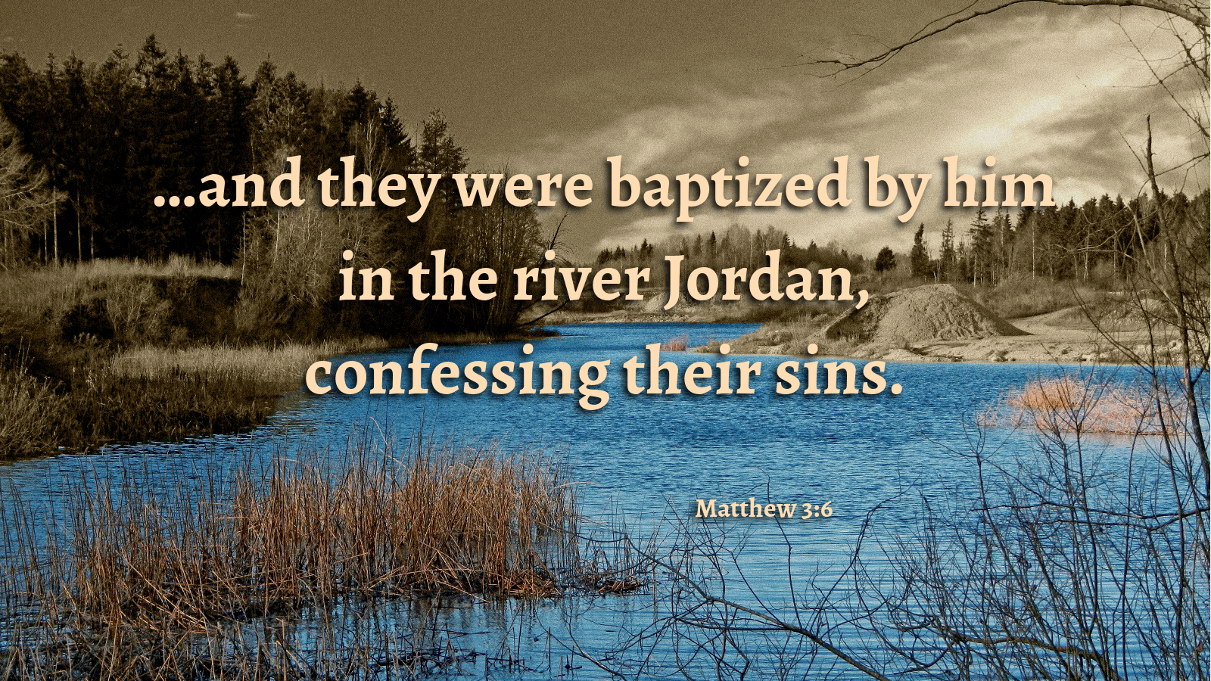

Preparing the Highway of Your Heart
December 4, 2016
Matthew 3:1-12
Grace and peace to you from God our Father and from Jesus Christ our righteous judge who is coming to clear the thrashing floor, amen.
It’s really hard for pastors to keep this season of Advent in perspective. Every year I find it gets harder and harder to keep Christmas until Christmas and hold the harsh truths of Advent up for all of you when I know all of us just want to get right to the joy of the babe of Bethlehem. Just a couple of weeks ago we read and I preached on the Crucifixion. Barb asked me why we had to hear such sad Gospel when Christmas is right around the corner. I said then and I say now, without Good Friday, Christmas is just another day. Now we have this Lizzie Borden image of God giving us the axe like a tree with the blight, or throwing us into a brush fire. The Second week of Advent doesn’t move us any closer to the joy of Christmas. Instead we get John the Baptist spitting out insults and crying, “Repent!” John didn’t demand some shallow "I’m sorry" one-time event kind of repentance, but the kind resulting from the axe slamming painfully at the root of our sin, so that we cry out from the offense of it all… Every year at this time I wince at preaching this word of God amidst the flurry of gift-buying, good-will, and glad tidings. Sometimes it just doesn’t seem to make sense…
I did a wedding a while ago for a couple I didn’t know, but they were relatives of friends of mine so I did the wedding. This week I received a call from the brother of the bride, a young man who I’ll call Sam. He said he got my number from the business card I had given to his mother as we were preparing for his sister’s wedding. Without even knowing who I am or much about me Sam launched into his story. He said he needed help. He wasn’t looking for the kind of help I’m used to being asked for. You know like help with the rent or utilities. That would have been easy. Sam wants spiritual help. He’s come to realize the great weight of his sins. Over the phone he began confessing them all to me. He said, among other things, he was a habitual liar. He had used all his family and his friends. He confessed to using drugs, although he caveated that particular sin by saying it wasn’t any really hard drugs, like heroin, just pot…He said he used pot as an excuse. After he seemed like he was finished listing every fault and every disgraceful thing he had done, I asked him if he knew that everybody has sinned and no one is perfect except Jesus and look what they did to him… He seemed to be genuinely sorry for his previous life and was searching for a different path for his future. I don’t know what that path will look like for Sam, but I’m meeting him for coffee and to talk. Please keep me and Sam in your prayers for God’s Spirit to lead us down the pathway toward that real repentance John the Baptist was talking about.
I’m telling you this because as I ponder the tension between the season of Advent and the joy of the Christmas gift from God, it struck me that there is no other path to that joy than through the hard work of laying the axe to our sin. The society and culture we live in tell us it’s time to start celebrating the joy of Christmas right now. When my niece’s husband was here over Thanksgiving he wanted to go to Cincinnati for a baseball card show. Melvin is an avid baseball card collector and has a basement filled with them. Since he had loaned his wife to us for over a month to help us pack for the move, the least I could do was take him. On the way back we hit a huge traffic tie up. I thought it was an accident, but it turned out to be a two mile back-up of cars all getting off I 75 at the exit where the outlet mall is located. It was black Friday and the bargain hunters were out in force. A lot of people buy into the myth that the joy of Christmas can be purchased at a bargain price at the outlet mall… The reality of God’s plan for the salvation of mankind is that the Grace of God, while free, isn’t cheap and true joy can only come after we’ve examined our lives and laid bare all those things we’ve done, all those things we’ve left undone and confessed them to God and changed our path. Christmas joy isn’t found at the mall, but when we honestly look into the mirror and assess our status before our maker.
When we confessed our sins earlier in this worship service, did you take time during the brief silence to personalize your confession? That brief silence is intended to offer you that opportunity. Too often I think about all the things I have on my todo list or wonder how the sermon I’ll be giving in a few minutes is going to be received. Even when we’re at our best and fully in the moment, is a brief silence really enough to do the kind of soul searching and talking to God about our sin that John the Baptist is calling for? This week as part of your preparation for the joy of Christmas, I challenge you to spend time in prayer reflecting on the condition of your lives. Are you baring fruit worthy of repentance? I think that means things like forgiveness, kindness, generosity, being a peacemaker and an advocate for justice for all people. There’s a tool I learned about several years ago that helps me stay grounded in this area. It’s called an altar call, but not the kind of altar call most people think about when they hear those words. The type of altar call I’m talking about is not done during a worship service or even with anyone else around. What I do a couple of times a year is, I just come here to this sanctuary when I can be all by myself. I kneel at the railing and have a long talk with God. No brief silence here. I spend as much time as I need. When I’ve done this I’ve never come away feeling that I’ve wasted my time. On the contrary, I come away refreshed, and confident in my relationship with God. During these talks I confess every sin I can think of. I literally bare my soul. There’s no need to hold anything back, it’s just me and God. It’s not like anyone else is going to know and God already knows, so there’s nothing to hide. I do have the advantage of being here a lot, so it’s a convenient place to do this altar call. You are all invited to come in here any time you like to do the same. If you need to come in for an altar call when nobody is here and you don’t have a key, just call and I’ll meet you here to open the door for you. If you try this discipline I will guarantee you will find it to be a rewarding experience and it will certainly help you to prepare the highway of your heart for the coming of the Lord.
As I was preparing this sermon it occurred to me this Advent tension I feel is created by my own resistance to having the highway to my heart prepared for Jesus’ coming. I guess it’s time for my Advent altar call… Because we can’t really know, can’t really feel the joy of Christmas until God axes away any obstacle that prevents union with our Lord. I won’t lie to you and tell you that if you come before the Lord in an altar call it’ll be fun or a happy experience. It might hurt a little, or a lot… But it will be the best work you’ve done to make room for a savior in your heart and in your life. The truth is the way to prepare the heart for the coming of the Babe of Bethlehem is straight through John the Baptist’s uncompromising cry, "Repent!"
May you find the time to examine your conscience and prepare the way for the Lord Jesus to enter your heart and life this Advent season. May God help you through the hard work of repentance. May God’s blessings of peace and a well healed soul be yours this Advent. Amen.

