CREDIT CARD AUTHORIZATION
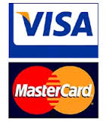
This form authorizes National Interpreting Agency to charge for services via credit card.
Please complete the below:
Name: __________________________________________________________________
Zipcode: __________________________________________________________________
Credit Card #: __________________________________________________________________
Expiration date: __________________________________________________________________
CVC Code: __________________________________________________________________
Amount: __________________________________________________________________
Date: __________________________________________________________________
Sign: __________________________________________________________________

