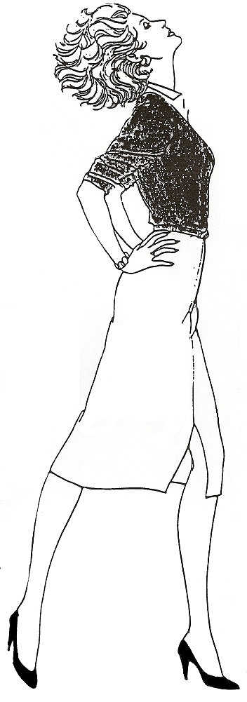
Contact your Shaklee Distributor for a wealth of information:

Women’s Health

ALWAYS START WITH A BASIC PROGRAM …
Protein – to build cells
Vitalizer – balances body chemistry
( which includes probiotics for the bowels )
Alfalfa – aids digestion
Herb-Lax – rids body of toxins
GLA – Omega 6 (essential fatty acids)
Vivix – a Cellular Repair & Anti-Aging Tonic

Memory: Mental Acuity (Premium Ginkgo Biloba Formula)

Baldness: Soy Protein, B Complex, Lecithin, Vita-E, Zinc, Vita-Lea, ProSanté
Hair Care Products

Headache: B Complex, Vita-C, Calcium, Vita-Lea, Flax Seed Oil, Stress Relief (Suggest reduce red meat)

Bad Breath: Zinc, Herb-lax, B-Complex, Vita-Lea, Alfalfa, Vita-C 100’s, Fibre Bars

Double Chin & Bustline: Extra C to support collagen, Cinch Program, Zinc, Flax Seed Oil, Lecithin

Waistline: Lecithin, Cinch – the Inch
Loss Program

Anything to do with the Skin:
OmegaGuard, GLA, CarotoMax, Zinc

Stretch Marks: Zinc, Vita-E,
B Complex, Vita-C, C&E Repair+

Menopause/Hot Flashes: OmegaGuard, Super Cal-Mag,
Vita-E, Zinc, Vita-Lea, Soy Protein, Menopause Complex,

Coughing: Take 2 Vita-C 100’s & 2 Alfalfa, every hour … plus suck on 2 Shaklee DR

Depression: MoodLift (St.John’s Wort), Stress Relief, B Complex, Soy Protein, Vita Lea

Dandruff: ProSanté Hair Care Products … Lecithin, Vita-E, B-Complex, Alfalfa, & CarotoMax

Dry, Brittle Hair:
Soy Protein, Lecithin,
B-Complex, and
ProSanté Hair Care Products

Acne: Protein, B-Complex, Zinc, Alfalfa, Herb-Lax, Vita-Lea, Lecithin, CarotoMax, GLA, Garlic, DTX, Enfuselle Skin Care Line

Oily Skin: Herb-Lax, Zinc, Lecithin, B-Complex, Enfuselle Skin Care Line

Dry Skin: Vita-Lea, Vita-E, CarotoMax, OmegaGuard, GLA, Alfalfa, and Enfuselle Skin Care Products

Nails: Soy Protein, Super Cal-Mag, B-Complex, Zinc, (suggest less sugar)

White Spots on Nails: Soy Protein, Zinc, Vita-E

Menstrual Cycle/PMS: Flax Seed Oil, Vita-Lea, Vita-E, Soy Protein, B-Complex, GLA, Vita-C, Alfalfa, Iron, Super Calcium Magnesium, (NO sugar or coffee - suggest exercise)

Cellulite: Lecithin, Cinch – the Inch
Loss Program, Exercise

Bruises: Vita C, Vita E, Soy Protein, Super Cal-Mag

Leg Pains: Vita-E, B-Complex, OmegaGuard, Mental Acuity

Stiff Joints: Alfalfa, Joint Health Complex, Herb Lax, Vita-C, Zinc, OmegaGuard, Lecithin

Bladder Problem: Vita-E, Zinc, Vita-C, Alfalfa, Super Cal-Mag,
B-Complex, Vita-Lea, CarotoMax, Garlic

Cold Feet: OmegaGuard,
B-Complex, Vita-E, Soy Protein, Lecithin, Super Cal-Mag, Alfalfa, DTX

Perspiration & Foot Odour: Zinc, Herb-Lax, Alfalfa, DTX, Optiflora, Fibre Bars

Varicose Veins: OmegaGuard, GLA, Herb-Lax, Vita-C, Vita E, Lecithin, Fibre Bars

Bones: Vita-Lea, Cal-Mag, Vitamin D3, Vitamin C, Alfalfa, Optiflora

