Doc Holley’s FAHRENHEIT 451 ESSAY
STUDENT’S NAME ___________________________ Class ______ Score _______
RL.9-10.1 | - I can cite text-based evidence that provides strong and thorough support for an analysis of literary text.
W.9-10.1 | - I can write an analysis of substantive topics or texts, using valid reasoning and sufficient evidence.
W.9-10.9 | - I can select evidence from literary informational texts to support analysis, reflection and research.
Directions: Write a formal essay demonstrating the standards below and knowledge from studying the above identified novel:
Respond to the following topic: 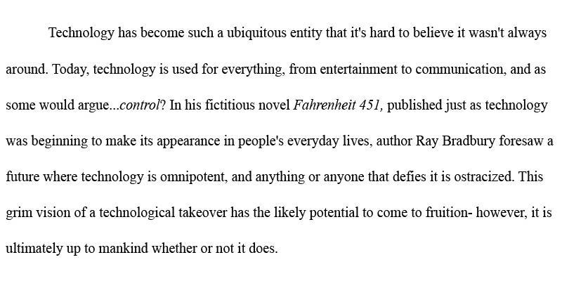
Your Title: ___________________________________

________________________________________________________________________________________________________________________________________________________________________________________________________________________________________________________________________________________________________________________________________________________________________________________________________________________________________________________________________________________________________________________________________________________________________________________________________________________________________________________________________________________________________________________________________________________________________________________________________________________________________________________________________________________________________________________________________________________________________________________________________________________________________________________________________________________________________________________________________________________________________________________________________________________________________________________________________________________________________________________________________________________________________________________________________________________________________________________________________________________________________________________________________________________________________________________________________________________________________________________________________________________________________________________________________________________________________________________________________________________________________________________________________________________________________________________________________________________________________________________________________________________________________________________________________________________________________________________________________________________________________________________________________________________________________________________________________________________________________________________________________________________________________________________________________________________________________________________________________________________________________________________________________________________________________________________________________________________________________________________________________________________________________________________________________________________________________________________________________________________________________________________________________________________________________________________________________________________________________________________________________________________________________________________________________________________________________________________________________________________________________________________________________________________________________________________________________________________________________________________________________________________________________________________________________________________________________________________________________________________________________________________________________________________________________________________________________________________________________________________________________________________________________________________________________________________________________________________________________________________________________________________________________________________________________________________________________________________________________________________________________________________________________________________________________________________________________________________________________________________________________________________________________________________________________________________________________________________________________________________________________________________________________________________________________________________________________________________________________________________________________________________________________________________________________________________________________________________________________________________________________
_________________________________________________________________________________________________________________________________________________________________________________________________________________________________________________________________________________________________________________________________________________________________________________________________________________________________________________________________________________________________________________________________________________________________________________
_________________________________________________________________________________________________________________________________________________________________________________________________________________________________________________________________________________________________________________________________________________________________________________________________________________________________________________________________________________________________________________________________________________________________________________
_________________________________________________________________________________________________________________________________________________________________________________________________________________________________________________________________________________________________________________________________________________________________________________________________________________________________________________________________________________________________________________________________________________________________________________
Draw an image to coincide with your essay:

