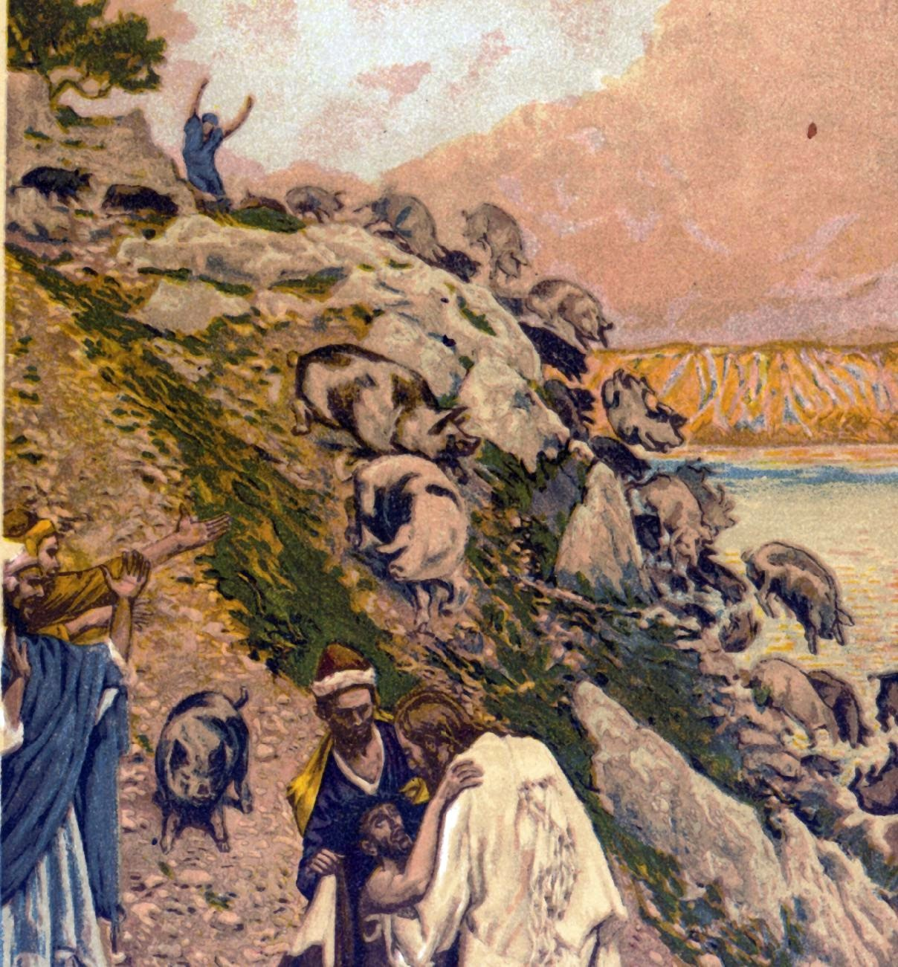

What’s In A Name
June 19, 2016
Luke 8:29-36
Grace and peace to you from God our Father and from the one with the power and authority to cast out demons, Jesus Christ, Our Lord, amen.
Today we’re going to start and end with a prayer. Please pray with me… Jesus, Son of the Most High God, thank you for divinely uniting this congregation and this pastor. Both have some experience battling demons. Keep us united and safe as we call upon your name to face whatever Legions of demons may come our way today or in the future. In your strong name we pray, amen.
What’s in a name? Well quite a lot really… When you know a person’s name you’ve demystified them. You’ve made them real in some sense. They become less scary because they are known. We are all afraid of the unknown and knowing the name of the other helps to calm our fears. On the other hand, when you know someone’s name you have some power over them. You can call them by name and command their attention. If I’m in some sort of trouble and I yell out “Help, Help!” Chances are nobody will come to my aid. We’ve all heard the stories about the rape in New York City that was witnessed by many people and not a one came to the victim’s aid or even called 911. If I take the same scenario where I’m in trouble and I call out “Andy or Betty, or Roxanne (or pick any name from the congregation), come help me!” The chances are much better that Andy or Betty or Roxanne will come to my aid. I had power over them to compel them to act.
There’s a lot going on with names in this story of the man with the demons from today’s Gospel. We’ll deal with the name of the demons in a bit, but right now I want to say a few things about the way this demon possessed man approaches Jesus. The first thing the man says is, “What have you to do with me, Jesus, Son of the Most High God? I beg you, do not torment me.” The Greek phrase we have translated as “What have you to do with me” is very ambiguous and hard to translate. One of my very expensive and scholarly commentaries, the Word Biblical Commentary, translates this as a question, “What good can come to me from contact with you, Jesus, Son of the Most High God?” I always thought these first words from this man’s mouth were really the words of the demons speaking. In my mind they went something like, “(speaking in my best demon voice) What have you to do with us…” After thinking about this alternate way these words can be translated, it makes much more sense if they are actually coming from the man himself and not from the demons. They are words of a desperate man who has lost his identity among all the voices inside his head and from those outside voices as well who defined him and also took away his unique identity. The man knew the name and the identity of the one who could bring back his dignity, his sanity, and his identity. Instead of being a taunt by the demons speaking through the man, what if this is actually the outcry of the one held captive, begging the Son of the Most High God to make good come from their encounter. He asks not to be tormented any longer, but to be saved.
Jesus asks the demon for a name and we learn the name is Legion, for they were many… Many for sure! At this point in the struggle between good and evil both sides now know the identity of their opponents. A Roman Legion consisted of between 6-8 thousand soldiers. That’s a lot of demons! That’s a lot of evil, even for Jesus to deal with! Not so for the Son of the Most High God. Jesus dismisses the Legion and gives them permission to go into the herd of pigs. In case you never knew this was the original recipe for “Deviled Ham…” This is a story that demonstrates the power of Jesus Christ to save, even a man possessed by at least 6000 demons.
In our day, we’re far more accustomed to attributing calamities and disorders to the forces of nature or to internal mental or emotional problems, to diseases, or to “man caused disasters”… The remedy today usually isn’t exorcism, but more often counseling or even better, medication. If we can call it a disease and give it a name, then we can get a prescription and a cure. This story speaks words of assurance and hope to you when every day is a battle with depression, fear, anxiety, compulsive behavior, bipolar disease, or any number of demons that torment your days and nights. If not mental illness we certainly have no shortage of other demons that haunt us. Many struggle with financial problems, debt too high or income too low, broken relationships, loveless marriages, workplace harassment and job insecurities. Then there’s the perpetual struggle of those caught in the bonds of sins such as addiction to… well, you name the poison, drugs, alcohol, “sins of the flesh”, idolatry… And the list goes on… If any of that describes you, I know you already know what it’s like to have your identity eroded by a “mob” of voices inside and out telling you that you are this disease or that diagnosis or this kind of sinner. You no longer have any individual identity. You lose your name, your individuality until all that’s left is a boiling struggle of conflicting forces. It’s as though the entire Roman Legion is at war within.
When we lift our heads from our own personal situations long enough to take a look at the world around us we see more of the same. This week I'm sickened by the heinous cowardly attack at the Pulse night club in Orlando. My heart is moved with sadness for the victims, their families, and loved ones. The dead bodies hadn’t even been removed from the scene before the arguments began over whether this was gun violence or radical Islamist Terrorism. The president gave a speech this week where he said calling this radical Islamist terrorism isn’t a panacea that will make these types of attacks go away. The other political side says that unless and until we label the disease we can’t hope to find the cure. I don’t know where you stand in relation to these issues. I’m not going to take one side or the other from the pulpit, but I will say this, the same name called on by a man possessed by a Legion of demons, the same name that cast out and utterly destroyed that same Legion of demons stands ready to save you from your Legion and ready to save our world from what seems to be our mega-Legions. That man, that name is Jesus Christ, Son of the Most High God! Jesus is the one we count on to save us, to give us our identity and to form us into a community where in his name we do in fact restore through the power of God’s love each other’s worth and dignity, sanity, and identity. In this community of faith you are no longer the depressed one or the manipulative one, or the judgmental one. We are all given our one true identity, Beloved Child of God. Whatever else, whoever else you might be, know this… first and foremost you are loved and valued because you are a Child of the Most High God!
Let’s pray… What good can come to me, to us from contacting you today, Jesus Son of the Most High God? We beg you to stop the torment in our lives and give us peace. Cast out the demons who constantly try to take away our identity as your beloved child of God and restore in us that uniqueness you gave each of us when you created us in your image. Work through each of us and through those we’ve chosen to be our leaders to defeat the mega-Legions that want to destroy our culture and our way of life. Keep us in your grace, O God and have mercy on our enemies. All this we pray in the name above all names, the Son of the Most High God, Jesus Christ our Lord, amen.

