Ktique Birman Kittens
Questionnaire

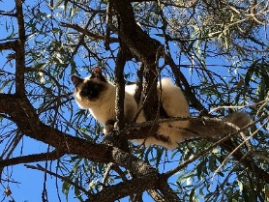
Scarlett enjoying some supervised outdoor time.
- Your name

- Your address

- Your email address

- Your phone number

- Are interested in a desexed pet companion or a show cat?

- Male or female

- Do you have a colour preference?

- How many other pets do you have? Please list type/age/breed

- Do you have children? (Birmans are great with children)

- Do the adults work outside the home?

- How many hours a day would the kitten be left alone?

- How do you feel about kitten claw marks on your furniture?

Prices:
Pet home de-sexed kittens are $2,000.
Show home kittens are $2,500
All kittens are Micro-Chipped, Vaccinated, Wormed, Vet Checked, Desexed (if applicable) and have QFA Pedigree Papers. They come with 6 weeks free Pet Insurance and a Gift Bag with lots of goodies.

Once your application is approved and when the kittens are born, we do require a $1000 holding deposit.

