**Homemade Vanilla Extract in Wax-Sealed Bottles**

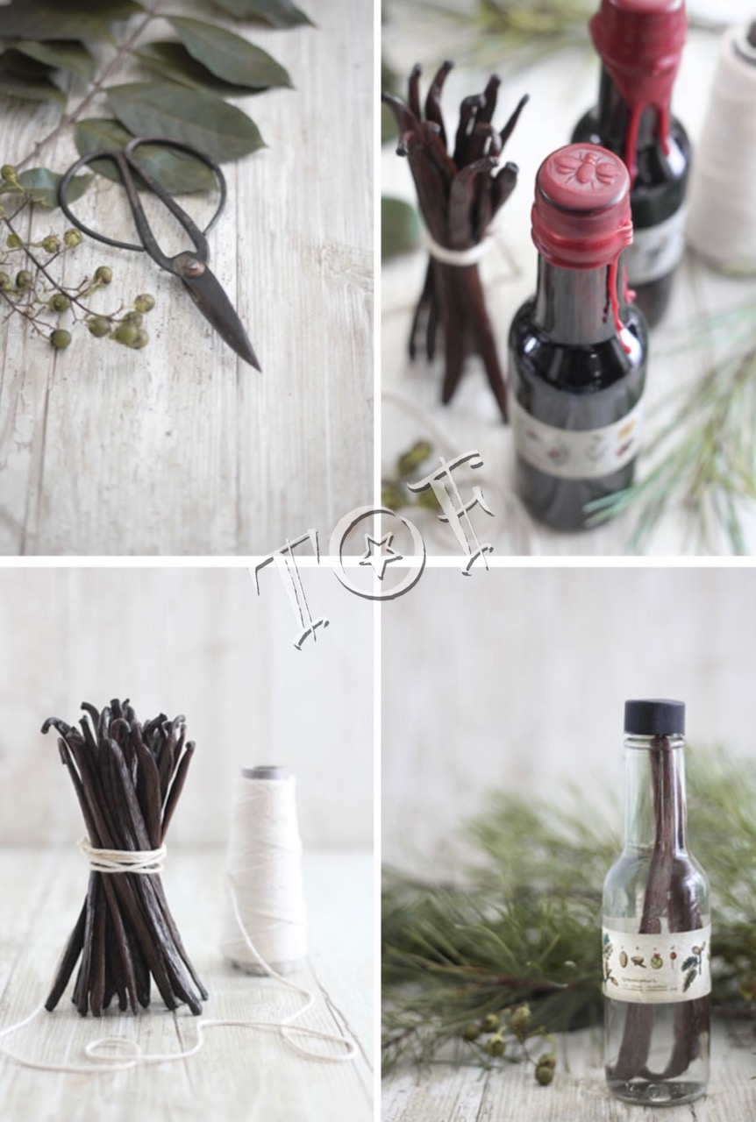

There must be nine hundred and ninety-eleven recipes for homemade vanilla extract online, and I suppose that’s why I’ve never seriously considered posting a recipe. Vanilla extract is something I make regularly and I use in almost every sweet thing I bake.

The reason why I love homemade vanilla extract so much is because I know it’s pure (I control the ingredients), it costs less to make and – most importantly – the flavor is superlative. As far as staple ingredients go, it’s pretty important to me.

My vanilla extract sits for 18-24 months.

* **35-40% alcohol** (70-80+ proof): Opinions are sure to vary on this, but I say garbage in garbage out so I use top of the shelf. I usually buy an expensive variety such as Grey Goose Vodka, Kirk and Sweeny Rum and Woodford Reserve Whiskey. I have used many others but these three produce smooth vanilla flavors.
* **Madagascar Vanilla beans, Mexican and Tahitian Beans** : Madagascar and Mexican vanilla beans are strongly fragrant and have a creamy taste that goes well in cakes, cookies and quick breads. Vanilla beans in general can be awfully expensive so I typically buy by the weight. There are many other varieties of vanilla beans not listed here but these three **beans I use specifically for extract making, and save the more pricey Tahitian vanilla beans for custards and frostings.**

From this ……too this

**The perfect gift for everyone.** Everyone I know has used Vanilla extract and its especially used by families during the holidays. Aside from the holidays and the avid bakers in my circle, but also the occasional chocolate chip cookie makers and even my pal who uses her oven as a make-shift magazine rack (she likes vanilla in her hot cocoa and coffee). Everyone can benefit from the loving touch of a little vanilla, if you ask me. My Vanilla Extract comes beautifully packaged and a must for every kitchen. You wont be disappointed in this tastey gift so give it a try!