Emotional Abuse Red Flags

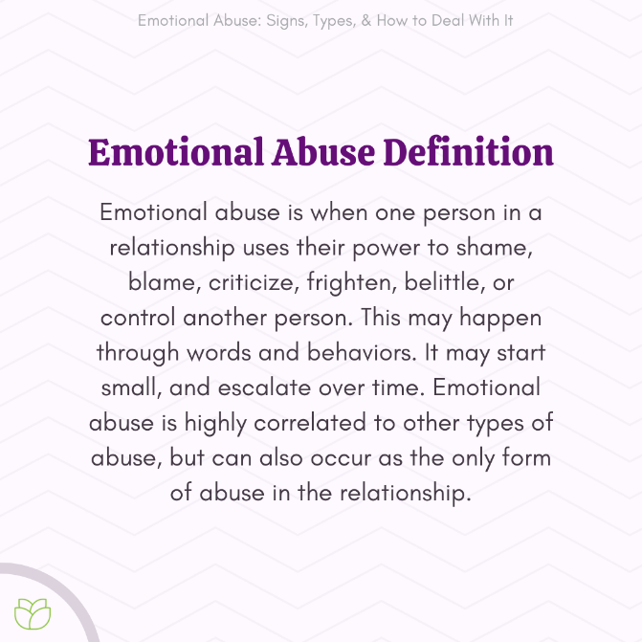
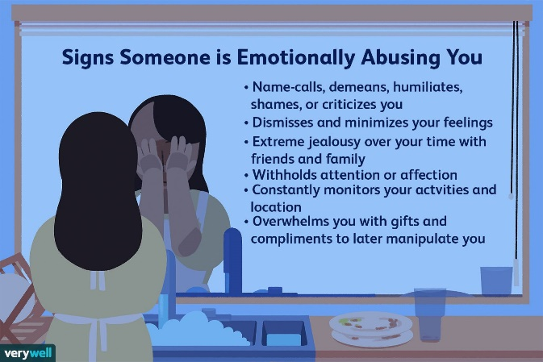
All of God's chosen at some time or another interact with people who are trying to dominate, control or break us down in some way. We are dealing with Narcissistic spouses, parents, siblings, extended family, bosses, co-workers and the list goes on. Knowing the signs will save your life. Remember we are fighting a spiritual battle so stay with God and he will arm you with the skills to fight these type of people. Keep in mind, you are not fighting the person. You are fighting the demonic spirit that is within them and coming against you. Their spirit knows how powerful you are and what you are here to do on earth. Their main goal is to delay you or stop you from moving forward. Attack on the mind is the easiest but most powerful tactic the enemy uses to disarm and weaken us.
https://m.youtube.com/watch?v=logQdS2egeQ&feature=youtu.be

