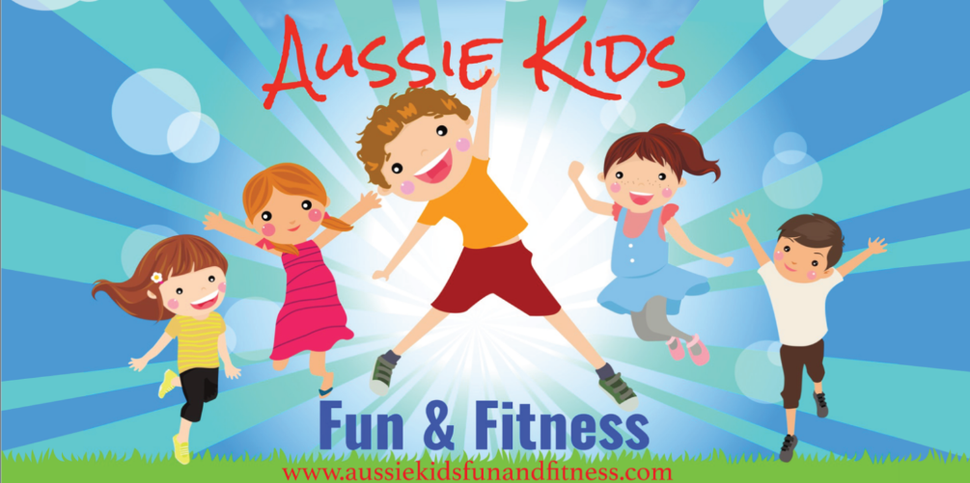

**CUDGEN PUBLIC SCHOOL Vacation Care Program – DEC 17th – JAN 4th**

**Thursday 17th December** **Christmas: Arts & Crafts Cooking Tattoos & Face painting Mascots**

**JUMPING CASTLE**

**AUSSIE KIDS FUN & FITNESS IS CLOSED FROM THE 25th December until the 3rd January **



**Children are required to wear enclosed Foot Ware and Socks, Bucket Hats (the Service has spare hats available) No Singlet Shirts, Bring Spare Clothes and a Water Bottle, Full HEALTHY Lunch each day unless stated otherwise. For Water Play Activities please bring: Swimmers, Towel, Rashie & Sunscreen.**

**Monday 4th January**

**Jumping Castle Giant**

**Yard games**

**New Year Calendars**

**Tuesday 22th December** **Excursion: Tabatinga Indoor Play Centre**

**Putt Golf, Bumper Cars, Huge Indoor Play Area Christmas Crafts**

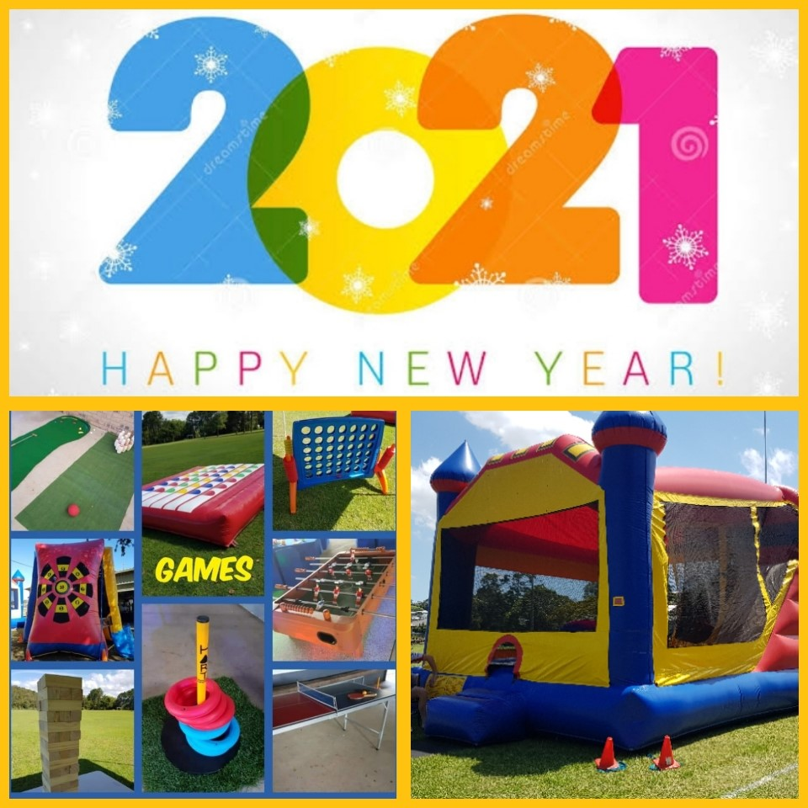

**Thursday 24th December Traditional Christmas Lunch** **Christmas Mascots** **Christmas Crafts Wrapping Presents for the less fortunate Families**

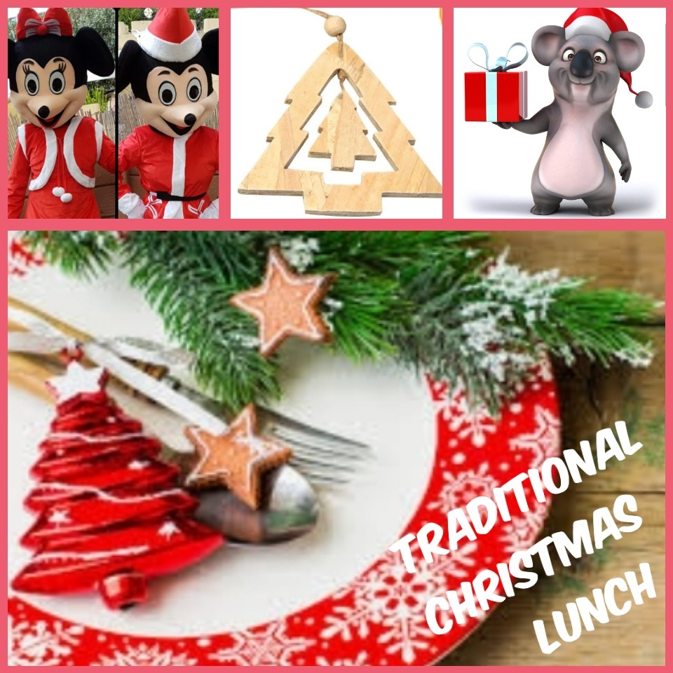

**Wednesday 23rd December Double Dive & Slide**

**Christmas Cup Cake Decorating Xmas Photo booth Christmas Sun Catchers**

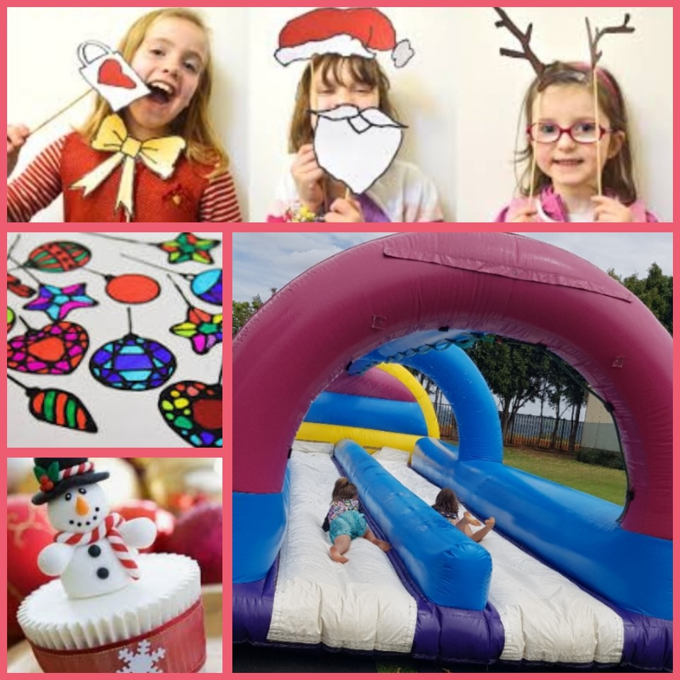

**Friday 18th December** **EXCURSION: Minjungbal Aboriginal Cultural Centre, Picnic Lunch**

**Dot Painting, Clay Creations**

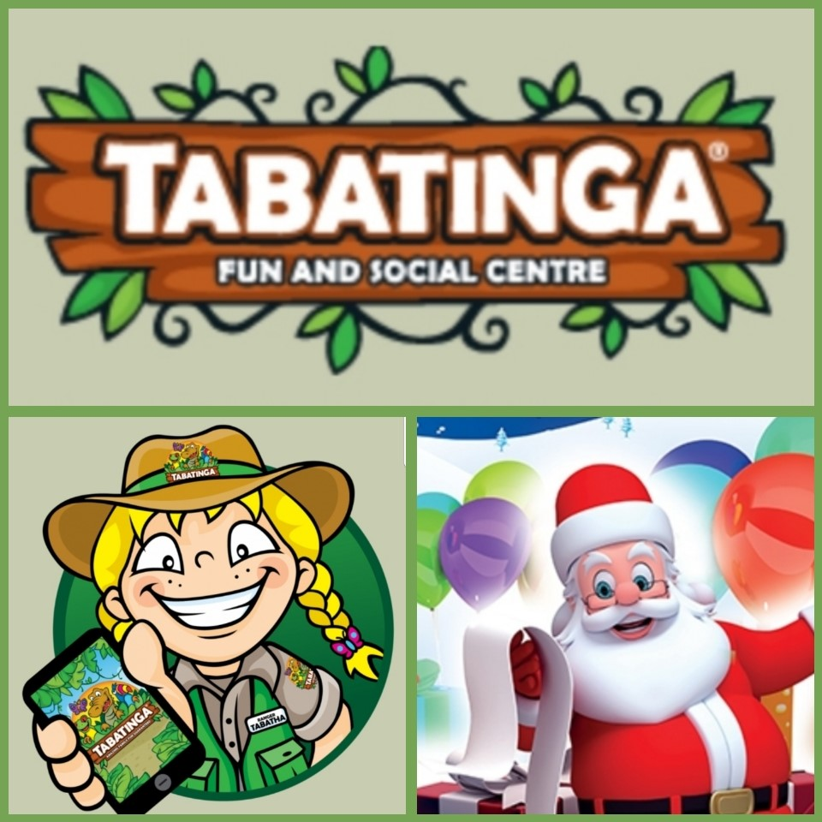

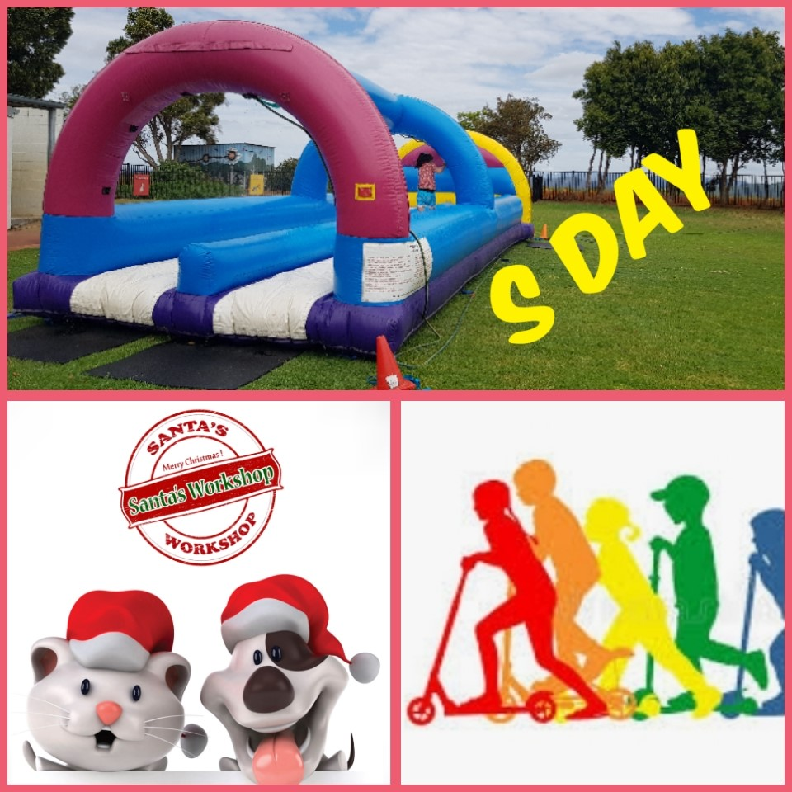

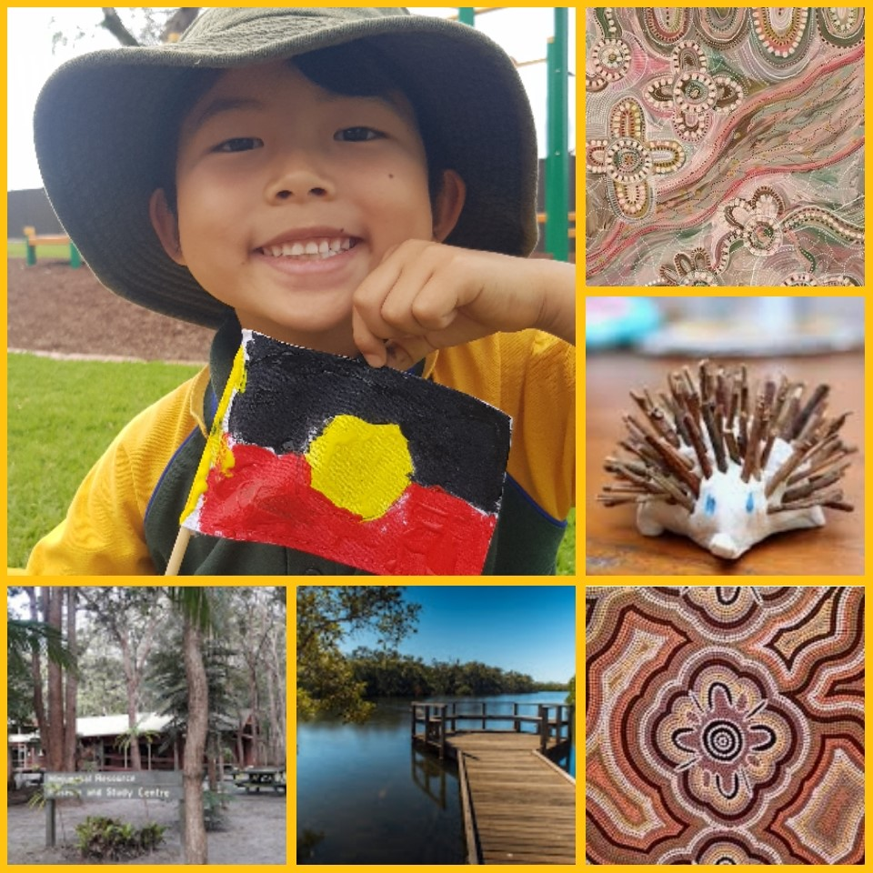

**BOOK ONLINE** [**www.aussiekidsfunandfitness.com**](http://www.aussiekidsfunandfitness.com) **PHONE: 0413974775**

**Monday 21st December** **S DAY** ***Huge Double Dive & Slide*** **Bring your Scooter & Helmet, Swimmers, Sunscreen & Towel Santa’s Workshop**