Do you know that Monday December 1, 2014 is world AIDS Day?

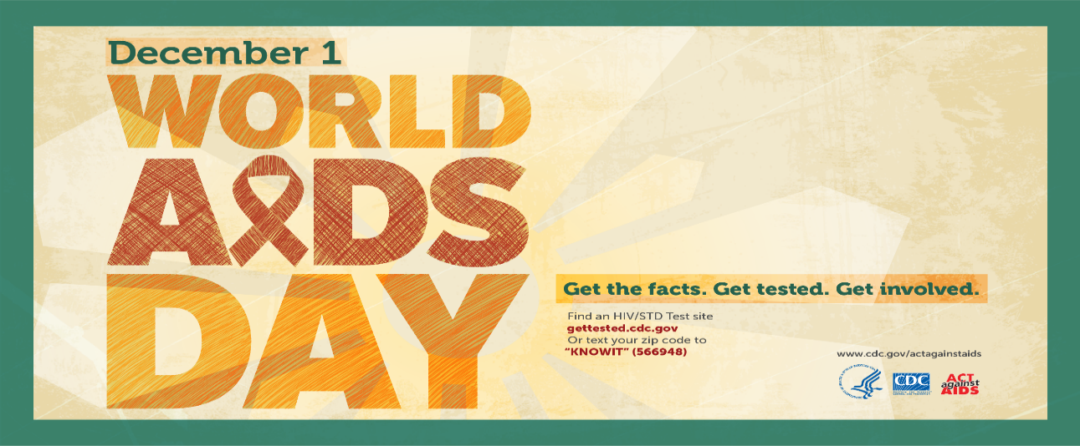

HIV-AIDS Facts
Compiled by: Admassu Mitiku, PhD

1. Immunodeficiency Virus (HIV) infects cells of the immune system breaking down the body's ability to fight some infections and other diseases.
2. Acquired immune deficiency syndrome (AIDS) is the advanced stage of HIV infection characterized by the occurrence of more than 20 different opportunistic infections or related cancers.
3. HIV can be transmitted in several ways, including: Unprotected sexual intercourse with an infected person; transfusion of HIV-contaminated blood; sharing of HIV-contaminated needles, syringes or other sharp instruments; transmission between a mother and her baby during pregnancy, childbirth and breastfeeding.
4. Globally, an estimated 39 million people have died from AIDS-related causes since the beginning, including 1.5 million in 2013 alone.
5. Worldwide, 35 million people were living with HIV in 2013 and an estimated 2.1 million people were newly infected with HIV in the same year. Of these, 3.2 million were children (over 240, 000 newly infection during pregnancy, childbirth or breastfeeding) and the vast majority of people living with HIV are from low-and middle-income (sub-Sahara Africa) countries.
6. Combination of anti-retroviral therapy (ART) prevents the HIV from multiplying in infected immune cells. That means, our immune cells are able to live longer and provide the body with protection from other infections.
7. Close to 12 million HIV-positive people had access to ART in low- and middle-income countries at the end of 2013. According to WHO treatment criteria and guidelines, about 85% of all people living with AIDS are eligible for ART.
8. Mother-to-child transmission of HIV is almost entirely avoidable through preventive interventions and keeping mothers alive. In 2013, 7 out of 10 pregnant women living with HIV (970, 000 women) received anti-retroviral drugs.
9. HIV is the strongest risk factor for developing active Tuberculosis (TB) disease. In 2012, approximately 320, 000 deaths (one-fifth of 1.6 million deaths of 2012) from tuberculosis occurred among people living with HIV. The majority (about 75%) of people living with both HIV and are from sub-Sahara Africa.
10. According to Associated Press (AP) report of November 26, Ethiopian health officials hope to break the record of tests (2,000 tests in one day) this coming weekend in honor of World AIDS Day on December 1. The previous record for number of HIV tests carried out in one day occurred in Argentina in November 2012, when 1,380 people were tested.
11. The Ministry of Health said the tests would occur in the country's Gambella region, where 6.5 percent of residents have HIV or AIDS.
11. It was also reported by UNAIDS that some 800,000 Ethiopians have been infected with HIV since the outbreak of the disease in the 1980s. A quarter of those infected were children.
12. According to World health organization (WHO), there are several ways to prevent transmission of HIV and the key ways are: Practicing safe sexual behaviors such as using condoms; getting tested and treated for sexually transmitted infections, including HIV; avoid injecting drugs and sharing needles and syringes and ensure that any blood or blood products that you might need are tested for HIV.
13. So far, two HIV infected patients and developed AIDs, the so-called the “Berlin patient” and Mississippi baby born to a mother with HIV are the only individuals cured from the disease. In both cases, there is no sign of viral infection and both appear to be free of HIV after completing their retroviral drugs. It is now understood that early detection and treatment is the key factor in living a long life after contracting HIV.
14. On the other hand, the “mystery” why some people with HIV do not get AIDS is now uncovered and the findings were published in Science: December 2010, Vol. 330 no. 6010 pp. 1551-1557. According to the researchers, these findings have to be confirmed and re-examined before they are accepted by the scientific community and the public.

