Li’l Dragons HONESTY worksheet (ages 4-6 yrs old)

Read the stories below, then the choices that follow. Circle the outcome that best shows HONESTY:
One day, Tim decided to get up early to make himself breakfast. While he was pouring milk on his cereal, he tipped over the bowl, spilling cereal and milk all over the floor. His parents hear the noise, and get out of bed to come find out what happened. Tim is afraid his parents might be mad at having been woken up early. What should Tim do?
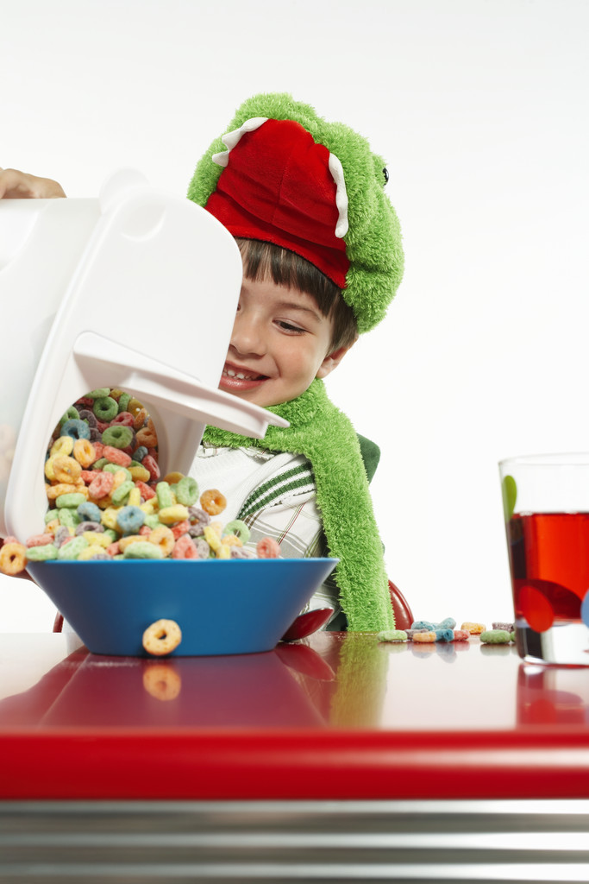
1) Tim quickly runs back to bed, and pretends to be asleep, like he’s been there the whole time…

2) Tim tells his parents what happened, cleans up his mess, and tries again with breakfast (maybe with some help…)

At school Thursday, Jenny is wearing a sweater than her friend Madeline thinks is really ugly. Of course, Jenny asks Madeline what she thinks of her sweater. What should Madeline say?

1) That Jenny’s sweater is really nice. She doesn’t want to hurt Jenny’s feelings

2) That she doesn’t think the sweater is cool enough for someone as awesome as Jenny.

3) That Jenny’s sweater is really ugly. Isn’t that honest?
Susie and Damon are playing baseball in Damon’s yard when Susie hits a foul ball that goes through the neighbor’s window. What should they do?

1) Go tell Damon’s parents what happened, and have the
parent’s take Damon and Susie to the neighbor’s house to
apologize

2) RUN! If no one sees them, they didn’t do it.

3) Race to the house; the first person to get there can tell on
the other person, and maybe get out of trouble

Your HONESTY:
Talk about a time when you showed HONESTY when you wanted to lie, and what happened:_______________________________________________________________________________________________________________________________________________________________________________________________________________________________________________________________________________________

