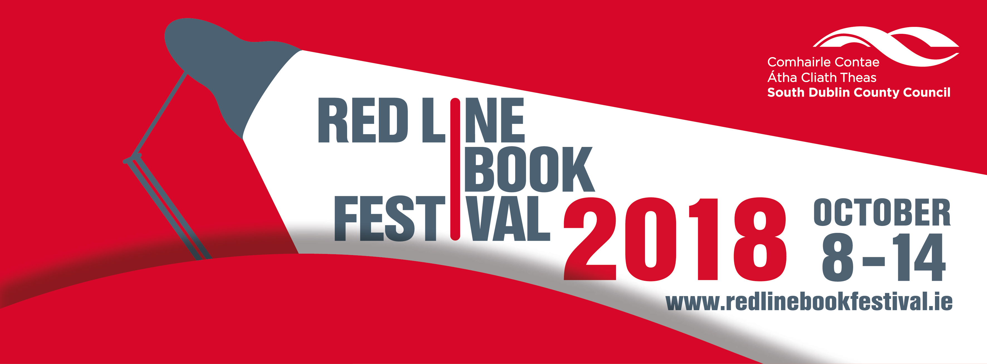
Red Line Book Festival 8th – 14th October 2018
Expression of Interest to Participate in the 2018 Red Line Book Festival
The 7th annual Red Line Book Festival takes place from 8th - 14th October 2018, across South Dublin County in libraries, the Civic Theatre, Rua Red Arts Centre, and other venues. The festival is funded by South Dublin County Council and managed by South Dublin Libraries and Arts.
The programme presents a high-profile, quality book festival within South Dublin providing a wide range of events. The festival engages in the exploration of ideas, literature, culture, creativity and imagination, and includes showcasing the best of national and emerging contemporary writing. In 2017, the festival featured 35 events attracting over 3000 people. Previous programmes can be viewed at www.redlinebookfestival.ie.
The Red Line Book Festival is a curated festival. Participation is by invitation only with participants selected by the festival curatorial team.
This year we are inviting submissions from writers/poets to submit ideas for events to be taken under consideration for the 2018 Red Line Book Festival.
The objective of this is to provide a platform for emerging and established writers/poets to reach new audiences, and audiences that may be new to the Red Line Book Festival.
Specifically this will include
- presenting a workshop/talk on their own particular area of expertise
- participation/attendance at a reading event with other successful contributors, culminating in a panel discussion, at times and venues to be decided.
Submissions could also include proposals for installations and innovative forms of presentation and proposals from writers working in cross-disciplinary contexts.
Please note that participants must commit to full availability for the duration of the festival.
Submission Requirements
Authors, publishers, and cultural organisations wishing to be considered for presentation in the Red Line Book Festival 2018 are invited to submit proposals and ideas to the festival selection panel. There is no fee to submit proposals.
When submitting proposals please use the enclosed application form, including the following details:
- Brief biography, to include recent publications, reviews, award nominations, and experience at presenting
- Outline of your idea for an event, including your target audience, and numbers.
- Ideas on how you can promote your event and the Red Line Book Festival.
- Breakdown of the costing of the proposal
- Commitment to full availability for the duration of the festival.
Submissions received will be acknowledged by email, but please be aware that due to the large number of entries, the panel cannot respond or offer assessment and feedback.
Submissions should be sent (3 signed hard copies) to:
Red Line Book Festival,
South Dublin Libraries Headquarters,
Unit 1, The Square Industrial Complex,
Tallaght,
Dublin D24 YXW3
The deadline for receipt of submissions is 12 noon on 20th March 2018.
Selected Criteria
Participation in the Red Line Book Festival is by invitation only. The selection process is competitive as the Festival is limited by funding, space and scheduling constraints. For events pertaining to new publications, preference is given to work published within 18 months prior to the festival.
Although preference may be given to writers and poets who have published books, applicants who have established credentials by satisfying the following criteria may be considered for participation in the 2018 Red Line Book Festival:
- A proposal which compliments and enhances the Red Line Book Festival programme
- The creativity & innovation of the proposal/idea
- Publications and awards
- Experience at presenting in their particular area, demonstrating ability to sustain an audience
- Resources to promote events and attract an audience
*Applicants whose proposals were accepted in 2017 will not be eligible to re-apply until 2019.
*Applicants who successfully submitted proposals in 2016 are eligible to apply again in 2018.
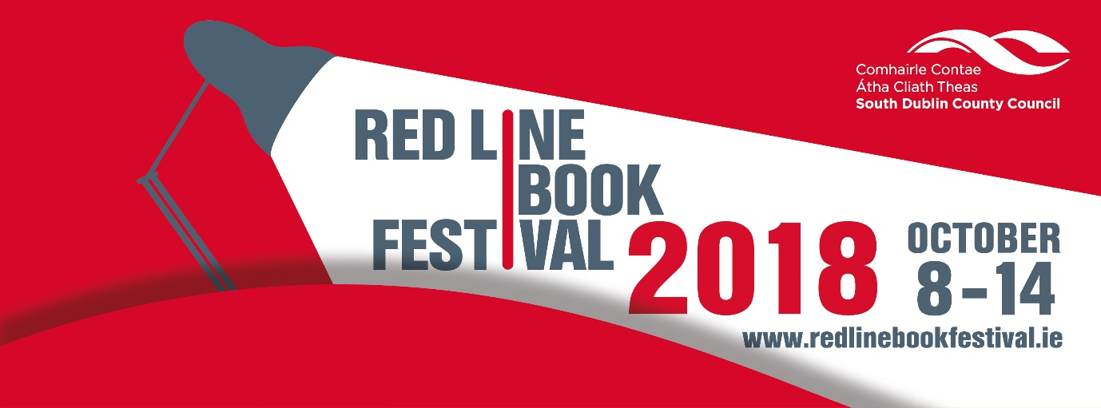

Expression of Interest to Participate in the Red Line Book Festival 2018
APPLICATION FORM

Name:
Address:

Email:

Phone:

Mobile Phone:

1. Brief biography, to include recent publications, reviews, award nominations, and experience at presenting.

2. Outline of your idea for an event, including your target audience, and numbers.

3. Ideas on how you can promote your event and the Red Line Book Festival.

4. Breakdown of the costing of the proposal.

5. Commitment to availability for the duration of the festival.

Signed:____________________________________________ Date:______________________

