Table of Contents
1 OVERVIEW 3
1.1 INTENSION AND HISTORICAL PERSPECTIVE 3
1.2 LIFE-CYCLE DOCUMENTATION ACTIVITIES 4
1.3 EFFECTIVE USE OF ELECTRONIC FILES 4
1.4 INTEGRATED FORM LOADER DASHBOARD 5
1.5 SINGLE FORM FOR ALL RELEVANT DATA 5
1.5.1 Operating Parameters Communication 5
1.5.2 Device Specification Documentation 5
1.5.3 General or Special Requirements Communication 6
1.5.4 Advantages of Combined Form Content 6
1.6 BASIC PHILOSOPHIES 6
1.7 COLLABORATIVE EFFORT BETWEEN SPECIFIER AND DEVICE MANUFACTURER 7
1.8 MULTIPLE EDIT SESSIONS AND REVISION MANAGEMENT 7
1.8.1 Continuing Reminder to Resolve All Properties or Identify as Not Applicable 7
1.8.2 Enhanced Data Formatting Assist Commenting 8
1.9 FORM TERMINOLOGY BASIS AND CONTENT 8
1.9.1 Basis of Component Type Terminology 8
1.9.2 Field Prompt Terminology Clarified “By Example” Pick List 8
1.9.3 Updated Pick List for Manufacturers 2017-2020 Data 9
1.10 TYPICAL DOCUMENTATION REQUIREMENTS 9
1.11 SUITABLE FOR INTENDED USE CONCEPT 9
1.11.1 Responsible Organization identification is Clearly Documented 10
1.11.2 Subtitle Identification of Main (Device) Component Type 10
1.11.3 Specification Identifications Required Document Number 10
1.11.4 Operating Parameters Form Sections 11
1.11.5 Device Specification Form Sections 11
2 DEvice Specification Form STyles 11
2.1 COMPLEX DEVICE SPECIFICATION 11
2.2 SIMPLE DEVICE SPECIFICATION 11
2.3 ENTERING OPERATING PARAMETERS DATA ON DEVICE SPECIFICATION FORMS 12
2.3.1 Operating Parameters Tutorial Document 12
2.3.2 Quick Start Tour Document 12
2.3.3 General or Special Requirements 12
3 DEVICE SPECIFICATION PROPERTIES 12
3.1 DEVICE PROPERTIES REQUIRED FOR UNAMBIGUOUS ORDERING 12
3.1.1 Subsection Order of Device Specification Forms 13
3.1.2 Subsection Content Order of Device Specification Form 13
3.1.3 Device Properties Copied to Instrument Index Data Spreadsheet 13
3.1.4 Primary construction material 14
3.1.5 End Connection Nominal Size, Rating, Type and Style 14
3.1.6 Input Sensor Type 15
3.1.7 Output Signal Type 15
3.1.8 Integral Indicator Style 15
3.1.9 Characteristic Curve 15
3.1.10 Failsafe Style 15
3.1.11 Type of Protection 16
3.2 COMMUNICATION INPUTS AND OUTPUTS LISTING 16
3.3 MANUFACTURER’S DEVICE PERFORMANCE CHARACTERISTICS 16
3.3.1 Max pressure at design temp 16
3.3.2 Minimum Working Temperature/Max 16
3.3.3 Measured Variable Accuracy or Accuracy rating 17
3.3.4 Measured Variable LRL/URL 17
3.3.5 Min (Measured Variable) Span/Max 17
3.3.6 Contact Ratings 17
3.4 ACCESSORIES REQUIREMENT LISTING 18
3.5 SPECIAL REQUIREMENTS LISTING 18
3.6 MODELING PHYSICAL DATA CONSISTENT DOCUMENTATION 18
3.7 CALIBRATION AND TEST RANGES FOR PHYSICAL AND VIRTUAL SIGNALS AND FIXED SETPOINTS 19
3.7.1 Calibration and Test Table Fields 19
3.7.2 Measurement /Test or Measurement Description 20
3.7.3 Measurement or Input Signal Input LRV/URV 20
3.7.4 Setpoint LRV/URV 20
3.7.5 Final Control Device Input Range 21
3.7.6 (Control) Action 21
3.7.7 Output LRV/URV 22
3.7.8 Setpoint Output LRV/URV 23
3.7.9 Measured Variable Scale Input LRV/URV 23
3.7.10 Measured Variable Scale Output LRV/URV 23
3.7.11 Calculated Variable Documentation 24
3.7.12 Software Configuration Documentation 24
3.8 MANUFACTURER AND MODEL NUMBER FOR ALL DEVICES, AUXILIARIES, OR ACCESSORIES 25
3.8.1 The Component Type Property 25
3.8.2 Manufacturer and Model Number 25
4 General or Special Requirements 25
5 Data Exporting for External Applications 27
5.1 DATA EXTRACTION AND EXPORT 27
6 FACILITATE ENHANCED WORK PROCESSES USING COPY CAPABILITY 27
6.1 COPY OPERATING PARAMETERS DATA FOR CONSISTENCY 27
6.1.1 Operating Parameter Data for Lines Containing One or More Instruments 27
6.1.2 Operating Parameters Data for Vessels Containing One or More Instruments 27
6.1.3 Copy Operating Parameters Data from a Form Developed Earlier 27
6.2 COPY TYPICAL DEVICE FORM DATA FOR EFFICIENCY 27
6.2.1 Create Library of Typical Device Specification Forms of High Usage Devices 27
6.2.2 Create Library of Typical Device Specification of Auxiliary Devices 27
6.3 CHANGE THE DEVICE SPECIFICATION FORM FOR A SPECIFIC TAG 28
6.4 COPY DATA BETWEEN SIMILAR TAGS OR APPLICATIONS 28
6.5 COPY DATA FROM SELECTED MANUFACTURER’S COMPLETED FORM 28
7 WORK SHARING OR COLLABORATION 28
8 Managing Externally Edited Documents 28
8.1 REVIEW MANUFACTURER(S) SPECIFICATION EXCHANGE DOCUMENTS 28
8.2 Evaluate Alternate Proposals 28
9 CUSTOMIZABLE TEMPLATES FOR OPTIMIZED WORK APPLICATIONS 29
10 HELP FUNCTIONALITIES 29
10.1 CONTEXT SENSITIVE HELP DEFINITIONS 29
10.2 FORM APPLICATION USER HELP 29
11 INTEGRATED INSTRUMENT INDEX DATA BROWSER 30
Appendix A - Determining mEASUREMENT Input Range-Values 31
Appendix B Definition of Terms 32

1 OVERVIEW
Instrument Specs and Index aims to provide crowd sourced tools for instrument device design documentation and consistent product driven specifications, to optimize the “suitable for use” determinations and facilitate documenting a complete device, accessories and related software configuration data for the purchase of these devices.

1.1 INTENSION AND HISTORICAL PERSPECTIVE
It is the intention of Instrument Specs and Index to handle any kind of instrument offered by multiple competing manufacturers which publish their technical data on the Internet. Therefore, frequent revisions and addition of new specification templates is a goal and expectation.
The historically available device specification forms are primarily applicable with processes for continuous flow of fluids or level measurement. This set of forms greatly broaden applications to represent those instrument devices used with:

- Discrete object automation
- Batch control devices
- Bulk solids processing
- Machinery monitoring and protection
- Environmental monitoring
- Fire monitoring and alarming
- Weight based batch control with recipes

A perspective of the magnitude of available Device Specification forms over the last 40 years is identified by comparison to two major publishing as shown below.

Form Basis | ISA 20  1981 | ISA-TR20-00.01 | InstrumentSpecsandIndex  2021
 |  | 2001
Analyzer forms | 0 | 8 | 50
Valve forms | 5 | 9 | 22
Flow forms | 5 | 19 | 50
Level forms | 4 | 14 | 37
Pressure forms | 4 | 11 | 24
Temperature forms | 4 | 9 | 15
Multivariable forms | 1 | 2 | 16
Speed | 0 | 0 | 10
Weight | 0 | 2 | 8
Others | 3 | 4 | 21
Total Device forms | 26 | 78 | 253
Single page/short forms | 15 | 16 | 136
Operating Parameters forms | 0 | 10 | 18

These specification documentation work processes and user interface techniques have been in use for decades in large integrated software applications but are unknown to previously have been available for individual form files.

1.2 LIFE-CYCLE DOCUMENTATION ACTIVITIES

The use of combined Operating Parameters and Device Specification form parts encompass the major life cycle activities of instrument specification documentation activities. Such work process activities are generally accomplished by multiple individuals within disparate departments and external partners, such as manufacturers or vendors.

The intended use of the specification form, such as a document for preliminary inquiry and quotation, a traditional specification, or a conforming specification, can affect how much of the form content is required to be used to accomplish the respective objectives.

1.3 EFFECTIVE USE OF ELECTRONIC FILES

These specification forms utilize dropdown list of preferred data values for most fields, which enables the originating specifier, vendors, manufacturers, or packaged equipment suppliers to complete the forms with device property terminology that is highly consistent and normalized. Therefore, the effective information exchange between the specification originator and the instrument suppliers, should be these electronic Word specification document files. These files can be easily edited with full functionality by any external party using Microsoft Word®.

Electronic specification form files enable the following:

- Work sharing which incorporates the supplier’s expertise in an efficient work process
- Import copying of electronic data which avoids significant errors that are prevalent in manual data entry or copying
- Technical bid analysis of multiple vendor’s proposals based upon identical documents

1.3.1 Numeric Data Validation

Numeric data validation is enforced for such properties that can have their numeric values Electronically Data Interchange (EDI) with external files that require valid data types.

When the user enters text data into such validated numeric data entry fields and tries to exit that field; the application will produce a warning sound and the status bar at the bottom of window will display the following message:
The user will then need to enter valid numeric data before moving to another location.

These macros enabled Microsoft Word® specification forms are designed for electronic file editing and integration with Microsoft Excel® and external software applications, using integrated XML technology. For their effective use, all files need to be located at a drive and folder location accessible to all intended internal project users.

1.4 INTEGRATED FORM LOADER DASHBOARD
A Form Loader Dashboard is included as the common interface for access to all templates, forms, Instrument Index files and their data storage folders.
Use the Form Loader Dashboard by double clicking the Desktop shortcut to activate the dashboard interface.

- Note: See Quick Start Tour document paragraph 3 for step-by-stem actions to work with these forms!

1.5 SINGLE FORM FOR ALL RELEVANT DATA

The Device Specification forms are robust documents which enable the consolidation on a single form of all the information relevant to an instrument’s application and specification.

1.5.1 Operating Parameters Communication
- Responsible Organization identification is clearly documented
- Specification Identifications required for document retrieval and status
- Administrative Identifications of modeled physical hierarchy
- Service Identifications design specifications
- Component Design Criteria specifications
- Material or Material Flow Conditions for multiple cases
- Process Design Conditions limit specifications
- Material Properties including safety health hazard classifications
- Revision Chronicle review and approval documentation

1.5.2 Device Specification Documentation
- Responsible Organization identification is clearly documented
- Specification Identifications required for document retrieval and status
- Device physical properties required for unambiguous ordering
- Communication Inputs and Outputs listing
- Manufacturer’s device Performance Characteristics
- Accessories requirement listing
- Special Requirements listing
- Modeling Physical Data consistent documentation
- Calibration and Test ranges for physical and virtual signals and fixed setpoints
- Manufacturer and Model Number for all devices, auxiliaries, or accessories

1.5.3 General or Special Requirements Communication
Optional General or Special Requirements documents any significant aspects that are not captured within the above sections and can be used by the specifier or form recipient to clarify such issues that need to be agreed upon for completing the work activity.

1.5.4 Advantages of Combined Form Content
- Ensures all parties have access to safety design information and operating specifications
- Provide bidding manufacturers access to design requirements in a concise document with minimum need for interpretation of generalized boilerplate specifications.
- Single source document to compare required device properties with manufactured product specifications, to review and approve suitability for use
- Optimize review of calibration ranges and software configuration signals with process operating and design limits
- Minimize supplemental communications with bidders to provide information required to configure manufacturers model number or selection of offered options.
- Optimize availability of installation ready devices including accessories, configuration, and special requirements documentation

1.6 BASIC PHILOSOPHIES
The instrument device design documentation is to ensure the plant owner’s expectations for compliance with documentation of recognized and accepted good engineering practices and compliance with codes and regulations. A major task of the engineering organization that is acting as the representative of the plant owner, is to provide the owner with documentation that identifies the design basis and the implemented solutions to providing a safe plant.

Each project will have a unique set of instrument application and design requirements that generally originate from multiple sources, such as:
- Client organization specifications
- Client project representative directives
- Directly referenced technology practices
- Engineering contractor general or project specific specifications
- Consensus standards identified as normative requirements
- Documented guidelines or recommended practices
- Practices that are carried forward from previous experiences

The design requirements identified in such documents frequently require application or project specific criteria to determine the appropriate alternative design. It is not uncommon to find conflicting requirements where multiple uncoordinated source documents are used. Therefore, a critical step in the engineering life cycle is the prioritization and resolution of specification requirements and their documentation within the specification forms; that will be used to communicate those requirements to the instrument suppliers.

1.7 COLLABORATIVE EFFORT BETWEEN SPECIFIER AND DEVICE MANUFACTURER

The Responsible Organization is not relieved of its above identified responsibilities by any action of the instrument supplier. Therefore, the unambiguous interpretations of the above design requirements should be documented before the specification forms are communicated to the bidders. Consultation with manufacturers to solicit comments on unresolved alternatives or requirement interpretations; should generally be addressed and the preferred resolution determined before the specification form documents are communicated to the bidders.

The Device Specification Part documents the proposed and eventually agreed upon, instrument device offered by the manufacturer, intended to meet all requirements of the purchaser.

- Note that device specification work process is generally a collaborative effort between the specifier and the device manufacturer. While many manufacturers will try to disclaim responsibility for selecting device properties, only they have the technology to fully understand the nature of their offerings. It is recommended that the specifier should enter device data primarily for those properties where experience has established a strong preference and allow the manufacturer to offer standard product properties based upon application experience and product performance data. Trust but verify such recommendations.
The specifier should direct the manufacture to fully document the device’s properties as grouped on the specification form. Negotiations often need to resolve final properties, but the final device documentation should accurately reflect the manufacturer’s data for the purchased device.

1.8 MULTIPLE EDIT SESSIONS AND REVISION MANAGEMENT

Most forms will need to be reviewed or edited after its initialization, to complete their data or add revision chronicle data, often by users that are different from the one who created the document. Therefore, consistent form file naming, location and retrieval will be facilitated with a Form Loader Dashboard provided as the common interface for access to all forms and their data storage folders.

1.8.1 Continuing Reminder to Resolve All Properties or Identify as Not Applicable
Word’s Content Controls utilize Web style placeholder text (PHT) that is automatically displayed, for all Text Box and the Combo Box controls that have not had data entered. Each editing session will resolve some properties with entered data, while the PHT will still identify other properties that need to be resolved or identified as not applicable (NA).

1.8.2 Enhanced Data Formatting Assist Commenting
Word’s full capabilities to enhance the display of data entry values are available. This can be especially useful to convey when data has been changed or needs special attention.

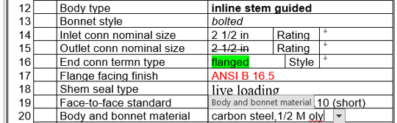

1.9 FORM TERMINOLOGY BASIS AND CONTENT

The Device Specification Part attempts to be inclusive of all reviewed device manufacturers literature and therefore frequently needs to generalize field prompts in each subsection. The pick list data is generally inclusive of all reviewed literature as well as common preferred values that can assist in promoting consistent terminology; where applicable.

1.9.1 Basis of Component Type Terminology
- Generalized device degrees of precision
- Differing prevailing terminology practices for generalized device classifications such as meter, monitor, transducer, sensor, probe, gauge, module, alarm, etc.
- Synonyms such as “by-pass level indicator” versus “magnetic level gauge”
- Prefixed with “sanitary” to allow searching based upon this usage
- Common application based such as “counting scale” or “prescription scale”
- Function identification like “level transmitter” versus construction style such as “differential pressure transmitter”
- Multifunctional inclusiveness such as “diff press ind w/switch” or “w/seals”
- Require abbreviated terms due to limited field length, such as “xmtr” vs “transmitter”
- Legacy terminology from before specific device standards were published

1.9.2 Field Prompt Terminology Clarified “By Example” Pick List
The nearly universal use of drop-down pick list can clarify the field prompts context, especially when abbreviations are used, or the forms are used by international users or manufacturers.
- Reviewing the precision, breath, and syntax of listed values can assist users, especially when new item values are being considered as appropriate.
- Recognizing familiar values can build confidence in the quality of the data being entered.
- Consistent use of “NA” for not applicable properties, minimizes assumptions about possible incomplete data entry and allows the Instrument Index Data calculated completion to more correctly calculate % completed data.

1.9.3 Updated Pick List for Manufacturers 2017-2020 Data
The pick list data for devices has been updated with manufacturers data sourced from Internet searches and typically included:
- Commonly more global or non-US manufacturers than US manufacturers
- 20-90 downloaded searchable PDF files per form
- Frequently technical data content approaching that recommended by IEC 61987
- Tables specifically identifying the manufacturer’s required properties and codes to build their intelligent model numbers
- Installation instructions which is used to understand recommended accessories
- Device software configuration instructions used to identify standard digital signal options and their allowable calibration units
- Local operator interface (HMI) optional features and programmability
- Agency certification options and details
- Remote interface and diagnostic software options and configuration

1.10 TYPICAL DOCUMENTATION REQUIREMENTS

29 CFR PART 1910--OCCUPATIONAL SAFETY AND HEALTH STANDARDS,
Subpart H--Hazardous Materials, Sec. 1910.119 Process safety management of highly hazardous chemicals

- Information pertaining to the hazards of the highly hazardous chemicals in the process.

- Toxicity information (Operating Parameters GHS health hazard)
- Physical data (Device Specification body section)

(2) Information pertaining to the technology of the process.
- Maximum intended inventory (Operating Parameters Level Process Design Conditions)
- Safe upper and lower limits for such items as temperatures, pressures, flows or compositions (Operating Parameters Process Design Conditions)

(3) Information pertaining to the equipment (includes associated instruments) in the process
- Materials of construction (Device Specification body section)
- Piping and instrument diagrams (P&ID's) (Operating Parameters P&ID/Reference drawing)
- Design codes and standards employed (Device Specification Compliance standard)
- Material and energy balances (Operating Parameters Material or Material Flow Conditions)

- Although the above documentation is specifically identified as required for highly hazardous chemicals in OSHA 1910.119, it frequently is also required to meet other codes and consensus standards as described below.

1.11 SUITABLE FOR INTENDED USE CONCEPT

The basic concept of determining if an item is suitable for its intended use, is the basis used to judge if good engineering practices are being followed. OSHA defines codes, and consensus standards as the minimum criteria for determining the suitability for use. The Device specification forms are effective consensus tools for documenting the device properties, for comparison with the requirements.

1.11.1 Responsible Organization identification is Clearly Documented
The Responsible Organization is the device owner’s representative responsible for documenting compliance with all legal requirements and “Good Engineering Practices”. This responsibility often is shared, based upon many different criteria, but generally can be established for the content of any specific document. That Responsible Organization’s logo, company name and company address should be documented in this section.

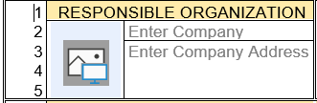

1.11.2 Subtitle Identification of Main (Device) Component Type
Form titles frequently need to use generalized subject terminology when multiple types of similar instruments are within the scope of that form. Therefore, Form Titles (Subject) are enhanced to include a Subtitle identifying the main Component Type (the highest-level classification terminology of a device), such as “LIQUID CHROMATOGRAPH”

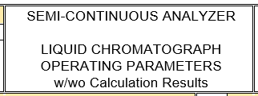

1.11.3 Specification Identifications Required Document Number
The Document number is required key information used for document retrieval in:

- The Form Loader Dashboard
- The integrated Instrument Index Data spreadsheet and browse interface
- Microsoft SharePoint and most other Document Management Systems
- Most software applications that manage electronic specification forms

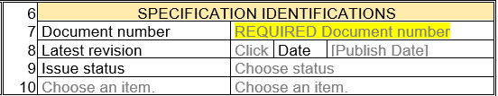

1.11.4 Operating Parameters Form Sections
The Suitable for use concepts for the Operating Parameters sections are described in the Operating Parameters Tutorial paragraphs 1.7.5 through 1.7.11.

1.11.5 Device Specification Form Sections
The Suitable for use concepts for the Device Specification form sections, corollate with the requirements established in the above Operating Parameters forms sections; plus, most properties identified in the below paragraph 3.

2 DEvice Specification Form STyles
Device specification forms utilize either of two Operating Parameters styles, depending upon the quantity of information that must be documented.

2.1 COMPLEX DEVICE SPECIFICATION

Complex Device Specification forms require extensive Operating Parameters data for review. Therefore, their forms duplicate the appropriate Operating Parameters form as their part 1 and add the Device Specification part and General or Special Requirements part, into a combined multipage integrated form.

- Note: See Operating Parameters Tutorial paragraph 2.6 for more detailed explanation.

2.2 SIMPLE DEVICE SPECIFICATION

Simple Device Specification forms require extremely limited Operating Parameters data for review. Therefore, their forms consolidate the properties of the Operating Parameters sections into a single consolidated section and add the Device Specification part, and General or Special Requirements part into a combined integrated short form.

- Note: See Operating Parameters Tutorial paragraph 2.5 for more detailed explanation.

- Note: Short forms represent about 40% of device specification forms.

2.3 ENTERING OPERATING PARAMETERS DATA ON DEVICE SPECIFICATION FORMS

Extensive documentation is available that identifies the major methods of entering Operating Parameters data which is referenced below and therefore will not be repeated.

2.3.1 Operating Parameters Tutorial Document

- 2.5.1 Directly Entering Process Data into Simple Device Specification Forms
- 2.5.3 Copy Data from Operating Parameter Form to Simple Device Specification Form
- 2.6.1 Directly Entering Process Data into Complex Device Specification Forms
- 2.6.2 Copy Data from Operating Parameters Form to Complex Device Specification Form

2.3.2 Quick Start Tour Document

- 1 Overview and Common Work Processes
- 3.1.1-3.1.4 Complex Device Specification Forms
- 3.2 Simple Device Specification Forms

2.3.3 General or Special Requirements
- 5 General or Special requirements

3 DEVICE SPECIFICATION PROPERTIES

3.1 DEVICE PROPERTIES REQUIRED FOR UNAMBIGUOUS ORDERING

The device properties pages are intended to document the manufacturer’s device properties that are required to unambiguously order the standard product offering of the manufacturer. Most manufacturers use extensive coding of their properties required for building a model number and placing a factory order. It is the intent of the specification forms to provide natural language descriptions of each of those properties; such that the product can be inspected, verified, or replaced without dependence on the vendor specific coding.

Many of the form’s properties may contain requirements or expectations of the specification originator, at the initial inquiry stage of the document’s bidding life cycle. The device property data should be owned by the supplier at the time that the purchase agreement is final. Therefore, the supplier must accept, or propose alternatives and change the specification’s data to reflect such deviations.
- Note: The use of Word’s enhanced data formatting can be excessively helpful in tracking such changes and reaching a consensus.
- Note: The content of the General or Special Requirements part supports Word’s ability to insert and mange comments, which is not available in the other form parts.
Ultimately, the specification originator must review and reach agreement on all device properties, before the “conformance” revision of the specification is issued for factory ordering. This may require several recycles of the specification document where the identification of changes will be a significant tool to maintain efficiency.

3.1.1 Subsection Order of Device Specification Forms
The subsections of instrument devices, and their associated secondary devices, have been data modeled to facilitate consistency of presentation between devices and between specification forms. The specification form has selected the appropriate generic property groupings, and arranged the respective specific subsections in the following recommended order:

- Pressure-containing shell properties
- Pressure-containing shell extension component properties
- Internal subcomponent properties
- Signal input/output extension component properties
- Integral input/output component properties
- Auxiliary devices properties
- Performance characteristic properties
- Accessories properties
- Special requirements
- Physical data properties
- Calibrations and tests properties
- Component identifications

3.1.2 Subsection Content Order of Device Specification Form
The properties of each subsection have been ordered to facilitate consistency of presentation between the properties of devices and between specification forms. Each physical property subsection should start with a “type” field, intended to clarify the context of the properties of that subsection. Therefore, field prompt labels for the same concept can be seen in multiple subsections.

3.1.3 Device Properties Copied to Instrument Index Data Spreadsheet
The quantity of the Device Specification part properties is too numerous for all to be copied to the Instrument Index Data spreadsheet. However, several properties are copied with special interest for comparison between tagged items and comparison to Operating Parameters requirements.

- Component type
- Primary construction material
- PC Max press at design temp
- PC Max design temp
- PC Min working temp
- PC Max working temp
- PC Min ambient working temp
- PC Max ambient working temp
- Signal power source
- Digital communication std
- Compliance standard
- Component Manufacturer
- Component Model number
- Estimated weight
- Calibration and Test fields

3.1.4 Primary construction material
The Primary construction material is the major pressure-containing shell component’s material, which is in contact with the process conditions. The field prompt label for this property will vary between device type, such as:
- Body / Fitting material
- Body/Casing material
- Body/Housing material
- Connection material
- Fitting material

There are at least 7 nations that have developed their own material identification schemes and massive questionable attempts to cross reference those schemes with multiple published material specification organizations. With some devices being offered in over 100 available materials, the consistency of material identification in manufacturers literature is extremely limited.
Since this property is copied to the Instrument Index Data table, limiting the variations can allow more meaningful sorting, Therefore, many listings use compounded nomenclature which identifies alternate representations of common equivalent materials. This can be educational in addition to somewhat effective for specifiers that are not material experts.

- 304 SST/CF8/1.4301
- 304L SST/CF3/1.4306
- 316 SST/CF8M/1.4401
- alloy B/Hastelloy® B
- alloy C/Hastelloy® C
- F51 SST/duplex /22% Cr
- Hastelloy® C-276/2.4819
- Monel® 400/2.4360
- Etc,

3.1.5 End Connection Nominal Size, Rating, Type and Style
The end connections of a device generally need to mate up to or be consistent with the associated process line properties, as documented in the Operating Parameters Service Identification section. Device nominal size less than full line size are common, but nominal pressure ratings and connection styles are generally identical to those of the line.
Since these forms are intended for international use, their pick list have been configured to support international piping standards as applicable to end connection properties, including:

- Metric
- EU
- UK
- German (DIN)
- Japanese
- South Korean
- US

3.1.6 Input Sensor Type
Transmitters with remote sensors, frequently utilize industry standard measurement sensors that have known characteristic curves. Standard sensors when used should be identified. Smart or Fieldbus devices frequently can be configured to derive the output scaling based upon the identified standard sensor.

3.1.7 Output Signal Type
Most transmitter and switch devices; have various output signal types offered by their manufacturers. The standard signal type identified in this field should establish the expected output signal units that are identified in the Calibration and Test output range fields.
When multiple output signals types are identified in this field, each of those signals should be identified on a line of the Calibration and Test table.

3.1.8 Integral Indicator Style
Devices can be specified with integral or local indicators, which can vary in functionality from simple analog signal meters, to smart meters that display digital data including engineering units. Smart or Fieldbus instruments frequently support more multi-variable output signals, than can be simultaneously displayed on the local indicator. Therefore, the Calibration and Test table should identify the range data for all measured or calculated variables that can be displayed.

3.1.9 Characteristic Curve
This field identifies the relationship of the output variable of a device, as a function of its input measured variable. This property may be a fixed design property for a specific device, or configurable from a selection of options provided by the manufacturer. Smart or Fieldbus transmitters sometimes can optionally be provided, with custom configuration curves which provide nonstandard relationships between the input and output signals.

3.1.10 Failsafe Style
Some binary output signal instruments include an integral relay function to reverse the shelf-state output signal action, based upon power or sensor failures. Such options, if present, must be included in the analysis of selecting the proper output signal action.

3.1.11 Type of Protection
There are over 20 types of protection recognized by the codes, of specific measures applied to electrical apparatus to avoid ignition of a surrounding explosive atmosphere by such apparatus. Their apparatus cost can vary significantly as well as sometimes requiring costly energy barriers to be provided at the source of their signal power. Therefore, the required type of protection should be unambiguously identified for each electrical component.

- Note: The Special Requirements property of “Certification type” generally list several testing agency different markings codes, which embed abbreviations for the types of protection. The data in the Type of protection field is intended to be a natural language identification independent of the different testing agency terminology.

3.2 COMMUNICATION INPUTS AND OUTPUTS LISTING

Many instruments now include functionality to accept external instrument signals to be used to compensate their primary measurement or to act as local data collection centers for concentrations of local instruments. Multiple digital output signals are also common to facilitate communications with remote control systems for software configuration, workstations, or inventory management systems. Wireless communication capability is also becoming widely available. This section’s information should be adequate to define the coded model number for such instruments.

3.3 MANUFACTURER’S DEVICE PERFORMANCE CHARACTERISTICS

The availability of the manufacturer’s device Performance Characteristics, that correlate to Operating Parameters requirements, are critical to the review of suitable for use. Many of these critical properties are copied to the Instrument Index Data spreadsheet custom view “Compare Design Conditions”, to allow side-by-side data comparison.

3.3.1 Max pressure at design temp
Because material strength decreases with increasing temperature, it is critical that device pressure ratings always are referenced to a material temperature rating. The reference design temperature should equal or exceed the Maximum Process Design Condition temperature.

The maximum pressure at design temperature can be interpolated from manufacturers tables or graphs, or calculated using proper formula coefficients.

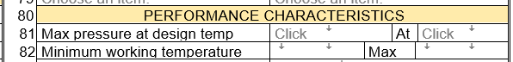

3.3.2 Minimum Working Temperature/Max
Many limiting factors such as seal material selection or heat transfer from the process connected portions of a device, to its electronic circuits, frequently limit the ability of a device to maintain its operating condition ratings. The manufacturers should identify the minimum and maximum working temperature limits consistent with the documented accuracy rating,

3.3.3 Measured Variable Accuracy or Accuracy rating
The accuracy of a device defines a limit that errors will not exceed when the device is used under specified operating conditions. Accuracy can be expressed as an absolute value with required corresponding units, or as an Accuracy rating relative value, with a required corresponding reference base.

These properties are generally dependent upon the selection of manufacturers’ sensing element option.

3.3.4 Measured Variable LRL/URL
The input measured variable or measured signal lower range-limit (LRL) and upper range-limit (URL), are the lowest and highest value that a device can be adjusted to measure. This property is dependent upon the selection of the manufacturers’ sensing element, which is generally itself coded into the model number.

3.3.5 Min (Measured Variable) Span/Max
These fields are the minimum and maximum algebraic difference (span) between the measured variable or measured signal, upper and lower range-values, that the device can be adjusted to measure. (These values may be identified in manufacturer’s literature as Span Limits). These properties are dependent upon the selection of manufacturers’ sensing element, which itself is generally coded into the model number.

3.3.6 Contact Ratings
While many device’s construction only has a single standardized contact rating, others offer extensive alternate rated constructions or wired external relays that provide much higher ratings. The specifier should enter the required maximum voltage and contact rating, for either AC or DC service. The manufacturer then can select the appropriate option and update the values in these fields.

If the specifier has not provided guidance on the desired ratings, the manufacturer should identify the standard AC and DC ratings, with the expectation that the specifier will confirm that suitability.

3.4 ACCESSORIES REQUIREMENT LISTING

The properties in the Accessories section are simplistic references to manufacturers’ offerings or field prompts to initiate consideration of such common offerings. Such minimized descriptions are generally acceptable because the manufacturer already is familiar with the proposed device and the Component Design Criteria properties. These accessories should be listed in the Component Identifications section, where the manufacturer and model number data can be investigated to review detail construction properties, if necessary.

3.5 SPECIAL REQUIREMENTS LISTING
The properties of the Special Requirement section are generally simplistic references to offerings or field prompts to initiate consideration of such common requirements as:
- Custom tag
- Reference specification
- Special preparation
- Compliance standard
- Certification type
- Special inspection
- Software configuration
- Software program
- Alarm level
- Legal for trade
- Calibration report
- Testing
- Packaging
- etc.

Such special requirements frequently have significant cost and delivery impact and may need quantification of expectations to be documented in the General or Special Requirement section. Manufacturers frequently code such requirements in their model number to alert their costing specialist or factory production order.

3.6 MODELING PHYSICAL DATA CONSISTENT DOCUMENTATION

The properties of the Modeling Physical Data section are limited to consistently capture the dimension of the envelope of space to reserve in the 3-D model, or the estimated weight that needs to be incorporated into various support design calculations. The early availability of such data, before waiting to receive precise data, can be a significant benefit for design work of other disciplines.

- Note: The Estimated weight numeric value is copied to the Instrument Index Data spreadsheet where it can be easily exported or summed after appropriate filtering.

3.7 CALIBRATION AND TEST RANGES FOR PHYSICAL AND VIRTUAL SIGNALS AND FIXED SETPOINTS

3.7.1 Calibration and Test Table Fields
The Calibration and Test table documents the ranges for all measured variables or signals as well as any required test. This table can be as minimal as that required for a primary element or exceed the available form space for multivariable or signal collector devices. The primary variable’s data will normally be on the first line and is copied to the Instrument Index Data spreadsheet for the main device Tag no/Functional ID.

Many single and multivariable instruments are capable of simultaneously outputting multiple output signals of analog, digital and binary types. Binary outputs may be initiated by a single event or frequently are a common output for many events such as waring messages or alarms. Where such dedicated options have been identified by instrument manufacturers, the appropriate Calibration and Test Section’s Measurement output descriptions have provided a pick list of known alternatives.

Example Test and Calibration Table for Primary Element

Example Test and Calibration Table for Multivariable Device with Digital Communication
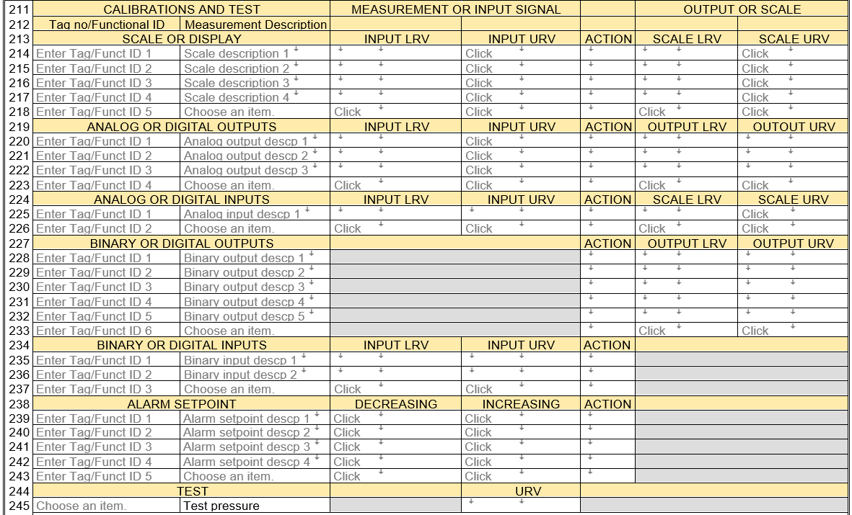

3.7.2 Measurement /Test or Measurement Description
The Measurement/Test or Measurement Description field (Prim_CAL_Input_Output Desc) will use a predefined label for devices that cannot provide options. However, smart, or digital devices generally offer options, so the manufacturers options are listed in the drop-down pick list. This value will be copied to the Instrument Index Data spreadsheet to clearly define the context of the calibration range fields in that presentation.

3.7.3 Measurement or Input Signal Input LRV/URV
For direct measurement devices these fields are the input measured variable or measured signal lower range-value (LRV), and upper range-value (URV), which are the lowest and highest value that a device is adjusted to measure.

For integral sensor transmitters, the measured variable may be different from the scaled process variable. An example is the measurement of differential pressure to infer a process flow rate; that is based on a calculated relationship between the measured variable and the scaled process variable.

For single variable transmitters, such as those that have remote sensing elements, assume that a calibration signal simulator is available for calibration activities of the transmitter. Therefore, enter the inferred process variable, rather than the actual input measured signal values generated by the simulator, as the lower range-value (LRV) and upper range-value (URV).

- These fields frequently are requested in the manufacturer’s literature for measuring devices, as “Calibration Range”, or some other ambiguous related terminology.

3.7.4 Setpoint LRV/URV
Physical switch setpoint activation, acts on a single input measured variable or measured signal, but generally have a fixed or adjustable dead band. Therefore, setpoints for decreasing measurement switches (low/low-low), should be identified by their decreasing lower range-value (LRV) or DECR SP. Setpoints for increasing measurement switches (high/high-high), should be identified by their Increasing upper range-value (URV) or INCR SP. Entering “NA” in the units field of the unused range-value will identify that the numeric value should not be required.

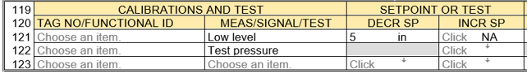

Switches which utilize a significant dead band, should identify both the decreasing lower range-value (LRV) or DECR SP and Increasing upper range-value (URV) or INCR SP.

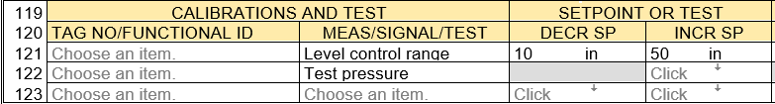

3.7.5 Final Control Device Input Range
For final control devices, the input signal lower range-value, and upper range-value, are the lowest and highest signal values that a device is adjusted to measure.

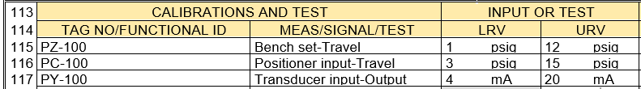

For non-smart and non-Fieldbus devices, these field values will generally be standardized instrument signal range values, such as 0-20, 4-20, or 0-10. They should generally be in units of mA, or V.

For smart or Fieldbus devices, these input signals will be digital, and generally will be identified in percent of the signal span.

3.7.6 (Control) Action
This field identifies the nature of the change of the output signal or physical position, effected by the input signal, that a device is adjusted to measure or initiate switch output configuration.

- Analog Signal Actions

For devices with analog output signals, the action should be identified as direct acting (direct) or reverse acting (reverse).

Although historically a major purpose of this action property was to allow implementation of a fail-safe output signal failure mode, it was not available on a wide basis. Therefore, it is not generally anticipated by instrument personnel, to be set to a value other than direct, except for some level measurements where the sensor is measuring the distance from the sensor to the level interface. In these applications, such as radar level transmitters, the output signal has its lowest value when the level is at its highest value. Therefore, those device’s action should be configured to be reverse, so that an increasing signal corresponds to an increasing level.

- Smart and Fieldbus type devices generally provide out of range limit alarms, and an independent diagnostic failure signal; that is frequently monitored and interlocked to minimizing operational failures. Therefore, the transmitter action property as a fail-safe design option, is generally not utilized.

- Binary Signal Actions

For devices with binary output signals (switches or relays), the action should document the switch “shelf-state” configuration, which is used for design, when wiring the device’s output signal. The switch action infers the transition from the normally open (NO) or normally closed (NC) pole state, to the opposite pole state, when the switch is activated.

- We normally design for “Fail-safe” instrument signal circuits, which corresponds to a open circuit representing the abnormal or failed state, and a closed circuit representing the normal or safe state. Therefore, the signal action must be specified which is consistent with the failure analysis for the device’s signal circuit. This analysis must recognize the potential difference between the shelf-state identification of action, and the normal operating switch action at increasing variable conditions (high setpoint), and that being actuated at a decreasing variable conditions (low set point).

3.7.7 Output LRV/URV
For a measuring device, these fields are the output signal lower range-value, and upper range-value, which are the lowest and highest value of the output signal that a device is adjusted to measure or switch signal value.

For transmitters that are smart or Fieldbus devices, these values will generally be identical to the input measured variable or measured signal lower range-value and upper range-value. They should be identified in the manufacturer’s “engineering units”, which is the device’s closest match to the projects defined unit symbol, for the measured variable. See manufacturer’s configuration documentation to identify available unit values.

For non-smart and non-Fieldbus devices, these field values will generally be the output signal lower range-value and upper range-value, as typically read on calibration equipment. They should generally be in units of Hz, mA, mV, Ohm, V or temperature units for scaled calibration equipment.

For modulating final controlling element devices, these field values will generally represent the position of a closure member, or the speed of a drive component. Their output lower range-value, and upper range-value, are the lowest and highest value of the position or speed, that a device is adjusted to manipulate.

The output range-value units should be those that are visible on the indicator of the control device, or should be identified in percent of span, when no visible indication is available.

3.7.8 Setpoint Output LRV/URV
Physical switch or relays the output signal lower range-value (LRV) and upper range-value (URV), should be identified as the desired value that is read on calibration equipment, which are the lowest and highest values of the signal circuit power source. We have assumed for the pick list values, that the signal power source is 24 V(dc) or 120 V(ac). Therefore, we should enter “0” volts and “24” or “120” volts as the expected output signal range-values

- Alarm Setpoint Output

Multifunctional digital devices use software to simulate switch functionality and generally utilize communication output components that may be common to multiple internal logic signals. Therefore, their output signal fields are grayed out.

3.7.9 Measured Variable Scale Input LRV/URV
These fields are the input measured variable or measured signal lower range-value, and upper range-value, which are the lowest and highest value of the measured variable that a device’s local or integral scale is adjusted to measure.

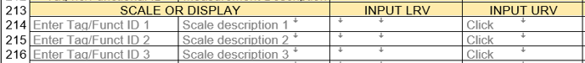

If the device is specified to be blind (no scale is required), these numeric values should be blank, and the unit’s field should contain “NA”.

3.7.10 Measured Variable Scale Output LRV/URV
These fields are the local or integral scale range lower range-value, and upper range-value, which are the lowest and highest value of the scale that a device is adjusted to display.

For transmitters that are smart, Fieldbus devices, or that use smart local indicators, these values will generally be identical to the input measured variable lower range-value and upper range-value. They should therefore be identified in “engineering units”, which is the device’s closest match to the projects defined unit symbol, for the measured variable. See manufacturer’s documentation to identify available unit values.

These values sometimes will be less than the scale input LRV/URV, if the display cannot handle as many digits as the input values. In this case, a scale factor must be utilized.

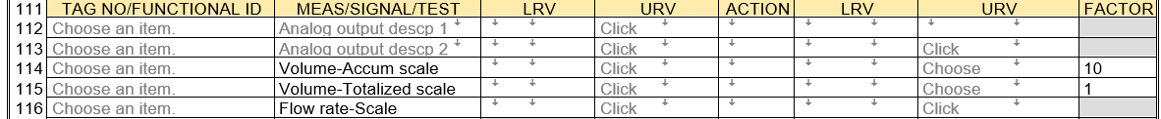

For non-smart and non-Fieldbus indicators, these values will generally be the percent of output signal span, as read on the indicator. These scales will generally use linear scale divisions, but may use square root divisions, for flow transmitters based on such characteristic curves.

3.7.11 Calculated Variable Documentation
Many multivariable instruments are now capable of calculating variable properties that are related to the instrument’s measured variable or compensating the measured variable based upon a second variable or a stored correlation table. Where such options have been identified by instrument manufacturers, the appropriate Calibration and Test Section’s Measurement descriptions provide a pick list of known alternatives. As with all pick list, new Measurement descriptions can be added to unambiguously identify other required variable signals.
Examples of such variable measurement descriptions include:
- Humidity, Dewpoint, Enthalpy, Frostpoint, mixing ratio, Wet bulb temperature, Haze, Referred humidity, Relative humidity, Absolute humidity
- Specific gravity, Density, Concentration, % Solids, Net solids, API Degree, Base density, Brix, Referred density, Alcohol proof
- Viscosity, Referred viscosity, Kinematic viscosity, Intrinsic viscosity, Apparent viscosity, Base viscosity
- Specific ions, Surfactant, Residual chlorine, Water hardness
- Turbidity, Opacity, Optical density, Absorption, Particulate, Color

3.7.12 Software Configuration Documentation
Comprehensive software configuration documentation is impractical within these forms, primarily due to its manufacturer specific expectations. However, most of such required information is related to the input and output signal properties which can be extensively documented in this table. If the software configuration is performed by the instrument manufacturer or purchaser, the information on these forms may be adequate documentation when combined with their standard practices that are documented elsewhere.

The signal specific data documented on these forms can be supplemented with standard software configuration practice requirements that can be documented in the optional General or Special Requirements page and may be adequate for the manufacturer’s configuration effort.

3.8 MANUFACTURER AND MODEL NUMBER FOR ALL DEVICES, AUXILIARIES, OR ACCESSORIES

3.8.1 The Component Type Property
The component type property is the highest-level classification terminology of the main device and was entered from a popup window when the Device Specification form was initialized. The main device name can be changed in this Component Identifications section, if desired. Such a change will automatically update the title block subtitle value.

Many instruments are assemblies of a main device and one or several auxiliary devices or accessories, such as a control value with auxiliary positioner, solenoid valve, and limit switches and an accessory air set. Those items that need a manufacturer and model number to document their properties, should be listed in this section.

3.8.2 Manufacturer and Model Number
Secondary components generally are manufactured by others than the main device and their model numbers are meaningful only in the context of those manufacturers.

Instrument products are generally manufactured based upon the manufacturers’ coded model numbers, created by vendors or factory representatives. Specification forms such as these, are seldom seen by the production organizations. Therefore, if the coded model number does not correlate with the specification’s natural language properties, the delivered product will not meet the expectations of the specifier. Returning the product for corrections will likely cause significant schedule impacts.

- Note: Time spent verifying the coded model number for long delivery devices, can prevent significant negative impacts.

4 General or Special Requirements
All forms include the optional General or Special Requirements Part which documents any significant aspects that are not captured within the other sections and can be used by the specifier or form recipient to clarify such issues that need to be agreed upon for completing the work activity. This form part will not print if no data has been entered. This section allows:

- Direct data entry or copy and paste of extensive formatted content incorporating all of Word’s formatting functionality, including embedded pictures
- Internet URL links to supporting material or Websites
https://www.emerson.com/documents/automation/Product-Data-Sheet-Rosemount-114C-Thermowells-en-80170.pdf
- Copied and pasted files for viewing or extracting files to other locations

- Insert any of Words illustration objects

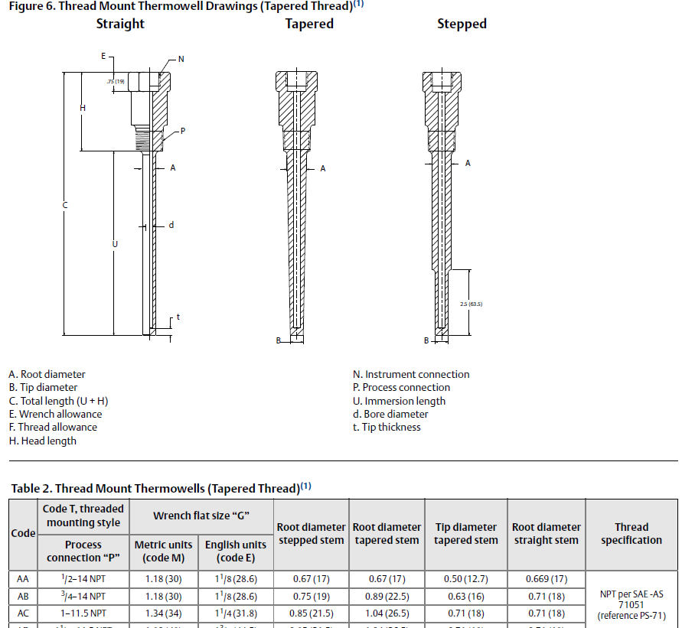

- Copy properties which will include their picklist and past multiple times to emulate multi choice pick list selections
Compliance standard | 3A sanitary standard
Compliance standard | ASME BPE
Compliance standard | NACE® MR 0175-2002
Compliance standard | USP CLVI
Compliance standard | 21CFR 177.2600
Compliance standard | FDA

- Functionality to automatically build the required Table of Contents from entered data using Heading 1, Heading 2 and Heading 3, can be activated by clicking the Update Table Icon.
- Insert and manage resolution of Words comment functionality.

- Let your imagination open to the endless possibilities of Word’s inherent functionality!

5 Data Exporting for External Applications

Data exports are outside the scope of these forms. Data exchange to such programs requires significant knowledge of such applications. Therefore, Word’s XML Mapping Pane which can be used to create Content Control mappings to referenced existing standard XML schemas, is not being used at this time.

5.1 DATA EXTRACTION AND EXPORT
All form’s property data can easily be exported using a free third-party add-in “Extract Data from Word Document File”, to many different common file formats.

https://gregmaxey.com/word_tip_pages/extract_data_from_forms.html

6 FACILITATE ENHANCED WORK PROCESSES USING COPY CAPABILITY

The ability to mass copy data between forms will allow efficient work processes and consistent data.

6.1 COPY OPERATING PARAMETERS DATA FOR CONSISTENCY

6.1.1 Operating Parameter Data for Lines Containing One or More Instruments
Copy from Operating Parameters data for lines containing one or more instruments, on form F1101, created at the earliest phase of a project.

6.1.2 Operating Parameters Data for Vessels Containing One or More Instruments
Copy from Operating Parameters data for vessels containing one or more instruments, on form L1001, P1002 or P1004, created at the earliest phase of a project.

6.1.3 Copy Operating Parameters Data from a Form Developed Earlier
Copy data from any Operating Parameters form to the appropriate Device Specification form.

6.2 COPY TYPICAL DEVICE FORM DATA FOR EFFICIENCY

6.2.1 Create Library of Typical Device Specification Forms of High Usage Devices
Create a library of Device Specification typical forms of high usage devices that can later be copied into multiple tag specific documents. Specifiers as well as manufacturers or vendors that are anticipating repetitive demands for completing these forms of specific device types, may choose to create Typical Forms as a source for efficiently copying their data to future Device Specification documents

- Note: See step-by-step actions described in the Form Help document, paragraph 6.

6.2.2 Create Library of Typical Device Specification of Auxiliary Devices
Create a library of Device Specification typical of high usage auxiliary devices such as solenoid valves or limit switches that can later be copied into multiple tag specific documents.

6.3 CHANGE THE DEVICE SPECIFICATION FORM FOR A SPECIFIC TAG
Change the Device Specification form for a tag on an existing form, such as a Linear Motion Type Control Valve to a Rotary Motion Type Control Valve, by copying the data into the new form and then perform editing in the new form.

6.4 COPY DATA BETWEEN SIMILAR TAGS OR APPLICATIONS
Copy data between similar tags or applications including those from other active or historical projects.

6.5 COPY DATA FROM SELECTED MANUFACTURER’S COMPLETED FORM
Copy data from the selected manufacture’s returned form file into the project master file, to update the specification form’s data with the manufacturer provided data.

7 WORK SHARING OR COLLABORATION

Extensive opportunities for work sharing or collaboration exist, where initialized or partially completed forms will be sent to an internal or external partner who do not have the installed file structure or Form Loading Dashboard.

Documents produced by these templates include all the Word macros, therefore they are editable with the functionality described in these tutorials and Quick Start Tour documents.

- Note: See Form Help document paragraph 4 for specific file handling details.

8 Managing Externally Edited Documents

Procedures for managing document revisions or versions is too variable and complex for this tutorial. However, a procedure to supplement and/or increment a suffix to the external edited file name, will prevent a overwrite of the origin data before the returned content can be reviewed and accepted.

When such document files are returned from external parties and saved from any mail or compressed file to the “Import temp” folder, they should have their files renamed to include a revision suffix.

As an example, renaming document number “PD FV-0001.docm” to “PD FV-0001 R1.docm” will allow that file to be integrated into the Project Form Data folder without overwriting the original file.

8.1 REVIEW MANUFACTURER(S) SPECIFICATION EXCHANGE DOCUMENTS

- Copy the (Manufacturer edited) document to the “Import temp” folder
- Review the (Manufacturer edited) form using the Form Loader Dashboard and the Project Form Data listing of files, located in the “Import temp” folder.

8.2 Evaluate Alternate Proposals

Loading files into the “Import temp” folder also allows managing alternate proposals of a single manufacturer or multiple proposals of alternate manufacturers. The only requirement is that the file names are unique. After a manufacturer’s proposal has been accepted, the alternate files can be deleted from the “Import Temp” folder.

9 CUSTOMIZABLE TEMPLATES FOR OPTIMIZED WORK APPLICATIONS

These form templates have significant ability to be customized for optimized work applications, as discussed in the Form Help document paragraph 5.

10 HELP FUNCTIONALITIES

10.1 CONTEXT SENSITIVE HELP DEFINITIONS

Help Definitions are available for many data entry fields when the user enters those field locations, on the form. The application’s status bar at the bottom of window will display the message to “Press Alt+F2 to display help text”.

If the user presses the Alt+F2 keys, a message window will display the definition such as shown below:
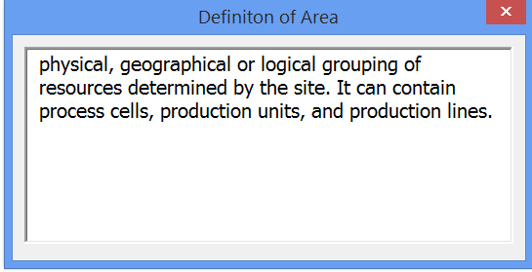

The displayed Help Definitions have generally been copied from various National and International Standards that are applicable to the Instrumentation profession.

10.2 FORM APPLICATION USER HELP

This Form Help Document has been integrated into the specification forms such that users can easily search for assistance in understanding the special features of the form application.

Start by clicking Word’s standard menu Help option, which opens the sub menu including the Link to Form Help Document:

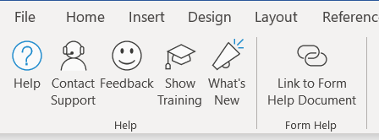

11 INTEGRATED INSTRUMENT INDEX DATA BROWSER

While specification forms are created as individual files, they generally are reviewed, approved, and packaged together for multiple different information exchanges. Our integrated Instrument Index Data browser is automatically populated when document files are saved, with over 80 fields of data. This tabular data presentation can be instrumental in review for inconsistencies between multiple forms, partial status of the form’s data entry or as an index to identify data related to a tag or functional identification.

- Notes: See Quick Start Tour document, paragraph 8.6 Integrated Instrument Index Data Browser for step-by- step usage.

Appendix A - Determining mEASUREMENT Input Range-Values

Measurement ranges must include Material or Material flow operating conditions and Process operating safety margins. Additional consideration should be made to include Process Design basis abnormal conditions, where they would not substantially reduce the measurement’s accuracy.

Typical measurement range Process Design Basis Abnormal Conditions
- High pressure including ambient influences; pressure oscillations and surges, improper operations, decomposition of unstable fluids, static head, and failure of control devices.
- Vessel pressure ranges include relief valve settings plus allowable overpressure
- Pressure ranges downstream of a regulator can be equal to upstream pressure if the regulator fails.
- Low pressure including the cooling of a gas or vapor in a system sufficient to create an internal vacuum.
- High temperature to consider at least fluid temperatures, ambient temperatures, solar radiation, heating or cooling medium temperatures.
- Temperature to include site climatological range
- Level range include where possible, total vessel volume, unless physically limited by overflow nozzles
- Level measurement may not be zero based where the measurement cannot measure below the reference datum point.
- Level measurement based on differential pressure, generally need zero elevation/suppression calculations to establish the range values
- Analyzers often have multiple ranges to cover their wide rangeability
- Flow rates can significantly exceed normal operations, when a regulating device (valve) fails or has significant excess capacity (valve travel). Include such ranges when practical.
- Differential pressure measurement across some equipment (filters, strainers) can be highly dependent on viscosity and plugging.
- Differential pressure producing flow elements are generally sized using calculated values dependent upon component characteristics and the calculation authority. The related transmitters must utilize range values identical to those documented in the calculation reports
- Pressure vacuum conditions can be created when liquid is removed from a vessel that does not have compensating pressure control mechanisms, or vapor condenses due to cooling.
- Weight measurements frequently tare out container weight, but the full measurement range should be evaluated for utilization
- Remote sensor transmitters generally need to obtain their input data from their associated element data sheet, in order to evaluate their range-values

The display and scale ranges are generally made identical to the measurement range, therefore:

- Avoid use of scaling factors (multipliers) that are not multiples of ten
- Utilize rounded off range values; to numbers that are multiples of ten (100, 1000, 10000)
- Local readout scales frequently are limed to 4 digits
- DSC displays are sometimes limited in the number of digits, to accommodate available screen presentations

Instrument accuracy is frequently related to measurement span
- Using measurement range-value less than the measurement range-limit, will provide improved accuracy for instruments with stated accuracy base reference of; % span
- future changes of the measurement range-values can generally be accomplished from remote locations for smart and Fieldbus instruments. Therefore there is minimal need for initial range-values to accommodate future range needs.

Multivariable Transmitter Secondary measured variables may have special ranges and units

- Secondary measured variables may need to be measured in absolute units, if they are used for internal calculations, such as mass flow or temperature compensation of flow or density.
- Secondary measured variables generally have default range-values defined by the manufacturer, which should be evaluated for acceptance if they include the required range
- The device internal temperature range-values are generally fixed by the manufacturer, and limited to the operating range limits of the device.

Appendix B Definition of Terms

action: the nature of the change of the output effected by the input.
NOTE: The output may be a signal or a value of a measured variable.

direct acting: An action in which the value of the output signal increases as the
value of the input (measured variable) increases.

reverse acting: An action in which the value of the output signal decreases as the
value of the input (measured variable) increases.

accuracy rating: In process instrumentation, a number or quantity that defines a limit that errors will not exceed when a device is used under specified operating conditions.

NOTE 1: When operating conditions are not specified, reference operating conditions shall be assumed.
NOTE 2: As a performance specification, accuracy (or reference accuracy) shall be assumed to mean accuracy rating of the device, when used at reference operating conditions.
NOTE 3: Accuracy rating includes the combined effects of conformity, hysteresis, dead band and repeatability errors. The units being used are to be stated explicitly. The absence of a sign indicates a + and a – sign.

Accuracy rating can be expressed in a number of forms. The following five examples are typical:
a) accuracy rating expressed in terms of the measured variable. Typical expression: The accuracy rating is ±1°C, or ±2°F.
b) accuracy rating expressed in percent of span. Typical expression: The accuracy rating is ±0.5% of span. (This percentage is calculated using scale units such as degrees F, psig, etc.)
c) accuracy rating expressed in percent of the upper-range value. Typical expression: The accuracy rating is ±0.5% of upper-range value. (This percentage is calculated using scale units such as kPa, degrees F, etc.)
d) accuracy rating expressed in percent of scale length. Typical expression: The accuracy rating is ±0.5% of scale length.
e) accuracy rating expressed in percent of actual output reading. Typical expression: The accuracy rating is ±1% of actual output reading.

characteristic curve: A graph (curve) or relationship which identifies the ideal values at steady-state, or an output variable of a device as a function of an input variable, the other input variables being maintained at specified constant values.

Configurable: A term applied to a device or system whose functional characteristics can be selected or rearranged through programming or other methods. The concept excludes rewiring as a means of altering the configuration.

dead band: In process instrumentation, the range through which an input signal may be varied,
upon reversal of direction, without initiating an observable change in output signal.

process variable: Any variable property of a process. The term process variable is used in this standard to apply to all variables other than instrument signals.

range: The region between the limits within which a quantity is measured, received, or transmitted, expressed by stating the lower and upper range-values.

range-limit, lower: The lowest value of the measured variable that a device can be adjusted to measure.

NOTE: The following compound terms are used with suitable modifications to the units:
measured variable lower range-limit, measured signal lower range-limit, etc. See Tables 1 and 2.

range-limit, upper: The highest value of the measured variable that a device can be adjusted to measure.

NOTE: The following compound terms are used with suitable modifications to the units:
measured variable upper range-limit, measured signal upper range-limit, etc. See Tables 1 and 2.

range-value, lower: The lowest value of the measured variable that a device is adjusted to measure.

NOTE: The following compound terms are used with suitable modifications to the units:
measured variable lower range-value, measured signal lower range-value, etc. See Tables 1 and 2.

range-value, upper: The highest value of the measured variable that a device is adjusted to measure.

NOTE: The following compound terms are used with suitable modifications to the units:
measured variable upper range-value, measured signal upper range-value, etc. See Tables 1 and 2.

scale factor: The factor by which the number of scale divisions indicated or recorded by an instrument should be multiplied to compute the value of the measured variable.

set point: An input variable which sets the desired value of the controlled variable.
NOTE 1: The input variable may be manually set, automatically set, or programmed.
NOTE 2: It is expressed in the same units as the controlled variable.

span: The algebraic difference between the upper and lower range-values.

NOTE 1: For example:
a) Range 0 to 150°F, Span 150 °F
b) Range –20 to +200°F, Span 220°F
c) Range 20 to 150°C, Span 130°C
NOTE 2: The following compound terms are used with suitable modifications to the units:
measured variable span, measured signal span, etc.
NOTE 3: For multi-range devices, this definition applies to the particular range that the device is set to measure.

transmitter: A device that senses a process variable through the medium of a sensor and has an output whose steady-state value varies only as a predetermined function of the process variable. The sensor may or may not be integral with the transmitter.

