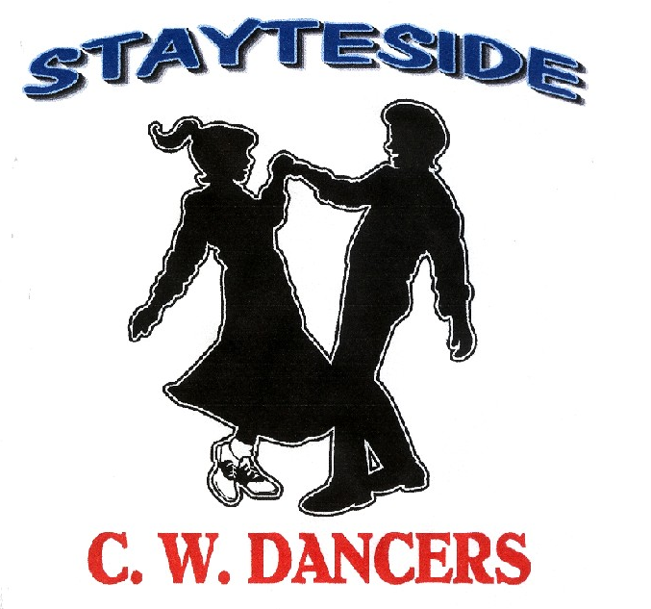

Once In A Lifetime

Description: Partner Dance. (64 Counts)
Start Position: Right Side by Side / Sweetheart Position.
Gent’s and Lady’s footwork the same throughout unless otherwise stated.
Choreographers: Carol* & George Stayte, (UK). *Qualified D & G Instructor. 02392 423925 carol.stayte@ntlworld.com
Music: Paper Rosie by Gene Watson CD: Best Of The Best (122 Bpm 16 Count Intro)
Alternative: Once In A Lifetime by Heartbeat. CD: Once In A Lifetime. (114 bpm. 16 Count Intro)
Tracks available from Itunes and Amazon.

1 DIAGONAL CROSS ROCK. BACK ROCK. STEP SLIDE STEP BRUSH.
1 – 2 Rock right over left, (Turning the body diagonally to the left) recover on left.
3 – 4 (Straighten up to LOD) Rocking back on right, recover on left.
5 – 8 Step fwd on right, slide left up to right, step fwd on right, brush left fwd.

2 DIAGONAL CROSS ROCK. BACK ROCK. STEP SLIDE STEP BRUSH.
1 – 2 Rock left over right. (Turning the body diagonally to the right) Recover on right,
3 – 4 (Straighten up to LOD) Rocking back on left, recover on right.
5 – 8 Step fwd on left, slide right up to left, step fwd on left, brush right fwd.

3 ROCK ½ TURN. STEP FORWARD. HOLD. PIVOT ½ TURN. STEP FORWARD. HOLD.
1 – 4 Rock fwd on right, recover on left, ½ turn right stepping fwd on right. Hold. Release left hands, right hand over Lady’s head.
5 – 8 Step fwd on left pivot ½ turn right, step fwd on left. Hold. Right hands over Gent’s head,
Right hands over Gent’s head, Rejoin into Sweetheart position.

4 GENT: STEP SLIDE STEP. HOLD (X2).
LADY: STEP SLIDE STEP. HOLD. 1/2 TURN. HOLD.
1 – 4 Both: Step fwd on right, slide left up to right, step fwd on right. Hold.
5 – 8 Gent: Step fwd on left, slide right up to left, step fwd on left. Hold. Release left hands, Right shoulder to Right shoulder.
Lady: ¼ turn right on left, ¼ turn right, stepping back on right, step back on left. Hold. RLOD

5 TURN 1/4. STEP TOGETHER, STEP SIDE, HOLD. CROSS ROCK ¼ TURN HOLD.
1 – 4 Gent: ¼ turn left to ILOD on right, step left next to right, step to side on right. Hold.
Lady: ¼ turn right on right step left next to right, step to side on right. Hold
Lady now behind Gent, rejoin hands to Reverse Indian Position to ILOD
5 – 8 Rock left over right, recover on left, ¼ turn left stepping fwd on left. RLOD Hammerlock, right hands behind Gent’s back.

6 PIVOT ½ TURN, STEP FORWARD HOLD. STEP LOCK STEP HOLD.
1 – 4 Step fwd on right, pivot ½ turn left, step fwd on right, Hold. LOD
Release right hands, raise left over Lady’s head. Rejoin into Sweetheart position.
5 – 8 Step fwd on left, slide right behind left, step fwd on left, Hold.

7 MAMBO FORWARD HOLD. BACK LOCK BACK. HOLD.
1 – 4 Rock fwd on right, recover on left, step back on right. Hold.
5 – 8 Step back on left, slide right across left, step back on left, Hold.

8 MAMBO BACK. HOLD. ¼ TURN, STEP TOGETHER, ¼ TURN. BRUSH FORWARD.
1 – 4 Rock back on right, recover on left, step fwd on right. Hold.
5 – 8 ¼ turn right on left, step together on right, ¼ turn left, stepping fwd on left, Brush Right fwd.
Count: 5 Indian position. Count: 8 Sweetheart position.

START AGAIN

