Junior Hair and Make-Up Checklist
Make-up
- Moisturiser or primer
- Foundation (Water-resistant/Sweat-resistant) – one shade darker than skin tone
- Blush – Neutral-warm pink/peach colour
- Eye shadows in three colours
  - Highlighter – very light – white or cream
  - Contrast – medium – peach, gold or beige
  - Contour – dark – chocolate brown
- Black waterproof liquid eyeliner
- Black waterproof mascara
- Red Lipstick – orange-toned red not a blue-toned red
- Lip liner pencil in the matching colour to lipstick
Make-up tools
- Foundation Sponges or Foundation Brush
- Blush Brush
- Eye Shadow Brush/s
- Brow Brush
- Lip Brush
Hair
- Hair brush
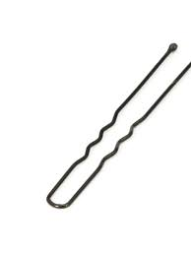
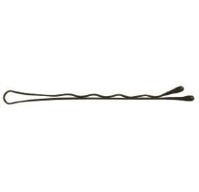
- Hair ties
- Strong hold hair spray
- Bobby pins
- Hair pins
- Hair net matching your hair colour (the larger type, not the small bun nets)

