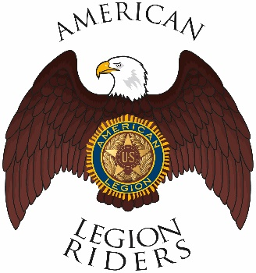

American Legion Riders Chapter 3, Hanford, CA
Minutes for October 12, 2021
Meeting called to order: The meeting was called to order @ 6:35pm. Prayer, Pledge of Allegiance and Preamble was said.
Officers Present: Vice-President Frank Pightling, Treasurer Geni Lefler, Secretary David Darrow, Judge Advocate Pat O'Brien, Sgt-At-Arms Jack Alford, Road Captain Robert Stover Excused: Chaplain Filly Reynolds

Members Present: Sheri O’Brien, Richard Garcia, Frank Silva, Kathleen McClary, Jon Bailey, Mike Calderon, Kathleen McClary, Dan Rushing, Richard Garcia, Scott Day
Guests Present: Gustie Compton,
Review of Minutes: Motion to accept minutes for September 14, 2021, was proposed by Pat O’Brien and seconded by Frank Silva and ratified by members.
Committee Reports: None
Treasurer's Report:
Chaplain Report: Edward James Grimly passed away, Harry Woods Area 5 Commander passed away
Unfinished/Old Business:
West Coast Rally was small.
745 Miles reported for rides since last meeting.
New Business:
Hanford Christmas parade will be day after Thanksgiving Time TBA. Attire black pants and white button-down shirt.
November 11th Ride for Veterans Day KSU at Armory on 10th by the tank.
9am KSU at hall for overnight trip to Three Rivers, lunch at Mountain House Café around 12:30
President’s meeting is 23rd of October post 26 in Bakersfield at 10am
November 13th Poker run in Bakersfield Mathews Harley Davidson KSU at 10am, 8:30 at Veterans Hall.
December hunt for Santa 9am 3rd Saturday
January 2022 fog run 9am 3rd Saturday
November 9th Salvation Army Kick Off dinner 5pm
Final Nominations for Chapter 3 President
Dan Rushing Accepted, James Landolt Accepted, Robert Stover Accepted, Frank Plightling declined. Members voted and James Landolt was elected as President.
Good of the Riders:
Agent orange exposure registration with the VA is very important.
Gulf War vets register for burn pits with the VA as well. Visit VA.GOV for more information
Remember to ride safe
Meeting adjourned 7:26

