Heel Thuds (helpful for AcidReflux/Heartburn)
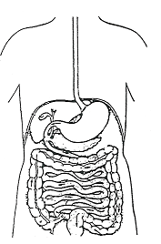
Normal – stomach valve about 1 ½ inches below diaphram
What causes heartburn:
- If the stomach gets jammed up against the diaphragm the sphincter valve can get stuck in the “hiatus” (the hole in the diaphragm that the esophagus goes through),
- and sometimes a bit of the stomach is squeezed up through the diaphragm into the thorax, forming a bubble called a hiatus hernia
In either situation, this allows gastric juices from the stomach to move up the esophagus.

Inside the stomach, the wall has a thick mucous lining to protect it from its own gastric juices. The wall of the esophagus does not have this thick mucous lining, so the gastric juices (which are very acidic) burn it, causing severe heartburn.
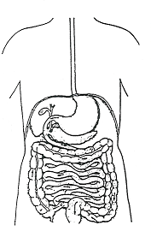
Stomach sphincter valve jammed against or stuck in “hiatus”.
A jammed sphincter valve or a hiatal hernia can be pulled back down below the diaphragm by following this procedure:
- First thing in the morning, drink about one quart of water. The purpose is to fill the empty stomach with water and make it very heavy.
- Then go up on your toes, and drop as hard as you can on your heels. These are called “heel thuds”. Do about 15 heel thuds each morning. Since the stomach is so heavy, this will help to start jerking it back down where it belongs.
- You may have to do heel thuds every morning for many days … anywhere from one to four weeks to get the hernia pulled back down. You will know when its down because you will not experience the acid reflux.
- The esophagus will take some time to heal from all of the burning, and you can help the healing by supplementing with Beta Carotene and chewing on Bifidus.
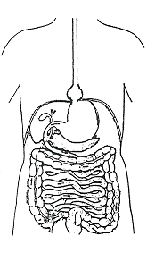
Bubble of stomach pushed up above the diaphragm … called a “hiatus hernia”.

If acid reflux is not addressed, the esophagus gets severely damaged by repeated burning. This causes a very high risk of esophagus cancer, so it is very important to GET SERIOUS about correcting the problem.

NOTE: Other tips that help with heartburn:
- swallow Shaklee Stomach Soothing Complex with meals
- chew on Shaklee chewable Bifidus tablets after meals
- drink ginger tea or peppermint tea
- chew on Shaklee chewable calcium/magnesium tablets
- take Shaklee Digestive Enzymes – EZ-Gest

