Zip-tie Ear Posting Supplies
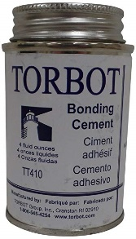
- Torbot Brand Medical Glue
Order a couple, because they are not
very big.
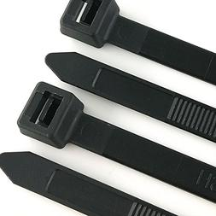

- 3/8” or ½” wide heavy-duty zip-ties, 12” - 26” long
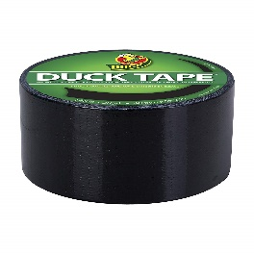
- Duct tape – regular sticky kind, NOT thin craft duct tape
Black or dark brown will be less noticeable

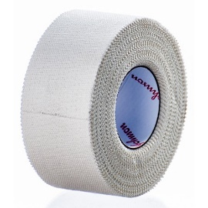
- Johnson & Johnson Brand Zonas Porous or cloth hockey stick tape
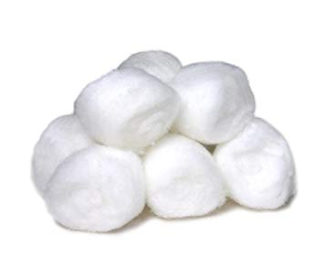
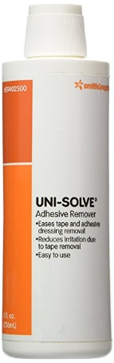
- Cotton Balls

- Uni-solve adhesive remover

Zip-tie posting method helps allow air to get to the healing side of the cropped ear, is more sanitary for the puppy, and can be left in a few days longer than with using foam backer-rod.
There are many instructional videos on YouTube on how to use this method, as well as photo instructions on my website.
The Torbot glue, Uni-solve Adhesive Remover, and Zonas/Hockey Tape can be bought online on ebay or amazon

