The Naturopathic Session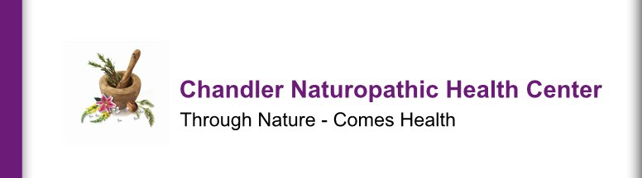
What to Expect

When you consult with Dr. Chandler for counsel, you will be greeted with a friendly smile and will find a person committed to a holistic approach to your health. You will find a quiet, comfortable and relaxing professional environment for your consultation and any follow-up sessions that you may want. You will experience techniques modalities that are consistent with Traditional Naturopathy and its philosophy. These techniques and modalities will enable your body to correct problems now and help prevent problems from occurring in the future. Information regarding your medical history, diet/nutrition and any stresses that you are experiencing, among other topics, will be gathered for the assessment.
The first “Initial” consultation usually lasts between one and one-half to two hours. This allows for through discussion of your total wellness concerns using a twelve topic “Wellness Wheel” and education on the methods used, topics, and/or scope of your concerns. During this first consultation, your self-report, your biorhythm chart, and a tongue and fingernail analysis will be used together to assess your wellness concerns.
Follow-up sessions are usually 30 minutes to one hour in duration depending upon individualized needs and wants. Also, based on individual wants and needs, a series of sessions (i.e. 3 reflexology sessions within a short period of time) could be suggested for any specific concerns the person may have.
Chandler Naturopathic Health Center is committed to making your experience with natural medicine a pleasant one. We will strive to be your choice as your “Local Natural Health Alternative.”

Through Nature – Comes Health

Dr. James M. Chandler D.D., RM., N.D

