Horses teeth, chewing and dental care

If you take a look in your horses’ mouth you’ll see a lot of teeth in there; on average horses have between 36 and 42 teeth. Baby teeth are pushed out from between 2yrs and 5yrs old. Permanent or adult teeth will keep growing for most of the horse’s life and they need regular dental care to ensure they can chew properly. All of your horse’s teeth grow about 3mm per year. The amount of wear depends on the type grazing and fodder horses have access to, as well as the health, habits, age and breed/genetics.
Horse’s front teeth are called incisors and these teeth cut the grass as they graze. Molars or cheek teeth sit directly behind the bars of the mouth (this is where a bit sits). Cheek teeth grind food before it is gathered at throat and swallowed.
A horse moves its jaws sideways to grind grass, hay or grains (outside-to-inside). A horse uses its tongue to hold a wad of food against its cheek teeth on one side only at a time (they cannot chew on both sides at once). Repeated chewing works the food into a spiralling, cigar-shaped wad and the food gets chopped finer and finer as it works its way down the cheek teeth.
Chewing mixes food with saliva, and is the first part of a horse’s digestive system.
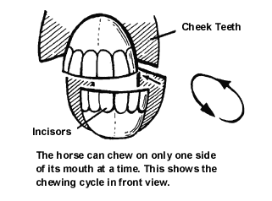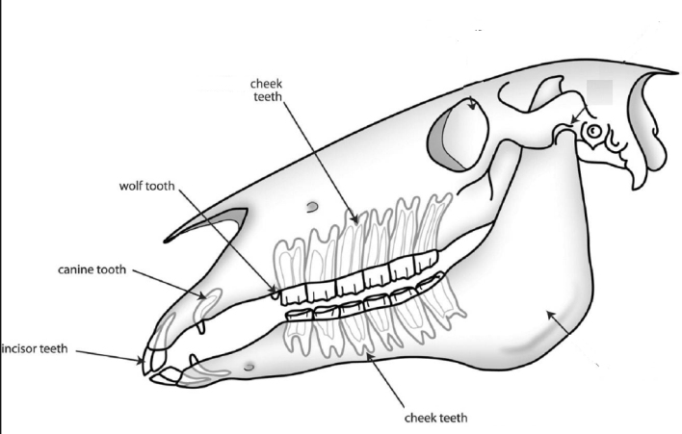

Common Dental Problems
Horses are prone to several tooth problems. These problems can result in poor health, weight loss, difficulty wearing a bit, and behaviour or performance problems when ridden. Uneven wear can cause sharp edges and hooks that require smoothing down to prevent damage to the inside of the cheeks or tongue and pain. Some horses have misaligned jaws that can be undershot or overshot, also called parrot mouth, which can cause wear and chewing problems.
Teeth can become infected and abscesses in the jaw can form if debris or plaque causes problems.. The yellowish or brownish colour of the teeth is normal. The teeth do not stay pearly-white because they become stained by the food eaten. However, the gums should appear healthy pink. Any change of gum colour can mean a health problem.

Dental Care
Horses need regular dental check-ups just like people do. The frequency that a dentist or veterinarian needs to check a horse’s mouth depends on the horse. Generally, once a year is sufficient and recommended. But some horses may need more frequent checks. When an older horse starts having problems grinding food due to worn or missing teeth, a veterinarian can help you determine the best diet for your horse.

