Cinnamon and Honey
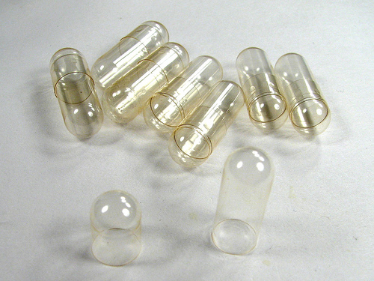
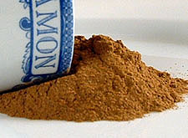
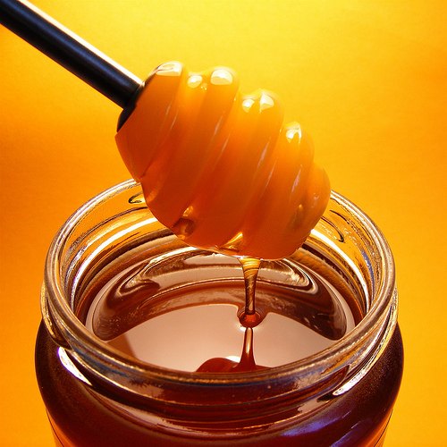

OPTION: Cinnamon can be put in capsules and swallowed

Facts on Honey and Cinnamon: It is found that a mixture of honey and cinnamon reduces many diseases. Scientists of today also accept honey as a (very effective) medicine for all kinds of diseases.
Weekly World News, a magazine in Canada, in its issue dated January 17th, 1995 has given the following list of diseases that can be reduced by honey and cinnamon:
HEART DISEASES:
- Make a paste of honey and cinnamon powder, apply on bread, instead of jelly and jam, and eat it regularly for breakfast.
- It reduces the cholesterol in the arteries and saves the patient from heart attack. Also those who have already had an attack, if they do this process daily, they are kept miles away from the next attack.
- Regular use of the above process relieves loss of breath and strengthens the heartbeat.
- In America and Canada, various nursing homes have treated patients successfully and have found that as you age, the arteries and veins lose their flexibility and get clogged; honey and cinnamon revitalize the arteries and veins.

CHOLESTEROL:
- Two tablespoons of honey and three teaspoons of Cinnamon Powder mixed in 16 ounces of green tea water, given to a cholesterol patient, was found to reduce the level of cholesterol in the blood by 10 percent within two hours.
- If taken three times a day, any chronic cholesterol is dramatically reduced. According to information received in the said Journal, pure honey taken with food daily relieves complaints of cholesterol.

ARTHRITIS:
- Arthritis patients may take daily, morning, and night, one cup of hot water. With two spoons of honey and one small teaspoon of cinnamon powder.
- If taken regularly even chronic arthritis can be reduced. In a recent research conducted at Copenhagen University, it was found that when the doctors treated their patients with a mixture of one tablespoon of Honey and half teaspoon of Cinnamon powder before breakfast, they found that within a week, out of the 200 people so treated, practically 73 patients were totally relieved of pain, and within a month, mostly all the patients who could not walk or move around because of arthritis started walking without pain.

BLADDER INFECTIONS:
- Take two tablespoons of cinnamon powder and one teaspoon of honey in a glass of lukewarm water and drink it. It destroys the germs in the bladder.

COLDS:
- Those suffering from common or severe colds should take one tablespoon lukewarm honey with 1/4 spoon cinnamon powder daily for three days. This process will reduce most chronic cough, cold, and help clear the sinuses.

UPSET STOMACH:
- Honey taken with cinnamon powder reduces stomach ache and also reduces stomach ulcers
GAS:
- According to the studies done in India and Japan, it is revealed that if honey is taken with cinnamon powder the stomach is relieved of gas.

IMMUNE SYSTEM:
- Daily use of honey and cinnamon powder strengthens the immune system and protects the body from bacteria and viral attacks. Scientists have found that honey has various vitamins and iron in large amounts. Constant use of honey strengthens the white blood corpuscles to fight bacteria and viral diseases.

INDIGESTION:
- Cinnamon powder sprinkled on two tablespoons of honey taken before food relieves acidity and helps digest the heaviest of meals.
INFLUENZA:
- A scientist in Spain has proved that honey contains a natural ingredient which reduces the influenza germs and reduces flu outbreak.

LONGEVITY:
- Tea made with honey and cinnamon powder, when taken regularly, slows down the ravages of old age. Take four spoons of honey, one spoon of cinnamon powder and three cups of water and boil to make like tea. Drink 1/4 cup, three to four times a day. It keeps the skin fresh and soft and arrests old age.
- Life spans are positively impacted, and seniors find themselves capable of doing more physical work

PIMPLES:
- Three tablespoons of honey and one teaspoon of cinnamon powder paste … apply this paste on the pimples before sleeping and wash it next morning with warm water. If done daily for two weeks, it gets to the root of the problem.

SKIN INFECTIONS:
- Applying honey and cinnamon powder in equal parts on the affected parts reduces eczema, ringworm and all types of skin infections.
WEIGHT LOSS:
- Daily in the morning one half hour before breakfast on an empty stomach … and at night before sleeping, drink honey and cinnamon powder boiled in one cup of water. If taken regularly, it reduces the weight of even the most obese person. Also, drinking this mixture regularly reduces the fat accumulation in the body even though the person may eat a high calorie diet.

CANCER:
- Recent research in Japan and Australia has revealed that advanced cancer of the stomach and bones have been helped dramatically. Patients suffering from these kinds of cancer should daily take one tablespoon of honey with one teaspoon of cinnamon powder for one month three times a day.

FATIGUE:
- Recent studies have shown that the sugar content of honey is more helpful rather than being detrimental to the strength of the body. Senior citizens, who take honey and cinnamon powder in equal parts, are more alert and flexible.
- Dr. Milton, who has done research, says that a half tablespoon of honey taken in a glass of water and sprinkled with cinnamon powder, taken daily after brushing and in the afternoon at about 3:00 p.m. when the vitality of the body starts to decrease, increases the vitality of the body within a week.

BAD BREATH:
- People in some parts of South America, first thing in the morning, gargle with one teaspoon of honey and cinnamon powder mixed in hot water, so their breath stays fresh throughout the day.
HEARING LOSS:
- Daily morning and night honey and cinnamon powder, taken in equal parts has been shown to help restore hearing with some.

