TRINITY UNITED METHODIST CHURCH
Pastor Doug Benton ___ Minister
August 29, 2021 Greeter: Myrtle Longshore Color: Green
FOURTEENTH SUNDAY AFTER PENTECOST
"We welcome you to our service this morning and pray that your time with us will be a blessing to you"
THE ORDER FOR WORSHIP
Prelude Phyllis Sanders
Let us silently prepare our hearts and minds for worship.
Welcome and Announcements Grady Senn
Chiming of the Hour Phyllis Sanders
Candle Lighting and Processional
“Stool Time with Pastor doug”
Call to Worship Pastor Benton
Opening Prayer Pastor Benton
Children’s Time Pastor Benton
Hymn of Adoration: “Joyful, Joyful, We Adore Thee” Page 89
*Apostles Creed Page 881
*Gloria Patri: “Glory Be to the Father”
Praises, Concerns and Prayers Grady Senn
Pastoral Prayer/Lord’s Prayer Pastor Benton
Tithes and Offering Ushers / Grady Senn
*Doxology: “Praise God From Whom All Blessings Flow”
*Hymn of Preparation: “Soldiers of Christ, Arise” Page 513
First Reading: Psalm 72 Sharon Baughman
Sermon Scripture: Ephesians 5:15-20 Pastor Benton
Sermon: Clean Hands Pastor Benton *Hymn of Service: “Stand Up, Stand Up for Jesus” Page 514
*Returning of the Light

*The Benediction Pastor Benton

*Three-Fold Amen and Going Forth: Phyllis Sanders
*Stand if able. God’s altar is open to you following the sermon.
Technician: Bryan Waldrop

The Altar Flowers are to the Glory of God.

Next Sunday – September 5

Altar Flowers: Joan Morris ; Greeter: Watkins Martin;
Scripture Reader: Harry Longshore; Technician: Caroline Senn

Our Faithfulness

Worship Attendance for August 22, 2021 43
Total Budget for 2021: $ 149,647.00
Weekly Offering Needed: $ 2,877.83
Offering Received August 22, 2021: $ 1,438.00
2021 Average Weekly Offering YTD: $ 2,146.00

The Concerns of Trinity

Our Known Hospitalized:
Recent Hospitalizations and/or Surgeries:
Nursing Home: Gloria Brehmer (Springfield Place), James Poag (White Oak)
Continued Prayers: Shirley Berry, Frances & Wade Pitts, Robert Pollard, Jeannette Poag, Hugh Boyd Davenport
Family and Friends of Trinity: Blake Hendrix, Wilson Bowles, Megan Wainwright, Neil Thomas, Francis Leopard, Kinsley Bouknight, Janna Longshore

WELCOME!
Thank you for coming today! We are delighted you are here! We hope you will join us again as we continue to discover the difference God’s love makes in our lives. If you have questions or desire to become a member of Trinity UMC, please speak to pastor. We are blessed because you’re here.

Trinity United Methodist Church Please visit our website for bulletins & newsletters:
1160 Trinity Church Road www.trinityumcnewberry.net
Newberry, SC 29108 Facebook: trinityumcnewberry
doug benton, Pastor
803-276-1245 (Church Office)
803-768-7687 (Church’s cellphone)
803-543-0082 (Pastor’s Cell)
dobenton@umcsc.net
Upcoming Events at Trinity

August 29: Back to School Ice Cream Social at 5:00 p.m.
Sept. 1: Men’s Club at 7:30 p.m.
Sept. 7: Women’s Club at 6:00 p.m.
Sept. 13: Admin. Council at 6:30 p.m.

Trinity
United
Methodist
Church

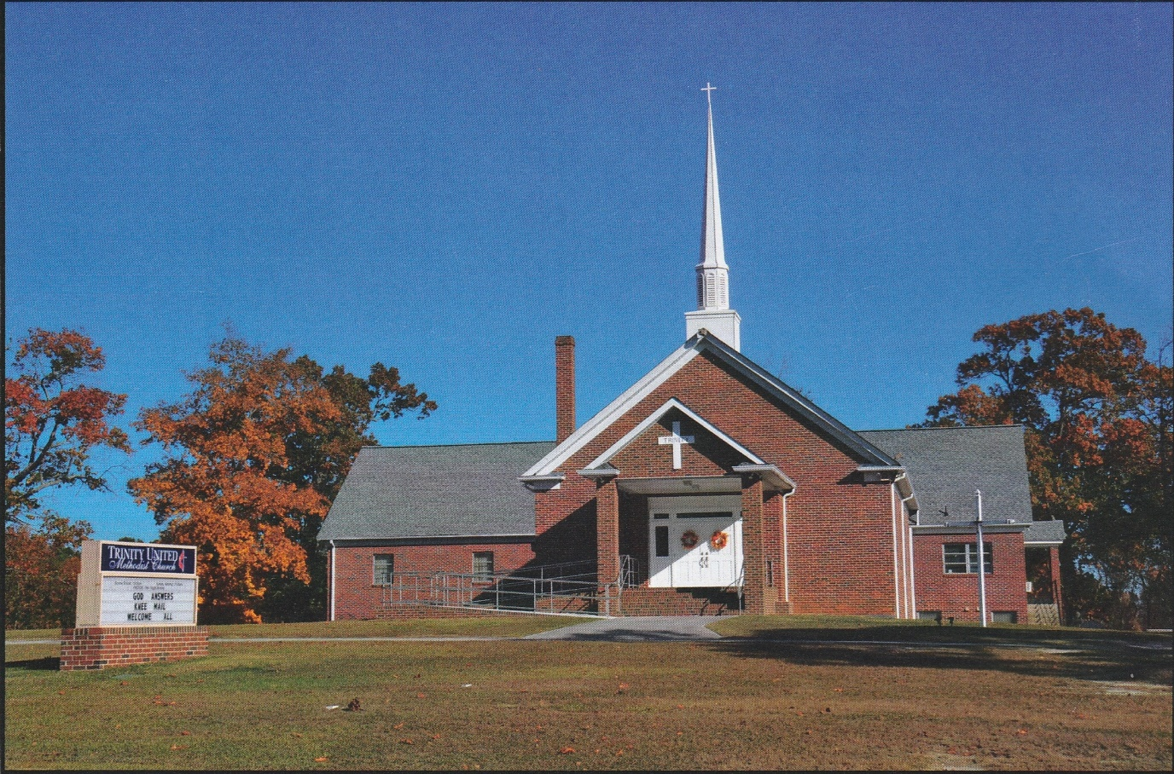

1160 Trinity Church Road
Newberry, SC 29108
trinityumcnewberry@gmail.com

