President's Message
December 2021

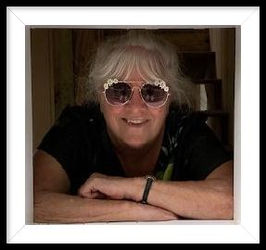

Hope you are all enjoying our glorious weather. I’ve been able to get out and enjoy some walks in our wonderful parks. We have an abundance of unique and beautiful parks.

We had a good turnout for Sunday/Funday at Carrabba’s, approximately 20 people and it was fun, with good food. I took home enough for two extra meals. Thanks to Linda Mills for planning the outing.

Looking forward to our Holiday Party coming up in a few days. There will NOT be a third Saturday member meeting as our party is our meeting for the month.

Our January meeting will return us to our pre-Covid facility that many of you remember. I feel so happy to again have a “home” for us and not have to scurry around looking for a place to meet. We will meet there the third Saturday of the month in January, February and March at 2:30 pm. Our picnic is in April at Eagle Lake Park.

Meeting location: St. Petersburg College, 2465 Drew Street, Clearwater. From the entrance off Old Coachman Road, come in on entrance at end of the last building and proceed to building ES. Come in main entrance to the building and the meeting room is right in front of you. It is number 104. Classroom–ES 104 or they call it CR–ES 104. There is good parking. Dine if you choose after the meeting will be at Saigon Bowl (Vietnamese food) at 2129 Drew St., Clearwater. We need to contact the restaurant in advance, so please let me know by January 13 if you plan to attend at 140gecko@gmail.com or 727-666-2740.

I’ve got a table for Early Bird Dinner Theater, 13355 49th St N., Clearwater, on January 29, at 4 pm. Jan Means, Bill Staab and I attended a play in November, food was good, play was so funny; we laughed a lot. Show is Boeing, Boeing and it looks very good. Check out plot: http://earlybirddinnertheater.com/site. $40 cash/check only at door. If you want to attend just let me know at 140gecko@gmail.com. Deadline is January 20. I don’t think you will be disappointed.

A new member orientation will be scheduled in January. For brand new members or anyone who has never attended an orientation and would like to learn more. Please email me if you would like to attend. The meeting will explain FFI, our local club, incoming and outgoing journeys. We will have a few of our experienced, long-time members speak, have questions and answers, some good snacks and visiting. Hope you will be able to make it.

In friendship,

Gena Cameron

