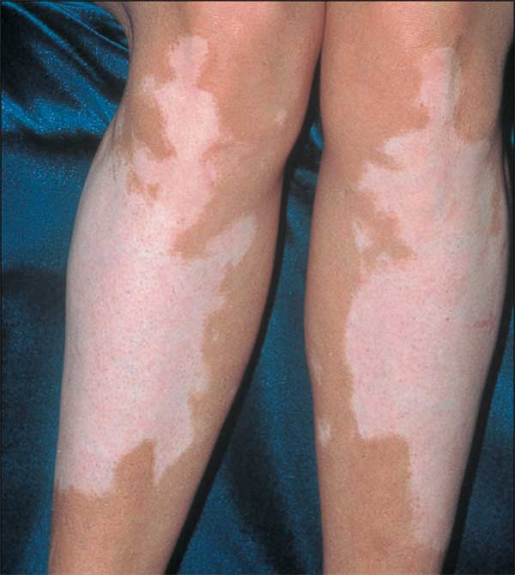
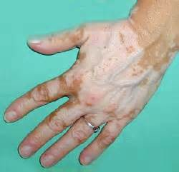
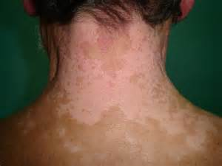

Vitiligo (Leukoderma)

Skin condition characterized by chalky white patches of skin surrounded by a darker border
- Does not itch or hurt
- The occur because the cells that normally produce the skin pigment melanin are absent
- Unpigmented areas are highly vulnerable to sunburn

Causes:
- Autoimmune problem
- Thyroid malfunction
- Hormonal imbalances
- Nutrient Deficiencies

Have thyroid & hormones checked and address holistically.

Suggested Supplements:

Step 1:
- NutriFeron
- Vitalizer (extra B Complex may be beneficial)
- B Complex
- Essential Fatty Acids: OmegaGuard / GLA / Flaxseed Oil Capsules in Canada
Step 2:
- Soy Protein and/or Shaklee 180 smoothees
- CarotoMax
- Vivix
Step 3:
- Extra Vitamin C
- FlavoMax in U.S.
- Zinc

Other Suggestions:
- Provide for excellent detoxification
- If you have allergies, address them (call 905-871-4281 for allergy test kit)

