New Jersey
Family, Career, and Community Leaders of America

2023 SCHOOL ADMINISTRATORS’ AWARD

Application Due: March 1, 2023

Without the support of school administrators, students could not take advantage of the many opportunities offered through Family, Career, and Community Leaders of America, Inc. Exceptional administrators encourage chapters to take advantage of FCCLA programs and develop leadership skills to prepare them for their multiple adult roles of family member, wage earner and community leader.

PURPOSE
New Jersey Family, Career, and Community Leaders of America’s School Administrators’ Award seeks to honor local administrators who give outstanding support to the organization on the local, state, and national levels. As advocates of the programs, activities, and achievements of our membership, supportive administrators advance the mission and purposes of FCCLA.

ELIGIBILITY
The administrator must have been in his/her position for two or more years and the chapter must have maintained their affiliation for three continuous years.

INSTRUCTION
An FCCLA member, adviser or parent may nominate a school administrator. To place a name in nomination, please submit the following information to your adviser by March 1, 2023:

- A completed typewritten copy of this application.

- Three letters of recommendation (one from each group listed):
- FCCLA Adviser
- FCCLA Chapter President/Officer
- Community Member or Parent
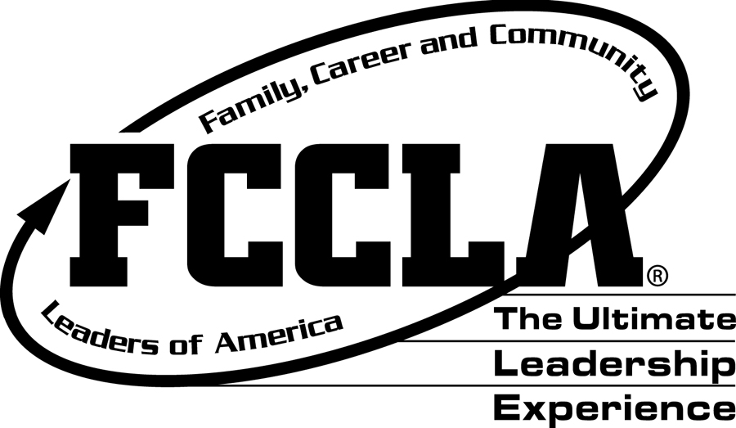
Return completed application to:
New Jersey FCCLA State Office
c/o Patricia DiGioia-Laird
NJ FCCLA State Adviser
855 Grove Avenue
Edison, New Jersey 08820-2200

New Jersey
Family, Career and Community Leaders of America
2023 School Administrators’ Award
Nomination Form
Application Due by: March 1, 2023

Name of Administrator

_________________________________________________________________________

Position Held

_________________________________________________________________________

Size of School (no. of students) __________________________________________

Size of FCCLA chapter (no. of students) __________________________________

School Address ________________________________________________________

_________________________________________________________________________

_________________________________________________________________________

School Phone Number

_________________________________________________________________________

Name of Nominator

_________________________________________________________________________

Position/Title

_________________________________________________________________________

Address ________________________________________________________________

_________________________________________________________________________

_________________________________________________________________________

E-Mail Address

_________________________________________________________________________
In the space provided, please tell how the nominee…

a) supports and encourages FCCLA sponsored activities and projects?

b) supports and encourages FCCLA advisers?

c) supports and encourages individual students?

d) significantly influences and encourages membership in FCCLA?

e) promotes FCCLA in the community?

f) supports career and technical education?

Please send this form to the NJ FCCLA State Adviser by March 1, 2023 along with support materials.

