REGISTRATION Packet

14th Biennial Conference of the
International Association of Special Education (IASE)

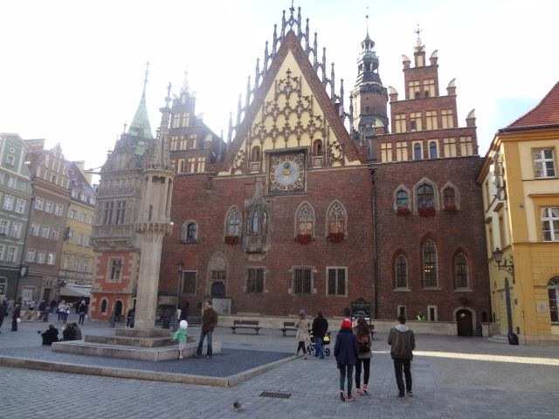

“New Dimensions toward Education, Advocacy and Collaboration for Individuals with Special Needs”

Wroclaw, Poland
June 21-25, 2015

A collaborative effort by the
International Association of Special Education
and the University of Lower Silesia.

REGISTRATION FORM
IASE 14th Biennial Conference
Wroclaw, Poland – June 21-25, 2015

Please complete a separate registration form for each participant. Duplicate this form as needed. Make checks or money orders payable to IASE in US dollars. Mail to: IASE Treasurer, Steve Leitz, 8220 67th St. Ct. NW, Gig Harbor, WA 98335 USA. Email: stevenleitz@gmail.com. Telephone: 1-253-857-6573. You may pay by credit card. IASE Federal ID# 43-1974089.

PLEASE PRINT CLEARLY!!

Surname:________________________________________First Name___________________

Mailing Address:_______________________________________________________________

City:______________________________________ State/Province:______________________

Country:___________________________________ Zip/Postal Code:____________________

Phone (O)_______________________________ (H or Cell)_____________________________

Fax:______________________________ Email:______________________________________

Gala Dinner: Yes___ No:___ Indicate Special Diet Needs:______________________________

Indicate Any Special Access Services Required:_______________________________________

Conference registration includes: Opening Reception, three days of conference sessions with daily lunches and morning breaks, Gala Dinner, and Conference Proceedings. Conference registrants will receive IASE membership for 2016!

REGISTRATION FEES

By February 1, 2015 After February 1, 2015

IASE Member ___$450.00 ___$550.00

Non IASE Member ___$500.00 ___$600.00

IASE Member
Developing Country ___$150.00 ___$250.00

Non IASE Member
Developing Country ___$170.00 ___$270.00

IASE Student Member ___$225.00 ___$325.00
(undergraduate and graduate students taking 15+ credit hours per academic year)

Non IASE Student Member ___$245.00 ___$345.00
(undergraduate and graduate students taking 15+ credit hours per academic year)

IASE Member Retired ___$225.00 ___$325.00
(65+ years old)

Non IASE Member Retired ___$275.00 ___$375.00
(65+ years old)

Extra Gala Dinner Tickets for a guest: ___ Number @ $60.00 = $_________________

Optional Tours:
School Tour: ___Number @ $25.00 = $_________________

Rehabilitation Center Tour ___ Number @ $40.00 = $________________

TOTAL REGISTRATION FEES: (payment in US dollars only) $__________________

Method of Payment: ___ Check/Money Order ___ Credit Card (see below)

Name on Credit Card;___________________________________________________________________

Credit Card Number: ___________________________________________________________________

Expiration date: _________________________ CVV code:___________________________________

Note: All presenters are required to register for the conference by February 1, 2015 or their names will not appear in the conference program. All registration forms and payment must be received no later than May 1, 2015. Registrants with special meal requests must list them on the registration form.

Cancellations MUST be made in writing for the IASE Board approval. Send to IASE, c/o Steven Leitz, 8220 67th St. Ct. NW, Gig Harbor, WA 98335, USA. Refund information: All refunds are subject to a $50.00 US processing charge. Cancellations made by April 1, 2015 full refund minus the $50.00 processing charge. April 2-15, 2015 a 75% refund (minus $50.00), April 16-30, 2015 a 50% refund (minus $50.00). No refunds after May 1, 2015.

PLEASE remember to register early as this conference is limited to the first 500 participants.

