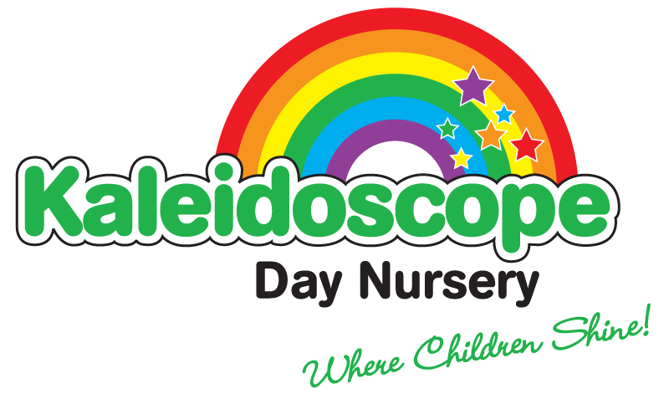

Issue 9
Review date: May 2023

Equal Opportunities, diversity, inclusion, british values

Kaleidoscope aims to meet the needs of each individual child and adult member regardless of their race, gender, age, class or ability. We work to ensure access to equal opportunities for all children and staff to develop into confident, competent, caring and self-aware people.
All members of our Nursery are to be equally valued and respected including children and adults alike.
No one should be discriminated against because of actual or imagined differences.
We aim to promote British Values as part of the spiritual, moral, social and cultural development of the children, this includes; Democracy, Rule of Law, Individual Liberty and Mutual Respect and Tolerance for those with different faiths and beliefs
The environment of the Nursery should provide and encourage the values to which we aim.
We are working towards Equal Opportunities in the following areas: -

Resources

We will endeavour to resource Kaleidoscope Nursery in the spirit of Equal Opportunities and promote positive images and attitudes in everyone i.e.-

- Recorded music and musical instruments which reflect our multicultural society
- Visual aids and equipment
- Equipment which is appropriate for children with physical disabilities
- Books in library which portray a diversity of cultures and languages
- Persona doll, to be used to talk about celebrations, culture, feelings etc

Ethos and Atmosphere

The positive atmosphere of Kaleidoscope Nursery should reflect our commitment to Equal Opportunities, and encourage the children to value and respect others:

- Visitors are welcomed
- Displays will be used to promote positive images
- Discussions within the group are used to reflect positive attitudes and celebrate achievements both within the nursery and in the wider community.
- Children and adults greet each other in a friendly manner.
- We are strongly committed to positive action to counter discriminate in all aspects of our work and care, this is done verbally in private i.e the office
- We aim to provide experiences and opportunities which are appropriate for all
- The nursery encourages parental involvement in all aspects of its equal opportunities policy.

Equal Opportunities Co-ordinator

We employ an Equal Opportunities Co-ordinator – Caroline Edwards, whose role is to:

* ensure everyone adheres to our policy
* be the focal point for day to day references on equal opportunity and give
general advice
* shall resolve any problem a member of staff shall refer to (regarding equal
opportunity), and refer to the Manager any problems for which they cannot
achieve a satisfactory solution
* access training courses and keep up to date with relevant changes and feed
back to staff at staff meetings

Staff

Kaleidoscope Nursery confirms its opposition to unfair discrimination in employment and commits itself to a comprehensive policy of equal opportunities. The aim of this policy is to ensure that the recruitment, election, training and promotion of staff is solely based on the criteria of merit and ability, and that no job applicant or employee will receive less favourable treatment on the grounds of gender, race, ethnic or national origin, marital status, domestic circumstances, age sexuality, disability, trade union activity, political or religious beliefs. All staff will be subject to DBS (data and barring service ) checks.

Review

This policy is a working document and will therefore be open to change and restructuring as and when the need arises. There will be an annual review which involves all staff members.

Signed: V.Goode Date: 11th April 2022

