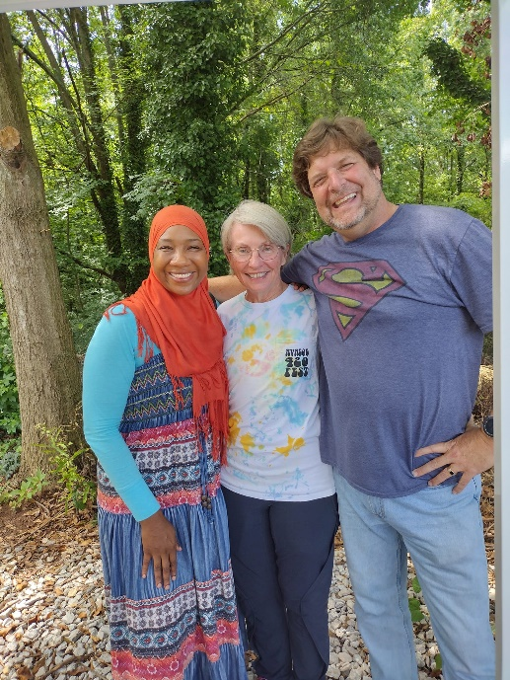
What a day y'all!! Glad Tidings was invited to an event for the homeless here in Gainesville where they could take showers🚿, change clothes, eat 🥪, etc. It was so overwhelming to see so many different non profit organizations come together, different faiths, but ONE mission. Thank you so much Michael (Director of Ninth District) for the invite!! I cannot wait to see what God is going to do in this city...the number of homeless individuals and families here is already astronomical, but they are predicting that the numbers are going to jump almost six-fold. Even with these predictions, I know with every fiber of my being that God is getting ready to move mightily between all of us for HIS people. There are so many of HIS Chosen here, I just pray we can transition them into a more stable and permanent situation 🙏🙏.
Michael Fisher, please keep doing what you are doing! And, thank you for bridging the gap and allowing others to join your mission! The positive energy that flowed through the event was truly undeniable. You are a God send🙌!
Jane and Joe provided the Mobile Showers (Overhead Cover Inc.)!!! You guys are so awesome!!!
Dallas, It was such a blessing meeting you..thank you for sharing your upcoming projects with me. We are definitely on the same page when it comes to how we want to make a difference in the community. I look forward to working together in the near future.
Thank you Lindsey (Wayfind Collective) for working towards bringing all of the organizations together!!!
Thank you Kerry (Ninth District) for all you do!! I can't wait to see what you are putting together for us..I know whatever it is, it will bring the much needed change to Hall County!
Belinda with Sunshine Seniors you are making a huge impact feeding 250 families every week! It was a pleasure meeting you. I can't wait to see what we are going to do moving forward.
It was definitely a pleasure meeting and speaking with everyone! I cannot wait until the next event!

