Scoliosis
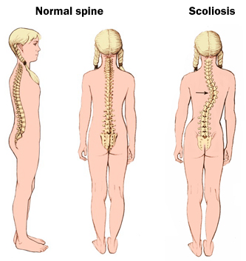

- Scoliosis is a sideways curvature of the spine.

- It occurs most often during the growth spurt just before puberty.

- Most cases are mild. Children who have mild scoliosis are
monitored closely, usually with X-rays, to see if the curve is
getting worse. In many cases, no treatment is necessary

- Some children need to wear a brace to stop the curve from worsening

- Severe scoliosis can be disabling. An especially severe spinal curve
can reduce the amount of space within the chest, making it difficult
for the lungs to function properly. Some need surgery to straighten
severe cases of scoliosis

Causes:
- Neuromuscular scoliosis … caused as a result of abnormal muscles or nerves. Frequently seen in people with spina bifida or cerebral palsy or muscular dystrophy
- Congenital scoliosis … due to bone abnormality or a birth defect that can be due to nutritional deficiencies in the mother during pregnancy (one more reason why it is critical that pregnant women are very serious about their nutritional intake when pregnant … you only get to grow a baby once!)
- Degenerative scoliosis … that is excessive wear & tear, often caused by inflammatory conditions in the back, such as arthritis that is not addressed appropriately
- Nutritional deficiencies during development … children are developing quickly, especially during growth spurts. The following are examples of children more at risk:
      - child who is a picky eater,
      - child who is a junk food eater
      - child who has been on a lot of antibiotics (which reduce absorption of minerals due to depletion of probiotics)
      - child who is an athlete that perspires out minerals and does not provide adequate nutrients to replace what is lost in perspiration
- Idiopathic scoliosis … has no specific known cause.

Symptoms:
- Uneven shoulders
- One shoulder blade that appears more prominent than the other
- Uneven waist
- One hip higher than the other
If a scoliosis curve gets worse, the spine may also rotate or twist, in addition to curving side to side. This causes the ribs on one side of the body to stick out farther than on the other side. Severe scoliosis can cause back pain and difficulty breathing.

Recommendations:
- In most cases, chiropractic practices can work wonders with cases of scoliosis. It is extremely important that you consult a chiropractor who has had prior experience with treating scoliosis. It is inadvisable to consult a chiropractor who has only theoretical knowledge of the disease, as your treatment could go wrong in inexperienced hands.
- It is critical that the diet is a very healthy diet, with lots of raw food
- Have a hair analysis done to determine if extreme mineral imbalances exist, or if heavy metals are interfering with proper development
- Provide an optimal smorgasbord of nutrients CONSISTENTLY in the diet by supplementation, paying close attention to optimal levels of:
      - Protein
      - Probiotics
      - Minerals
      - Vitamin D

