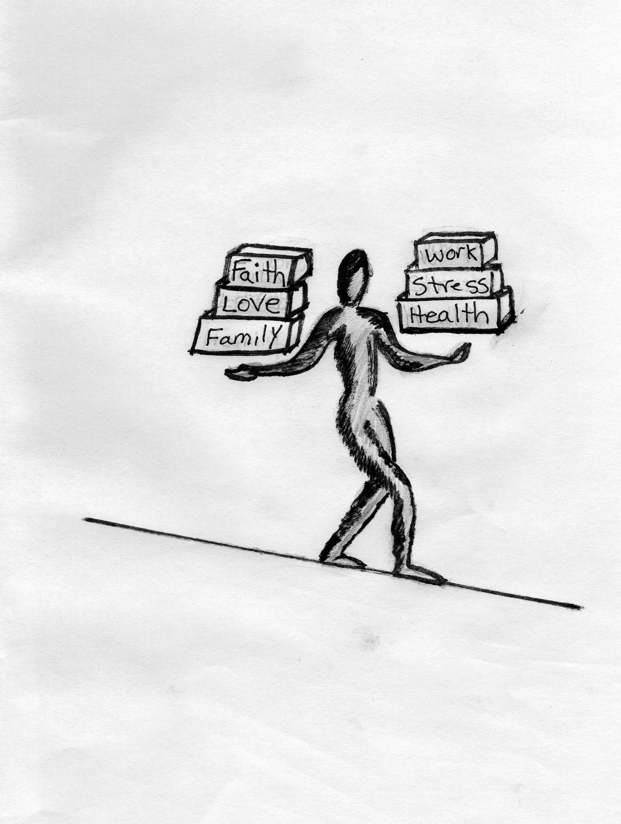
“Balance” Counseling & Mediation
965 E. Yosemite Ave, Suite 1B, Manteca, Ca 95336
(209) 470-3295

Marital Questionnaire:
Have you and your spouse/partner participated in professional marriage counseling in the past? Yes No
What forms of couples help have you received or tried (i.e. seminars, books, classes etc…) ?
Is your spouse willing to participate? Yes No
What are you core beliefs? (i.e. religious, spiritual, marriage concepts)
Do you and your spouse/partner share those beliefs? Yes No
If not, what are the differences?
Do the differences cause problems between you? Yes No
Are you cheating on your spouse? Yes No
Do you believe your spouse cheating on you? Yes No
What would like to see happen in this relationship? ____________________________________________________________

Short Questionnaire 1= Never or Almost never; 2 = Once in a while; 3 = Always or Almost always

I am not sure if I want to save my marriage.
Little arguments escalate into big fights with accusations, criticism, name-calling, or bringing up past hurts.
My partner criticizes or belittles my opinions, feelings, or desires.
My partner seems to view my words or actions more negatively than I mean them to be.
When we have a problem to solve, it’s like we are on opposite teams.
I hold back from telling my partner what I really think and feel.
I feel lonely in this relationship.
When we argue, one of us withdraws, that is, doesn’t want to talk about it anymore or leaves the room.
I have been unfaithful to my partner.
My partner has been unfaithful to me.
I believe my partner is not committed to the marriage.
Score

