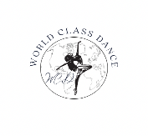World Class Dance October 2022 Newsletter
Parents & Students,
Fall has arrived and our students are adapting to their classes and instructors very well. As the colder and wet weather approaches please make sure you hang your coats up, place wet shoes on shoe trays and rest of belongings in a cubby. It is extremely important that you know your dancers class start and end time. As we have had students entering the wrong class rooms because they were too early in addition to students arriving ½ way through instruction, or not getting picked up on time. Dancers should not arrive more then 5-10 minutes prior to instruction. Please do not check in and drop your dancer off before that. As well as making sure your dancer is picked up at the end of their instruction. Our staff needs to continue instruction and our desk staff is not responsible to watch your children.
All Pom & Cheer students please have an all-white cheer sneaker for class. Hip-Hop students are to have an all-black gym sneaker for class. Do not wear your pom, cheer, hip-hop or any style dance shoe outside. They need to be used for the dance floor only. The only students who may have bare legs are our pom and cheer students for safety with stunts. All other dancers must have tights or leggings: no bare legs. Our next shoe order will not be placed until December break.
We do not have make up classes. Each class is at a different pace, technique, combinations, different instructors & students. Consistency is always best for our students. Solo lessons are only offered to competitive dancers with 2+ years competitive experience.
Please make sure to create a login on our parent portal. It is your responsibility to keep your payment info, address, phone and email up dated and you can do so on our portal. Keep following, liking and sharing our fun daily/weekly posts on social media. All add-ons, drops and class transfers must be completed by November 15th .
Important Dates:
10/10 – OPEN – Columbus Day
10/17-10/21 – Observation Week #1: Recreational parents may observe the last 10 minutes of instruction.
10/24-10/28 – Halloween Costume Week – Wear your Halloween costume – We will have a costume contest. Winners will be announced on social media.
10/31 – CLOSED – Halloween: Have fun – Stay safe!
SAVE THE DATE: 2023 RECITAL – FRIDAY JUNE 9TH at Ballston Spa High School More details will follow in the coming newsletters
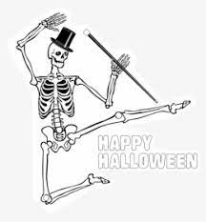
World Class Dance * Clifton Park Center * (518) 982-1768 worldclassdanceny@gmail.com * www.worldclassdanceny.com

