Something a little different Answers: 1. A cross; 2. Bread; 3. No - it’s a moveable feast; 4. Chile; 5. 40 days 6. Shrove Tuesday/Pancake Day ;7. With nails through his hands and feet 8. Eggs; 9. Friday; 10. Holy Week (week preceding Easter week); 11.Barabbas; 12. 3 (Three); 13. The Mount of Olives ; 14. Spanish ; 15. The Belfast agreement; 16. The Last Supper; 17. Hats; 18. He rose from the dead; 19. A chief tax collector; 20. Chocolate Eggs

Crossword Answers
ACROSS: 1, Cosmic. 4, Thomas. 8, In his. 9, Delaiah. 10, Falwell.
11, Water. 12, Recovered. 17, Sidon. 19, Radiant. 21, Centaur.
22, Broil. 23, Eleven. 24, Prison.
DOWN: 1, Cliffs. 2, Scholar. 3, Issue. 5, Holy war. 6, Moist.
7, Sphere. 9, Deliverer. 13, Candace. 14, Deacons. 15, Psyche.
16, Stolen. 18, Dance. 20, Debar.

Service times at St Mary’s

Sunday: 10:30am Holy Communion
or Morning Prayer
Normally the first and third Sunday is Holy Communion with Morning on the second and fourth. Baptisms by arrangement with the Rector.

Tuesday: 10.00am Holy Communion
12.15pm Lunch-time Service

Readers contributions to the magazine are always welcome. Hard copy (hand written if easier) to the Rectory address or by email: to : st.marysstockport@gmail.com
Editorial discretion with regard to content and space available will apply.
St Mary’s in the Marketplace
St Mary’s Rectory, 24 Gorsey Mount Street,
Stockport, SK1 4DU.
0161 429 6564 www.stmarysinthemarketplace.com.
St Mary’s in the Marketplace
Parish Magazine
April 2014

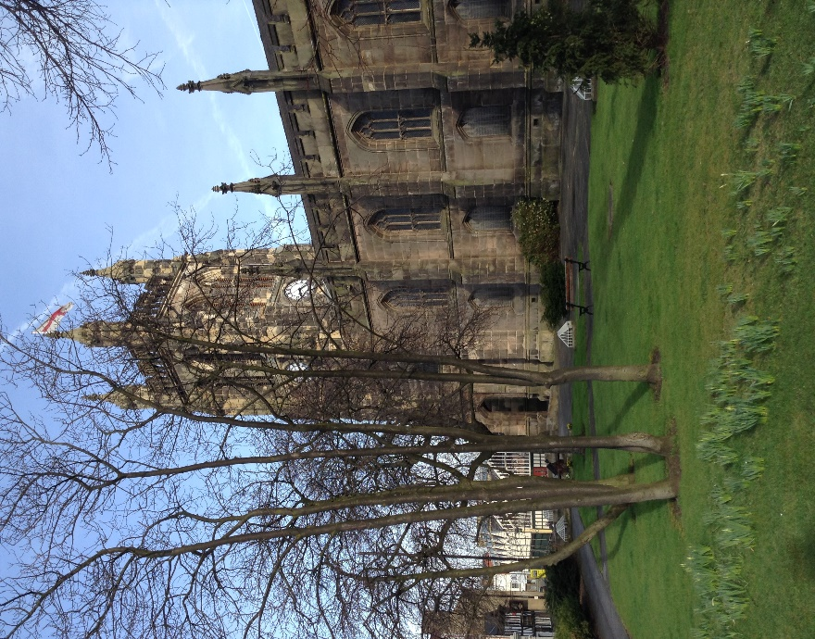

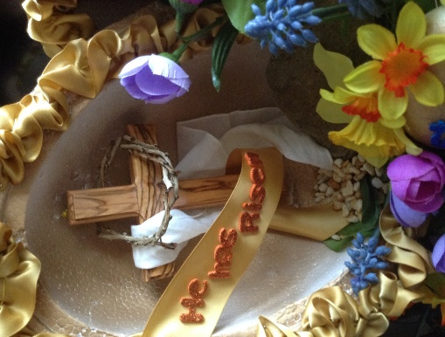

50p
From the Rector’s “ i-Pad”
Dear Reader
As I sit in my kitchen in the early morning , the sun is streaming through the window flooding the table with light and bringing sunshine into my eyes and warmth into my heart and soul. Dawn is a beautiful time of day to be alive, to see and to experience. I am fortunate , I know, in as much as that my lovely Rectory, home for the time being, faces east and west, thus giving me the benefit of the rising sun in the morning from February onwards, and the dappled rays of the setting sun in the evening, from the west, as I sit out in the garden on summer days. It is a blessing to live here, in the Rectory.
At this time of year, also, the Rectory garden comes alive with spring flowers, which makes a particularly attractive spectacle. It all began back in January with the arrival of the snowdrops. Then came the brightly coloured crocuses, followed only a week or two later by the first yellow daffodils, which are now coming into full bloom of many types, although they will be at their best in May. Do come and see my garden in Spring, in a special Sunday tea party to be announced! All very traditional!
Easter comes very late this year, but there will be no shortage of daffs at least ! The popular or rather the secular image of Easter nowadays is the Easter Egg and the Easter Bunnie, which are all very endearing. I still have ones uneaten from last year, they are so sweet! In Switzerland, where I will have been just before Easter, the shop windows are full of delightful arrangements of such images, far more so than in this country. They have nothing to do with Easter as a Christian festival!
Easter is both a solemn and a joyful festival. It is a story of life and death and resurrection . There can be no real celebration of Easter, the Christian Festival, without the drama of Maundy Thursday , the trauma and pain of Good Friday, followed by the emptiness and bereavement of the Saturday. The Cross makes sense of Easter. There can be no celebration of resurrection without crucifixion, death and burial. This is our Creed, fundamental to the Christian Faith.

Calling all members of the St Mary’s Tuesday Choir (new members also welcome) to join Eileen in preparing for a special Heritage Weekend Concert on Saturday, 13th September 2014.

Heritage Open Days have given the Stockport Heritage Trust a window of opportunity over the years to do many and varied things. This year (2014) will be extra special – so do look out for their programme of event(s).
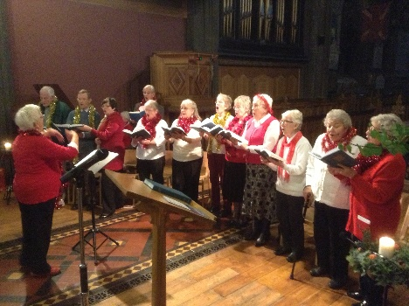
The St Mary’s Tuesday Choir, which normally only performs at one of our lunch-time Christmas services, has been invited to participate in this special event and to sing a selection of WW1 songs.

Eileen needs you…… and says “I consider it an honour to be involved in this Experience, so this is an early invitation to one and all to join us Will you be there …”

Talk to Eileen Lockett if you are interested in joining the choir, announcements will be made when rehearsals start!

St Mary’s Thursday Club
(a sort of Knit “n” Natter)
Everyone Welcome

Thursday 10.30am (or thereabouts)
Re-introducing in a new format our Thursday morning meetings at St Mary’s when you can bring your own work to complete (WHATEVER THAT MIGHT BE), do something completely new – or if you prefer do nothing at all…
Not everyone wants to undertake a craft activity (and we understand that) but you can bring your paint brushes or card making materials if you wish (as not everyone wishes to knit or sew either)
The objective is simply to offer the chance to take a break from everyday life, have a cuppa from the café (or whatever) and enjoy friendship and companionship.
If you do fancy having a go at knitting or crocheting then that’s fine. On the other hand, you may prefer to do needlework or something completely different. We can no doubt find someone to show us any new skill we fancy doing – and even ask the odd speaker to come and talk to us from time to time, or take a trip out. If you have a couple of hours to space, why not give it a go!
Whatever your choice of activity, it would be lovely to see you and maybe share your hobby with us. Whether you are making items for yourself, family, friends or making items for one of our events, everyone will be most welcome.

Easter Egg Festival
at
St Thomas’ Church, Stockport

An Easter Egg Festival will take place at St Thomas’
between the 25th – 26 April
Why not pop along and have a look and the Easter Eggs – including the submission from St Mary’s.
Opening times:
Friday, 25th April 10.00am-4.00pm
Saturday, 26th April 10.00am-4.00pm
Sunday, 27th April 12.00 noon – 4.00pm

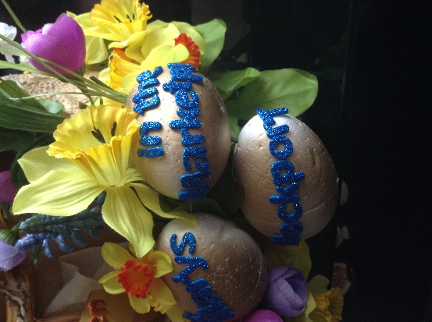
St Thomas’s is a grade-1 listed building in the heart of
Stockport hoping to encourage a greater sense of
community in the local area. To that end the church is
holding an “Easter Egg Festival” similar to a Christmas Tree festival – but a collection of giant eggs decorated by various
businesses, individuals, schools, charitable
organisations and (in support of the venture)
St Mary’s.
Ours is not exactly “giant” in size, it
just about reaches the minimum size specified,
but we are at least doing our bit to help -
so please go along if you possibly can and
support Andrew Lythall and his team .

THE CONSECRATION OF WOMEN TO THE EPISCOPATE
We are informed by Bishop Peter that following the decision by General Synod to refer the legislation to the Dioceses for a shortened period of consultation, with a response required by the 22 May, the Diocese of Chester is arranging for a special meeting of Diocesan Synod on the evening of the 21 May. There are also three open meetings around the Diocese when folk of all persuasions might meet together with the Bishop of Chester, Libby Lane (Dean for Women in Ministry) and some of the General Synod representatives, to discuss the legislation and its potential operation.
The meetings are scheduled as follows:
Wednesday, 30 April Foxhill
Thursday, 1 May Parish Centre, St Peter’s, Heswall
Tuesday, 6 May St Andrew’s, Cheadle Hulme
Meetings will start at 7.30pm with refreshments from 7pm.

And the legislative process….
DRAFT BISHOPS AND PRIESTS (CONSECRATION AND ORDINATION OF WOMEN) MEASURE AND DRAFT AMENDING CANON NO 33 can be viewed on line and like all Church Law is complex yet in many ways fascinating – if you are interested in such things! .
If a majority of diocesan synods approve the draft legislation, it will return to the General Synod in July 2014 for Final Drafting Stage and the opportunity for consideration in accordance with the requirements of Article 7 of the Constitution (which would involve a reference to the House of Bishops and, if required by any of them, references to the Convocations and the House of Laity). The Final Approval stage, at which two-thirds majorities are required in each House, may also be taken in July. If approved, the Measure will then go to Parliament for consideration by the Ecclesiastical Committee and approval by both Houses of Parliament
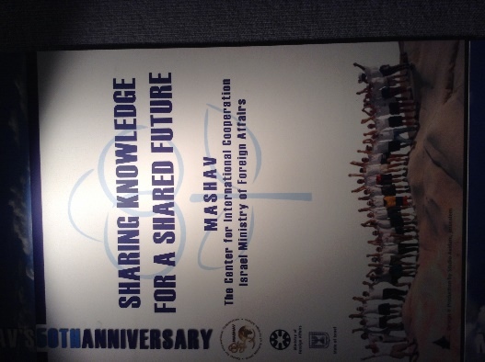
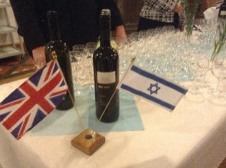
MASHAV
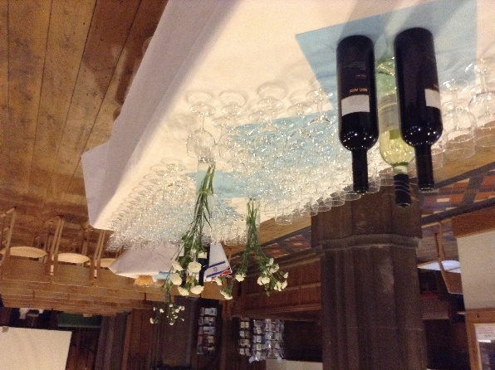

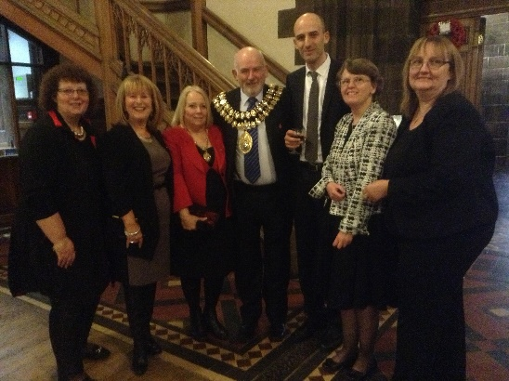
St Mary’s has been pleased to be able to hold the MASHAV exhibition recently starting with a special service (Tuesday lunch-time) and VIP Reception (given by the Israel Information Centre in association with Stockport Metropolitan Borough Council). Opening on the 25th February, the display remained available for public viewing up to the 16th March.

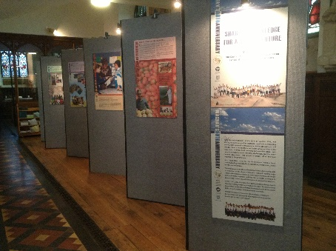
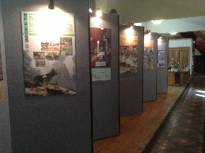

nOW FOR SOMETHING A LITTLE DIFFERENT
OUR EASTER 20 QUESTIONS QUIZ

1. 'Crucession' is a procession headed by which symbolic object?
2. At the Last Supper, what food did Jesus liken to his body?
3. Does Easter fall on the same dates every year?
4. Easter Island belongs to which South American country?
5. How many days does Lent last for?
6. What day precedes Ash Wednesday?
7. How was Jesus fastened to the cross?
8. What symbol of the empty tomb is commonly decorated at Easter by kids?
9. In the Easter song, Lord of the Dance, on which day did the “world turn black”?
10. What comes first Easter Week or Holy Week?
11. What was the name of the murderer released instead of Jesus by Pilate?
12. Jesus prophesized that Peter would deny him how many times?
13. On the side of which hill was the garden of Gethsemane?
14. Pascua is the name for Easter in which language?
15. Signed on Good Friday, 10 April in 1998, what other name is the 'Good Friday Agreement' know as?
16. What came first, Jesus' crucifixion, resurrection or the Last Supper?
17. An 'Easter parade' can be an event consisting of a strolling procession on Easter Sunday. People traditionally dressed in new and fashionable clothing but what item of clothing do ladies' strive to impress others with?
18. What happened to Jesus on Easter Sunday?
19. Which job did Zacchaeus hold in the bible?
20. What sweet objects are commonly 'hunted' by children at Easter time?

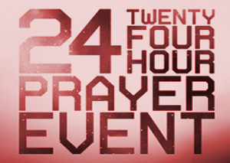
Easter Prayer24
“God’s people worshipping with praise and prayer,
lifting up the name of Jesus across Stockport”
Thursday 17th April – Maundy Thursday
7pm Celebration of The Lords Supper with ministers from Stockport
churches

9pm “In the Garden” reflections on Gethsemane

10.30 pm Time of Fellowship and refreshment

Midnight Personal / Small Group Prayer

Friday 18th April – Good Friday

Midnight - 8am “Watch with me one hour” – one hour prayer watches

8am Fellowship Breakfast

9am Quiet Prayer and reflection

10am Family Service at St Mary’s

10.30 am “Walk of Witness” – starting from St Mary’s in Marketplace

12 15pm St Mary’s lunchtime service

12 30 pm “Taize Service”

2pm – 5pm “Way of the Cross” - reflections on the Cross

5pm Time of fellowship and refreshment

6pm – 7pm “Its Friday….. but Sunday’s coming”
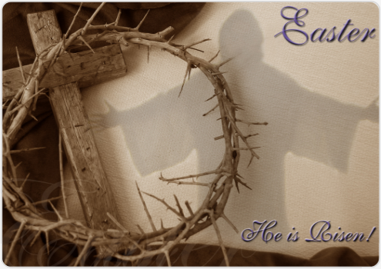
Easter Sunday, 20th April

6. 00am Dawn Service
at St Mary’s
Followed by 6.30am Breakfast

10.30am Holy Communion

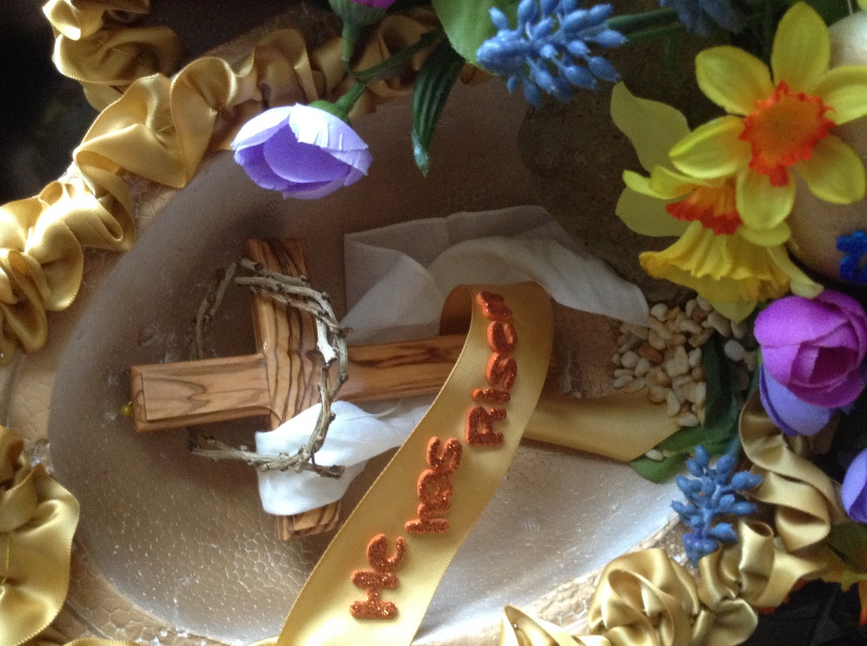
We cannot guarantee that the sun will actually be visible, but it is the thought that counts and we hope that as many of you as possible will join us for this special start to Easter Day at 6am. Breakfast will be served afterwards in the Nave Café with our normal morning service starting at 10.30am.

St George’s Day Wednesday, 23rd April at the Nave Café

There is no more quintessential English ritual than the ceremony and serving of Afternoon Tea. So that is exactly what we are going to do – only a little more substantial than a cucumber sandwich and a slice of cake.

We’ll stick to the correct day/date and serve “tea” (an evening meal) at 5pm (or thereabouts – latecomers can catch up with us) at the Nave Café, St Mary’s in the Marketplace. Tickets: £10.00

help has arrived…. for those of us with difficulties walking up and down steps … the arrival of the hand rail near the south entrance. such a simple structure will make all the difference. Thank you to those involved in organising and providing it.
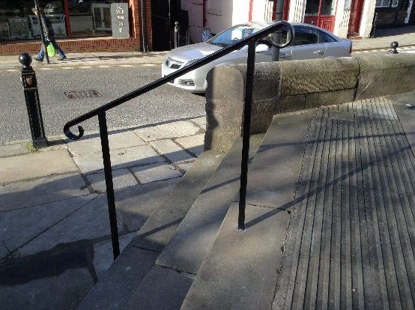

Bishop of Stockport

It is now widely known that Bishop Robert is leaving the area to take up an appointment as bishop of exeter. In just over five years Bishop Robert has made a tremendous contribution to the life of the Diocese, and will be greatly missed.

We have been asked if we would like to contribute towards a leaving gift, the Parochial Church Council have therefore approved the payment of £50, a cheque for which has been made payable to “The Bishop of Chester’s Discretionary Account” (as directed by Bishop Peter), and forwarded to Bishop’s House.

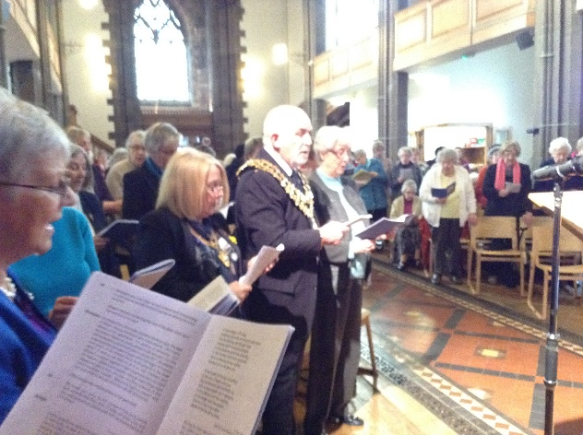
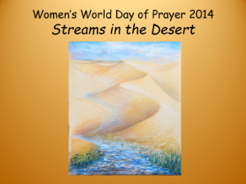
It’s all over for another year, but on Friday, 7th March 2014 and St Mary’s came alive to the sounds of Egyptian music, followed by a special service (attended by the Mayor and Mayoress of Stockport, Cllr Chris Murphy and Mrs Dot Murphy) prepared for the Women’s World Day of Prayer by the Christian women of Egypt. The service was led by Catriona Smith (St Mary’s) with members of various other churches also taking part. The address was given by the Rev Margaret Tait. We are pleased to have been able to send the sum of £231.50 the WWDP from the collection taken at the service.

The World Day of Prayer is a global, ecumenical movement of Christian women joining together to observe a common day of prayer each year on the first Friday of March.

The motto “Informed Prayer and Prayerful Action” signifies that prayer and action are inseparable.
Next year:
2015 | Jesus Said to them:  Do You Know What I Have Done to you?" | The Bahamas

I am very grateful to Anne and Peter Rodger and REV320, together with fellow Christians in the town for the idea and decision to bring "Prayer24 " back into St. Mary's for the days of preparation leading up to the great Christian Festival of Easter, following the success of Prayer24 at New Year.
It will be the first time that such a length of time has been set aside in church for a major prayer event, and there is no more important time in the calendar than Holy Week to do this. From Maundy Thursday onwards the focus will be on JESUS, his life and death and resurrection.
The Christian Church is doing its best to Christianise the sale of Easter Eggs with sale of Real Easter Easter eggs, which are readily available at CLC BOOKSHOP our much valued local Christian bookshop.
I hope and pray that this community, which includes YOU, dear reader ,will make every effort THIS YEAR to claim for yourself THE REAL MEANING OF EASTER, by sharing in Prayer24 , at church or at home, in services or in simple times of prayer alone or with others, focussing on Jesus and his Passion.
There is no greater news for the world today than this, that JESUS IS RISEN FROM THE DEAD AND ALIVE TODAY!
May you know the sunshine of God's saving love in your life!
I wish you, dear reader, a VERY HAPPY EASTER!

Rev. Roger Scoones
Rector, St.Mary's Stockport

What is “afternoon tea” anyway?
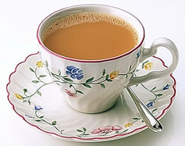
It is believed that credit for the custom of the Afternoon Tea goes to Anna, the 7th Duchess of Bedford in the early 19th century. The usual habit of serving dinner as late as 9pm left the Duchess hungry in the late afternoon. To stave off the hunger she would order tea, bread and butter and cakes to be served in her room. This was thought to be an excellent idea and the habit caught on and the afternoon tea was born. Following on from this custom came the 'At Home' essentially an extension of the afternoon tea which involved into inviting relatives and friends round for tea and sometimes entertainment - though more often just simple conversation and idle gossip. On every day at least one was held somewhere. The hostess remained home all day to receive guests, serve tea, cakes, sandwiches and other niceties and protocol demanded on receiving an 'At Home' notice that unless regrets were sent, invitees must attend. .
Afternoon Tea Today

The tradition of 'At Home' has long died out, but the serving of Afternoon Tea continues. Many leading hotels serve Afternoon Tea from about 3pm until 5pm as well as cafes and tea shops. One well-known tea room, Bettys in Yorkshire, has a global reputation for serving the quintessential meal.

So….. we’ll expect to see you on the 4th May
(see Coming in May)

Behind the scenes with the Secretary Bird
The preparation for hosting a concert of some 90 musicians and an anticipated audience of 150 or so can be a little daunting. The staging needs to go up, the layout of the chairs will have to be changed - with all 200 of the new chairs put in place as well as some of the old ones stored in the gallery. All this has to happen between the end of the Sunday service and 2pm, when the orchestra is scheduled to rehearse the whole programme. By 5pm everyone will take a break and stay in church for a “picnic” tea and then prepare for the real thing starting at 7pm. Interval drinks and snacks need to be prepared (well first things first the crisps and biscuits etc. need to be bought) and at the appropriate time on the night “served”, with separate refreshments put in place for the musicians – lots to do! That is just about every cup and saucer we own… and afterwards they all need washing, the kitchen cleaned and sanitized, the staging packed away and the chairs cleared. The floors swept …. the toilets cleaned and the list goes on!
So you have to ask yourself, is it worth all the trouble? Well the answer is YES, of course it is.
For our next major event in May (see advert), the set-up is even more complex, with banners, false partitions and special lighting to be put in place (mainly whilst the church is open to the public). Rehearsals (with professional models) will all start at 8am in preparation for two public viewing during the day of a very special show “Making Headway” with a private viewing in the evening for some 150 VIP guests attending a drinks reception. Everything to be stripped and moved out by around 10pm that evening and the church returned to normal before Sunday service the following day.
Event management can be hard graft (with many weeks of planning in certain circumstances) but extremely rewarding when it all comes together on the day!

We are delighted to be able to welcome the Stockport Youth Orchestra to St Mary’s, and to host part of the Stockport Creative Festival. Plans are also in hand to welcome the Dovedale Singers back to St Mary’s and for the Ladybrook Singers to pay us a visit. We are to host the Archdeacons Visitation this year and at least two Civic Services with various other special events around WW1, in particular around August and September. We are bringing into St Mary’s an exhibition of work from the Penny Lane Photographic Club and already have a busy Christmas schedule in the planning stages. Special ringing days are in the planning stages too – including a full peal of the bells of St Mary’s later in the year.
We are therefore well on track with our aim to bring the community into St Mary’s and take St Mary’s into the community. Possibly one of the best moves made, as the nights lengthened and the weather turned cold, was to open our doors on most Sunday evenings (there have been a couple of exceptions when we have had events running) to the Loaves and Fishes Street Kitchen.
Pure Innovations have proved idea partners with us in running the Nave Café, and we have now started discussions with them to look at expanding the service(s) offered and their involvement with us.
Exciting times…

SMHeap
Christ’s Bell
THE BELL
I KNOW WHO I AM
I am God’s child (John 1:12)
I am Christ’s friend (John 15:15)
I am united with the Lord (1 Cor: 6:17)
I am bought with a price (1 Cor: 19-20)
I am a saint (set apart for God). (Eph. 1.1)
I am a personal witness of Christ . (Acts 1:8)
I am the salt and light of the earth (Matt 5:13-14)
I am a member of the body of Christ (1 Cor: 12-27)
I am free forever from condemnation (Rom. 8: 1-2)
I am a citizen of Heaven. I am significant (Phil 3:20)
I am free from any charge against me (Rom. 8:n31-34)
I am a minister of reconciliation for God (2 Cor 5: 17-21)
I have access to God through the Holy Spirit (Eph. 2: 18)
I am seated with Christ in the heavenly realms (Eph. 2: 6)
I cannot be separated from the love of God (Rom 8: 35-39)
I am established, anointed, sealed by God (2 Cor 1: 21-22)
I am assured all things work together for good (Rom 8: 28)
I have been chosen and appointed to bear fruit (john 15:16)
I may approach God with freedom and confidence (Eph 3: 12)
I can do all things through Christ who strengthens me (Phil 4 : 13)
I am the branch of the true vine, a channel of His life (John 15: 1-5)
I am God’s temple (1 Cor 3: 16). I am complete in Christ (Col 2: 10)
I am hidden with Christ in God (Col 3:3). I have been justified (Romans 5.1)
I am God’s co-worker (1 Cor 3:9; 2 Cor 6:1). I am God’s workmanship (Eph 2:10)
I am confident that the good works of God has begun in me will be perfected (Phil
I have been redeemed and forgiven(Col 1:14).I have been adopted as God’s child (Eph 1:4)
I belong to God
Do you know
Who you are?

Revd. Bernard Elsdon

Crossword

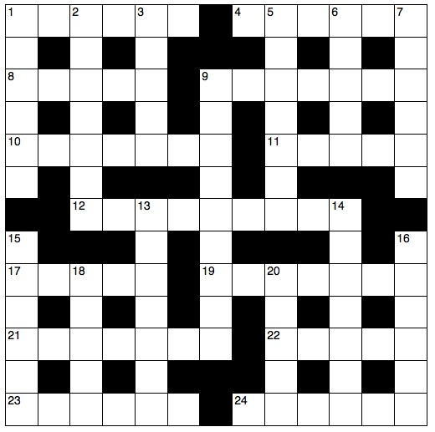

Across
1 Relating to the whole universe (6)
4 The disciple who made the remark in 8 Across (John 20:24) (6)
8 ‘Unless I see the nail marks — — hands, I will not believe it’ (John 20:25) (2,3)
9 He urged King Jehoiakim not to burn the scroll containing Jeremiah’s message (Jeremiah 36:25) (7)
10 Baptist minister and controversial founder of America’s Moral Majority, Jerry — (7)
11 ‘Look, here is — . Why shouldn’t I be baptized?’ (Acts 8:36) (5)
12 Repossessed (Genesis 14:16) (9)
17 Port from which Paul sailed on his last journey to Rome
(Acts 27:3–4) (5)
19 ‘Moses was not aware that his face was — because he had spoken with the Lord’ (Exodus 34:29) (7)
21 Roonwit, C.S. Lewis’s half-man, half-horse (7)
22 Grill (Luke 24:42) (5)
23 ‘The lot fell to Matthias; so he was added to the — apostles’ (Acts 1:26) (6)
24 ‘I was sick and you looked after me, I was in — and you came to visit me’ (Matthew 25:36) (6)
Down
1 Coastal rockfaces (Psalm 141:6) (6)
2 Academic (1 Corinthians 1:20) (7)
3 Publish (Daniel 6:26) (5)
5 For example, the Crusades (4,3)
6 11 Across is certainly this (5)
7 He reps (anag.) (6)
9 Liberator (Psalm 18:2) (9)
13 Man who asked the question in 11 Across was in charge of all her treasury (Acts 8:27) (7)
14 They must be ‘worthy of respect, sincere, not indulging in much wine’ (1 Timothy 3:8) (7)
15 The human mind or soul (6)
16 ‘O Lord, while precious children starve, the tools of war increase; their bread is — ’ (Graham Kendrick) (6)
18 ‘We played the flute for you, and you did not — ’
(Matthew 11:17) (5)
20 Bared (anag.) (5)

Coming soon…

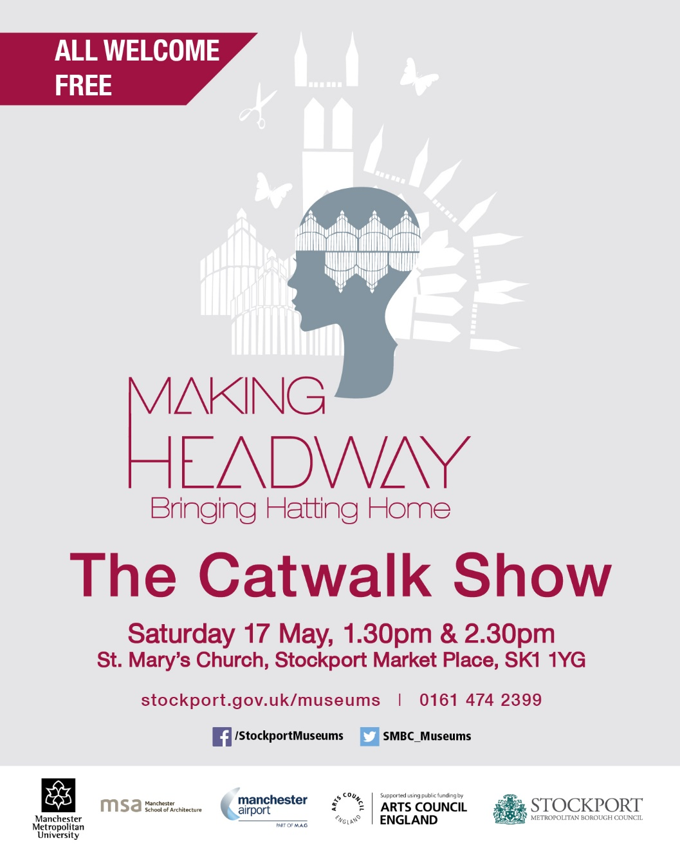

20th Anniversary of the Ordination of Women in the Church of England.

This year marks the 20th Anniversary of the first Ordination of Women to the Priesthood in the Church of England.

To mark the occasion there will be number of celebratory events:

- Nationally – there will be a special service at St Paul’s Cathedral on Saturday, 3rd May

- Locally (details to be announced) it is anticipated that the anniversary will be marked in some form or another on Sunday, 4th May, following the national service of celebration in St Pauls Cathedral the previous day.
- Provincially – there will be a special Service of Celebration on Saturday, 17 May at York Minster

- Within the Diocese, a special garden party is to be held at Bishop’s House for women clergy in the Diocese – now standing at around 130 – on the 7th June.

====================================================
On 12 March 1994, the first 32 women were ordained as Church of England priests at a service officiated by Bishop Barry Rogerson at Bristol Cathedral. The women were ordained in alphabetical order, Angela Berners-Wilson was therefore considered to the very first woman to be ordained.

Tuesday, 8th April
Christian Aid Super Soup Lunch (2) at the Nave Café
12.00 noon to 2.00pm

Also on Tuesday, 8th April Deanery Confirmation
St Saviours Parish Church Great Moor 7.30 pm
Bishop of Chester
Saturday, 12th April 11.00am
Bishop of Stockport Farewell Service – St George’s Stockport
Sunday, 13th April 12.15pm
Meeting of Parishioners & Annual Parochial Church Meeting
Are you interested in standing for election as a member of the Parochial Church Council (we have nine elected vacancies to fill) or acting as a Sides-person then let us know before the meeting.

It is election year for Deanery Synod representations, we are therefore entitled to elect two Deanery Synod representatives for Stockport St Mary. Nominations to date are Adam Pinder and Frank Hamett, however if you feel that you could represent us, and wish to stand for election, again just let us know before the meeting.

Coming in May….

Roger’s “Daffodil” Afternoon Tea
Sunday, 4th May
St Mary’s Rectory 4.00pm

Stockport Creative Festival
Saturday, 17th May
in and around the Market Hall and including a fashion event in St Mary’s [see advert]]

Social Evening at the Nave Café

Saturday, 24th May 7.00pm [details to be announced]

================================================================

Tuesday, 27th May – Archdeacon’s Visitation
for Chadkirk, Mottram & Stockport

Please note that Church Wardens and Sides-persons MUST attend
St Mary’s in the Marketplace 7.30pm

