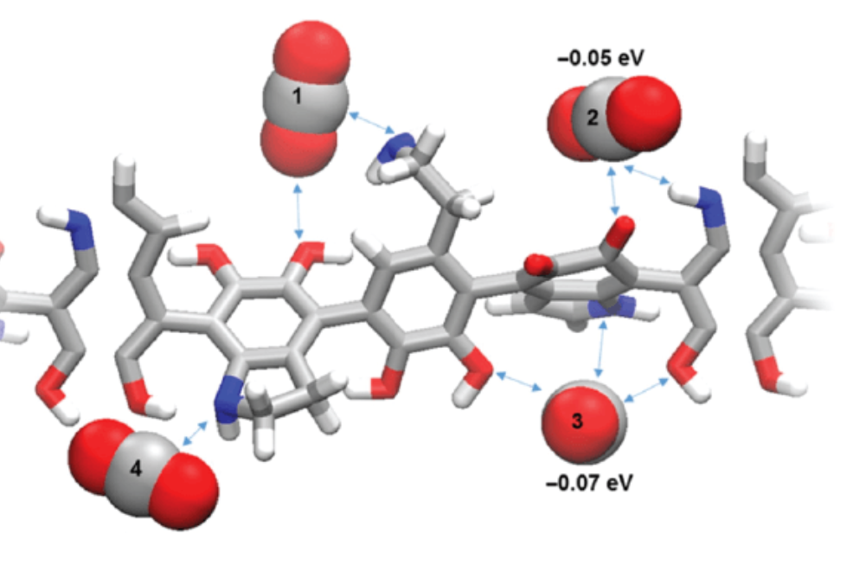
Combustion Fuel Catalyst technology and
How they help optimize combustion
Most fuels are comprised of hydrocarbons and compounds that contain carbon and hydrogen atoms. Ideally oxygen converts all hydrogen to H2O while the carbon is transformed into CO2.
Achieving a perfect combustion process is almost impossible. Fuels like diesel and gasoline burn when they react with the oxygen in the air. The combustion process doesn’t react normally and ends up as an incomplete combustion. A partial combustion process produces harmful by-products like partially burned hydrocarbons (Vox) and Nitrogen Oxides (NOx). A reduced fuel economy also occurs because not all the fuel is effectively processed to produce the horsepower (BTU’s). The internal combustion works under the principle of putting an amount of high energy fuels, such as gasoline & diesel, in a small enclosed space and igniting to produce energy. This energy creates motion that propels the engines of a vehicle.
Fuel Combustion catalysts help to minimize incomplete combustion. Fuel combustion catalysts work by lowering the activation energy or the initial energy required to create chemical reactions. In the case of diesel or gasoline the activation energy comes in the form of oxygen. The combustion process within the engine can be improved by the application of fuel combustion catalyst. Additional means in which the technology can be applied to control combustion reactions is to optimize the fuel preparation by splitting long molecules into shorter ones. This is achieved with fuel oxidation to release heat energy. You also can destroy pollutant gases in the exhaust by utilizing a fuel combustion catalyst.
The fuel additives that utilize a combustion fuel catalyst instead of an octane or cetane booster can work in many ways by targeting the core problems which occur with partial combustion. They can help lower oxygen requirements of the fuel to finally undergo the chemical reactions in the combustion process. Because of the lower air requirements a more perfect burn happens and more energy is produced. By using a combustion fuel catalyst in the fuel additive in lieu of an octane booster or cetane booster, you have the ability to use the same fuel additive for both gasoline and diesel. Additionally, the combustion fuel catalyst aids in better burning of fuel and un-burned fuel due to lower temperatures.
Another benefit of this type of technology is it produces reduced emissions in to the environment. Noxious emissions are the result of partial combustion, so the combustion fuel catalyst helps promote the combustion of carbon particles and condensed tar. With this reduction of emissions and soot you achieve better air quality and cleaner running engines along with increased fuel economy. This technology also aids in the overall performance of the vehicle itself. Because of the increased combustion achieved, the general efficiency of the engine also improves and the corrosion and sludge build up is also reduced. These additional advantages improve heat transfer, reduce overall maintenance, costs and extend the life of the engines.
In conclusion, a combustion fuel catalyst helps lower air excess, provides combustion at a lower temperature than an octane or cetane booster and lower the NOx emissions. An excellent product that also includes a “Burn Rate Modifier” and the very effective combustion fuel catalyst is XFO by Strategic Solutions Integrated. For more information email john.neunan@ssi-inc.org or call 443-416-7500. www.ssi-inc.org.org

