Whole Numbers Unplugged
Junior Mathematics
Study of Whole Numbers
(Integers, Coordinates, Algebra and Functions)
(Grades 6, 7, & 8 )

LEARNING LOG

Name: ___________________________

Middle School Whole Numbers Learning Log

Copyright: Barbara J. Smith

First Edition, March 2018
3600 Yonge St.
Toronto, Ontario, Canada M4N3R8

Author: Barbara J. Smith

For other access and permission to use this resource and revise/customize it, please contact:
zpdschoolandcurriculumdesign@gmail.com

This document edition will be used as a pilot resource to support innovative schools. The intent of sharing this first version with students, staff and families from different schools globally, is so we can gather further input for future revisions of this living curriculum.

All we ask that if you use these materials that you give credit to and the author(s) of this initial work, in your introduction.

PURPOSE of LEARNING LOG RESOURCE:

- To support the Florida State Mathematics Standards
- To support independent and paired study during station work
or during home study (holiday or at-home interest/extended
homework activities)
- To add support as an enrichment or remedial resource
(students can work at their own pace)
- To provide a learning log (evidence of learning) built in to
student resources

The 3 Year MATH Challenge!

Guide (Expert) 270 + points
Pathfinder (Apprentice) 240 - 269 points
Rookie (Novice) < than 240 points

Challenge | Maximum Points
Integers and Coordinate Quiz | 50
Algebra Quiz | 50
Functions Quiz | 50
Math Project  - Year 1: (Coordinates) Ideal – Mote Marine  - Year 2:  - Year 3: | 100
Math Habits and Practices | 40
Classroom Work (Learning Log entries) | 10
TOTAL | 300

TABLE OF CONTENTS

PAGE | Essential Understandings to Master | Got it! | Florida Department of Education Standards

Review
 | - Greatest Common Factor |  | MAFS.6.NS.2.4:  MAFS.6.NS.2.2
 | - Long Division
 | Math Project

Integers and Coordinates (Number Systems)
 | - Positive and Negative Coordinates |  | MAFS.6.NS.3.6
 |  |  | MAFS.6.NS.3.8
 | - Additive Inverse
 | - Real Life Problems

Algebra (Expressions and Equations) Operations: From Addition to Multiplication
 | - Expressions and Exponents |  | MAFS.6.EE.1.1; MAFS.8.EE.1.3
 | - Order of Operations |  | MAFS.6.EE.1.2
 | - Equivalent Expressions |  | MAFS.6.EE.1.3; MAFS.6.EE.1.4
 | - Inequalities |  | MAFS.6.EE.2.5
 | - Variables |  | MAFS.6.EE.2.6
 | - Linear Equation Pairs |  | MAFS.8.EE.3.8
 | - Real Life Problems |  | MAFS.6.EE.2.6
Functions
 | - Input and Outputs |  | MAFS.8.F.1.1
 | - Comparing Functions |  | MAFS.8.F.1.2
 | - Linear and Non-linear Functions |  | MAFS.8.F.1.3
 | - Rate of Change |  | MAFS.8.F.2.4
 | - Functional Relationships in Graphs |  | MAFS.8.F.2.5
 | - Slope |  | MAFS.8.EE.2.6
 | Appendix

MATHEMATICIANS DO…

(Habits and Practices)
A Rookie or novice mathematician – needs the example to complete the math task.
An expert or ‘Guide’ mathematician – does not need the example to complete the math task. S/he can explain how to do it to others

MATHEMATICIANS SAY…
The expert mathematician explains to self and others using math words how to complete the task. The use “math detective language”

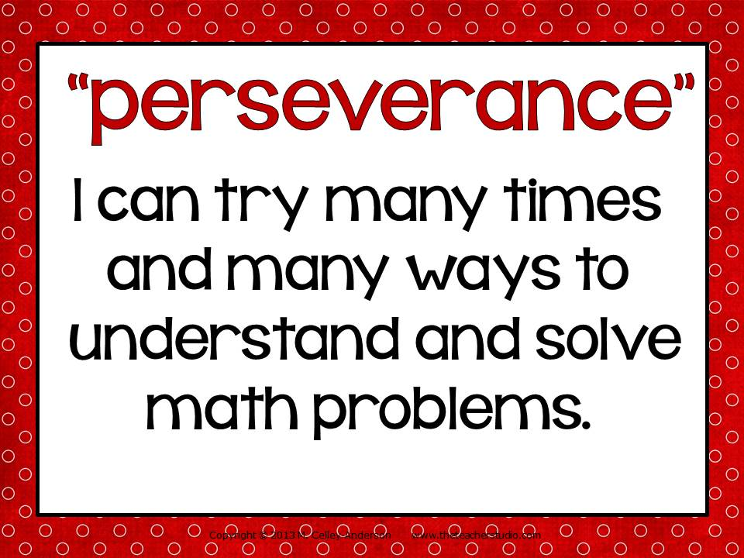
http://1.bp.blogspot.com/-N5fM3XYBmpY/UttGN44O51I/AAAAAAAAItc/Oi7EKOD0qgQ/s1600/Slide4.JPG

Contract (Commit to Becoming a Mathematician)
- I will not give up learning the rules of math. ______
- I will re-read and check over my work. _____
- I will teach what I learn to someone else. _____

- http://www.business.techniquest.org/itemimages/1e5482f9e076709b5dac38506b32f786.jpg

- Review – Factoring and Division

Screen Test:

Maybe you already know this? Show your teacher what you know!

Question | ROUGH WORK
7) Factor 48.

8) Find the Greatest Common Factor (GCF) for 32 and 48

- Write the number you circled in words:

How well did I complete these tasks? | Like a Guide (expert) | Like a Pathfinder  (apprentice) | Like a rookie (need more help & practice)

Essential Skill (ES) Target - MAFS.6.NS.2.4 (Review)
Find the greatest common factor of two whole numbers less than or equal to 100 and the least common multiple of two whole numbers less than or equal to 12. Use the distributive property to express a sum of two whole numbers 1–100 with a common factor as a multiple of a sum of two whole numbers with no common factor.

- Greatest Common Factor

RULE: You factor numbers to get down to the prime numbers (the numbers that can only be divided evenly by 1 or itself). You can find the GCF (Greatest Common Factor) when you compare the factors of two numbers. Note: composite numbers can be divided evenly by numbers other than 1 and itself!

For example, express 36 + 8 as 4 (9 + 2).
EXAMPLE:
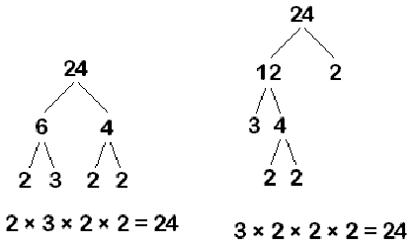  http://www.mathscitutor.com/articles_imgs/867/prime-12.gif | 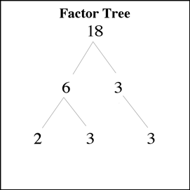  http://mrweis.files.wordpress.com/2008/09/factortree.gif
- Find the GCF (Greatest Common Factor) of 36 and 54.
The factors of 36 are 1, 2, 3, 4, 6, 9, 12, 18, and 36.
The factors of 54 are 1, 2, 3, 6, 9, 18, 27, and 54.
The common factors of 36 and 54 are 1, 2, 3, 6, 9, 18
Although the numbers in bold are all common factors of both 36 and 54, 18 is the greatest common factor. http://www.helpwithfractions.com/greatest-common-factor.html

TRY IT OUT:
- Find the factors of the following pairs and figure out their GCF.

1) 21 | 35 | ROUGH WORK
Therefore, the greatest common factor is: ______.

2) 48 | 72 | ROUGH WORK
Therefore, the greatest common factor is: ______.

3) 93, 39 |  | ROUGH WORK
Therefore, the greatest common factor is: ______.

TECH TIME:
- http://www.mathgoodies.com/factors/factor_tree.asp
- http://www.aaamath.com/g72b-grt-com-fac.html#section2
- http://www1.teachertube.com/viewVideo.php?video_id=9793
- http://www.schooltube.com/video/7d1a4d1a539e42c9aff8/Greatest-Common-Factor-GCF-2

STEP OUTSIDE:
- In pairs, take your whiteboards outside and count your steps to the end of the road. This will be your first number.
- Then count your steps back, but stop ½ way.
- Use these two numbers to figure out the greatest common factors of both numbers.
- Place your work on the next page:

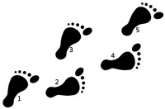

_______ ______ |  | ROUGH WORK
Therefore, the greatest common factor is: ______.

- Share your findings with the class.

TECH TIME:
- http://www.softschools.com/quizzes/math/place_value_and_expanded_notation/quiz677.html
- http://www.youtube.com/watch?v=e-pSz9p0Mvo&feature=fvwrel

How well did you use find the Greatest Common Factor (GCF)? | Guide (Expert) | Pathfinder  (Apprentice) | Rookie  (Not Yet)

6. Fab 4 Multiples (6,7,8 & 9)

RULE: To find the Fab 4 multiples, multiply each digit by 1, 2,3,4,5,6,7,8,9,10,11,12 to get the first 12 multiples. Knowing the pattern of multiples helps you memorize your speedy multiplication tables.

- Sing along with the following videos:
  - https://www.youtube.com/watch?time_continue=178&v=9os1VUUp5io (5 x 6)
  - https://www.youtube.com/watch?v=9XzfQUXqiYY ( 3 times)
  - https://www.youtube.com/watch?v=VEnQbnxWtqM (7)
  - https://www.youtube.com/watch?v=0X620IeUkYE (8)
  - https://www.youtube.com/watch?v=q_zUEV5uK8Q (9) gentle song

EXAMPLES:

7, 14, 21, 28, 35, 42, 49, 56, 63, 70, 77, 84… (multiples of 7)

9, 18, 27, 36, 45, 54, 63, 72, 81, 90, 99, 108… (multiples of 9)

TRY IT OUT:

1) List the multiples of 6 up to 72.

___ ___ ___ ___ ___ ___ ___ ___ ___ ___ ___ ___

2) List the multiples of 8 up to 96.

___ ___ ___ ___ ___ ___ ____ ___ ___ ___ ___ ___

3) List multiples of 11 to 121.

___ ___ ___ ___ ___ ___ ___ ___ ___ ___ ___
4) Complete this chart .

MULTIPLES CHART *Fill in the rest…. CHUNK (Do 6,7,8 and 9)
 | X1 | X2 | X3 | X4 | X5 | X6 | X7 | X8 | X9 | X10
1 | 1 | 2 | 3 | 4 | 5 | 6 | 7 | 8 | 9 | 10
2 | 2 | 4 | 6 | 8 | 10 | 12 | 14 | 16 | 18 | 20
3 | 3 | 6 | 9 | 12 | 15 | 18 | 21 | 24 | 27 | 30
4 | 4 | 8 | 12 | 16 | 20 | 24 | 28 | 32 | 36 | 40
5 | 5 | 10 | 15 | 20 | 25 | 30 | 35 | 40 | 45 | 50
6
7
8
9
10 | 10 | 20 | 30 | 40 | 50 | 60 | 70 | 80 | 90 | 100

TECH TIME:
- https://www.youtube.com/watch?v=VhpUt0vXI4w
- http://espanol.video.yahoo.com/watch/1380772/4752513
- http://www.helpingwithmath.com/by_subject/factors_multiples/fac_multiples.htm
- http://www.ezschool.com/Games/MultiMultiples.html
- http://www.math-play.com/Factors-and-Multiples-Jeopardy/Factors-and-Multiples-Jeopardy.html

Home Challenge – “Pillow Talk” – Do multiples of 6 to 60, 7 to 70, 8 to 80, and 9 to 90 in your head before you go to sleep. Count multiples instead of sheep!
Multiples (Lists of Product) | 60 sec | 30 sec

6, 12, 18, 24, 30, 36, 42, 48, 54, 60

7, 14, 21, 28, 35, 42, 49, 56, 63, 70

8, 16, 24, 32, 40, 48, 56, 64, 72, 80

9, 18, 27, 36, 45, 54, 63, 72, 81, 90

*Sign the Multiples Quilt (poster on wall):
Sign if you can say the “6” multiples in under a minute! | Sign if you can say the “7” multiples in under a minute!
Sign if you can say the “8” multiples in under a minute! | Sign if you can say the “9” multiples in under a minute!

STEP OUTSIDE: Skipping Multiples
Using skipping ropes, jump and say out loud multiples of 6,7,8 and 9.

How well did I complete these tasks? | Like a Guide (expert) | Like a Pathfinder  (apprentice) | Like a rookie (need more help & practice)

Extension:
- Create a quilt for 11, 12, 13, 14 and see which ones you can do in under a minute!
- Calculate exponents and correctly use the order of operations.

ES Target – Factor & find least common multiples for simple numbers (1-100)

2.Common Multiples

Rule: To find common multiples between two numbers you compare multiples for each number and list which ones are common. To find the LOWEST COMMON MULTIPLE (LCM), you list the lowest number that both groups have in common!

EXAMPLE:
- Find the Lowest or least common multiple for 3 and 9.

SHOW THE WORK.

3 – 3,6,9,12,15, 18, 21, 24, 27, 30…
9 – 9, 18, 27….

Common Multiples = 9, 18, 27
Lowest Common Multiple = 9

TRY IT OUT:
- Find the common multiples and the LCM for 2 and 7.
2- _____________________________________________________(end at 40)
7- ___________________________________(end at 42)

2) Find the lowest common multiple for 4 and 6.
4 - __________________________________________
6- ______________________________________________

3) Find the LCM for 5 and 8.

TECH TIME:
- http://www.factmonster.com/ipka/A0933352.html
- http://www.mathsteacher.com.au/year7/ch03_prime/02_comm/comm.htm
- http://www.mathsisfun.com/least-common-multiple.html

How well did you factor & find common multiples for simple numbers (1-100)? | Guide (Expert) | Pathfinder  (Apprentice) | Rookie  (Not Yet)

ES Target - MAFS.6.NS.2.2 - Fluently divide multi-digit numbers using the standard algorithm (Review)

2. Dividing the Giant Numbers

- Divide by Single Digit Numbers

RULE: Put the number being divided (the “dividend” under the bracket; put the number doing the dividing “the divisor” on the left of the bracket. Leave room for the quotient (the answer) to go above the bracket!

EXAMPLES:
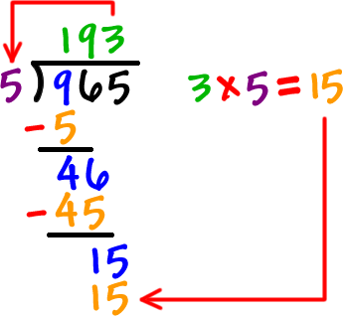  http://www.coolmath4kids.com/long-division/images/long-division-31.gif | 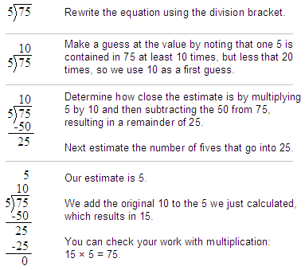  http://cnx.org/content/m26903/latest/graphics1.png

TRY IT OUT:
Question | Rough Work

1) 252/6

2) 104/8

3) 414/9

TECH TIME:
- http://www.youtube.com/watch?v=yUp8biwdvA4&feature=relmfu
- http://www.quia.com/mathjourney.cgi
- http://www.numbernut.com/basic/activities/div_quiz_2x1rem.shtml
- http://www.glencoe.com/sec/math/studytools/cgi-bin/msgQuiz.php4?isbn=0-02-105733-8&chapter=8&lesson=2&&headerFile=0

How well did I complete these tasks? | Like a Guide (expert) | Like a Pathfinder  (apprentice) | Like a rookie (need more help & practice)

PEER TEACH

It is time to replay the rules with a partner.
1. Take turns.
- Use examples to explain the rules.
- Get some scrap paper.
- Replay it using the examples above.
- Replay it without looking!

b) Dividing by 2 or More Digit Numbers

Rule: Multiply to guess the first number to place in quotient. Then subtract what you multiply from dividend. REPEAT until you get to O remainder. In whole numbers – there are no remainders. If you get one, you need to go back and check for careless errors.

EXAMPLE:
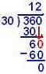  http://www.tutornext.com/system/files/u27/fig4.JPG | 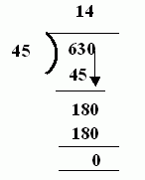  http://www.kwiznet.com/px/homes/i/math/G5/di45.gif

TRY IT OUT:
(a) 1,034/47 | ROUGH WORK
(b) 9,828/78

(c) 24,986/62

TECH TIME:
- http://www.quia.com/mathjourney.cgi
- http://www.eduplace.com/kids/hmcam/practice/templates/rules.jsp?ID=hmcam_ep/gr5/15&GRADE=5&UNIT=6&CHAPTER=15&UNIT_TITLE=Operations%20with%20Decimals&CHAPTER_TITLE=Divide%20by%202-Digit%20Divisors
http://www.kwiznet.com/p/takeQuiz.php?ChapterID=2357&CurriculumID=5&Num=3.9

STEP OUTSIDE: Dirt Division
- Experiment with dividing numbers outside.
- Keep track of which numbers wind up giving you no remainders, and which ones have remainders.
- Talk about patterns and ways to predict how certain numbers may leave no remainders and others do.

How well did you multiply and divide with two digit numbers without remainders (distributive property)? | Guide (Expert) | Pathfinder  (Apprentice) | Rookie  (Not Yet)

QUIZ TIME – Can you complete without looking at examples?

- Circle the place value of 7 in each number:

- Create a number; ? ___________

- Circle ???r from the following list:

852,903 698, 441 819, 278 698,456

- Write the number you circled in words:

- What is a digit? A digit is___________________________.

Questions I can now answer…
What is the greatest common factor?
What operations are involved in division?
How well did I complete these tasks? | Like a Guide (expert) | Like a Pathfinder  (apprentice) | Like a rookie (need more help & practice)

- The Math Project

Year 1 –
I. Linear Growth:
Suppose that the town has a fixed increase in population growth number of population increase each year.
Choose the amount of population growth each year = 200
(Hint: Choose a whole number for your growth rate, rather than a percent.)
a) Fill in the following chart:
Year (t) Population (P)
t = 0
(2010) 1000
t = 1
(2011) 1000+200=1200
t = 2
(2012) 1000+400=1400
t = 3
(2013) 1000+600=1600
t = 6
(2016) 1000+1200=2200
b) Find a linear equation in the form P = mt + b (y = mx + b), which gives the population, P, t years from 2010.
Answer:P=200t+1000
Show your work here: Using the slope intercept form, with slope=growth rate =200, intercept= initial population=1000
c) Use your equation in part b to approximate the population in the year 2025.
Answer:
Show your work here:
d) Use your equation in part b to approximate how many years it will take the population to reach 7000.
Answer:
Show your work here:
e) Graph this function in MS Excel by plotting the points found in your chart in part a. Label your axes with time on the x-axis and population on the y-axis. Copy and paste your graph here:
Believe it or not, you have done the hard part.
Because you have the variables (letters from equation) defined, you just need to plug in the numbers for each:
Year ( t in years from 2010) Population (P)
Formula: P=200t+1000
Part C: Use your equation in part b to approximate the population in the year 2025.
What are you looking to find? (time or population)
So how many years have past? 2025-2010 = ?
Where does this number fit (time or population) in order to find what you are looking for?
Part D:Use your equation in part b to approximate how many years it will take the population to reach 7000.
What variable are you given (time or population)?
Which variable are you trying to find (time or population)?
Part E:Graph this function in MS Excel by plotting the points found in your chart in part a. Label your axes with time on the x-axis and population on the y-axis. Copy and paste your graph here:
Use time on the horizontal axis (x-axis) and population on the vertical axis (y-axis).
Your chart should look like this;
t / P=200t+1000 / P
0
1
2
3
t will be the x values and P will be the y values.
Adapted from http://mathcentral.uregina.ca/QQ/database/QQ.09.09/h/s1.html

- Example: If Jorge's house is at (5, 8) and his friend Lexi's house is at (5,1), and each square on the grid represents one block. How many blocks would Jorge have to ride his bike to get to Lexi's house? Answer: 7 blocks
  - ASK: Where is the origin of this coordinate grid? Answer: (0,0)
  - How do I graph the point where Jorge's house is located? Answer: begin at the origin, go 5 to the right and then 8 up
  - Lexi's house? Answer: Start at the origin, go 5 blocks to the right and 1 up
  - What is the distance between Lexi's house and Jorge's house? 7 blocks (If needed have students count the boxes to determine answer)
ASK: What other method could we use tho find the distance? (ex. subtract the two numbers)
  - Pass out blank coordinate grids. (blankgraphpaper.pdf) or (Twocoordinategrids.pdf) If you use the pre-made coordinate grids students will not need to do the next 3 bullets.
  - Fold paper in half short way (hamburger)
  - Make 2 coordinate grids, one on the top and one on the bottom.
  - To make a coordinate grid you will draw a vertical axis (y-axis) and a horizontal axis (x-axis) that cross in the middle (the origin)
  - Have the students try another example. (-7,6) (-1,6)
  - After determining the correct distance (6 units), give students 2 min. to determine any similarities or differences between the two problems.
  - Have students discuss thoughts with shoulder partner, 30 seconds.
  - Ask for volunteers. Sample answers: both times the points were in the same quadrants, the first coordinates were the same in the first problem, and the second coordinates were the same in the second problem.
ASK: How would our method of solving change if the points were in different quadrants?
Example: Krissy is at school which is located at (5,3). She has to walk home which is at (5,-1). How many blocks will she have to walk?
  - Graph both points, count the blocks
  - Does our subtraction method still work?
  - How do we find the absolute value of a number? What are the absolute values of 3 and -1?
  - What is another method we could use that involves using absolute values?
  - Sample answer) absolute values are 3 and 1, if we add these two numbers we get the right distance
  - Have students try a problem with their shoulder partner.
  - Tell them they must write the steps they would take in words after they solve it numerically.
Example: Molly is at the bank located at (-3, -4). She must drive to the grocery store next which is at (8, -4). Using two different methods, determine how many blocks she will have to drive?
  - Answers: (counting 11 boxes or subtraction 8 -(-3) = 11 or absolute value of 8 is 8 and absolute value of -3 is 3; 8 + 3 = 11)

Guided Practice: What activities or exercises will the students complete with teacher guidance?

Have partners make a second coordinate grid on the bottom of the graph paper. On it they must make an imaginary town and label the different buildings with the correct coordinate points. Provide the buildings they must include and the coordinate point where that building should be located.
  - Town Hall (2 , 5)
  - Fire Station (-4, 5)
  - Library (-4, -7)
  - Ice Cream Shop (3, -5)
  - Central Park (0, 0)
  - Grocery Store (2, -8)
  - Police Station (0, 6)
  - Gas Station (-4, -5)
Have students answer the following questions with their shoulder partner: They must solve each problem in two different ways. (These questions should increase in difficulty and require higher level reasoning.)
  - What is the distance from the Fire Station to the Library? (12 blocks)
  - How far would the Mayor have to walk to get to the grocery store? (Students must determine that the Mayor would start at the Town Hall) (13 blocks)
  - Compare a walk from Central Park to the Police Station and a walk from the Gas Station to the Ice Cream Shop? (The gas station is one block farther. 7 blocks to 6 blocks)
  - Using what you have learned can you determine how far Perry would have to ride his bike if he is starting at Central Park and going to the Ice Cream Shop and can only travel North, South, East, or West. (8 blocks)

Independent Practice: What activities or exercises will students complete to reinforce the concepts and skills developed in the lesson?
  - Students will now create their own imaginary town on a coordinate grid. (This is a completely new town. Not the one created with a partner in the Guided Practice)
  - Pass out the premade coordinate grid (coordinategridforindependentpractice.pdf)
  - Remind the students that they have the example of the town done in the formative assessment, and the example they just created with their partner in the Guided Practice assignment and you can show them (samplestudentwork.pdf)
  - After they create a new town, they must find the distance between two of the buildings using two different methods.
  - They must also create a distance word problem based on their imaginary town.
- Patty Sisson
- District/Organization of Contributor(s): Manatee
Laser cutting: http://www.cpalms.org/Public/PreviewResourcePerspectivesVideo/Preview/120692 (coordinates)

Year 2

Daily Learning Log and Math Detective Habits:

___ stayed on task (worked well with partner and independently)

___ used math detective language to teach ideas

___ work is neat and easy to read

___ completed work by following instructions

___ work shows precision

B. Integers and Coordinates

Screen Test:
Maybe you already know all this? Show your teacher what you know!

- Complete the ern:

- Find

ES Target - MAFS.6.NS.3.6 - Understand a rational number as a point on the number line. Extend number line diagrams and coordinate axes familiar from previous grades to represent points on the line and in the plane with negative number coordinates.

3. Positive and Negative Coordinates

- Recognize opposite signs of numbers as indicating locations on opposite sides of 0 on the number line; recognize that the opposite of the opposite of a number is the number itself, e.g., –(–3) = 3, and that 0 is its own opposite.
- Understand signs of numbers in ordered pairs as indicating locations in quadrants of the coordinate plane; recognize that when two ordered pairs differ only by signs, the locations of the points are related by reflections across one or both axes.
- Find and position integers and other rational numbers on a horizontal or vertical number line diagram; find and position pairs of integers and other rational numbers on a coordinate plane.
ES- Target - MAFS.8.EE.1.3 -
- Use numbers expressed in the form of a single digit times an integer power of 10 to estimate very large or very small quantities, and to express how many times as much one is than the other. For example, estimate the population of the United States as 3 × and the population of the world as 7 × , and determine that the world population is more than 20 times larger.

Rule: How do we solve math problems?
- Read the question first to find out what you are trying to find
- Re-read the problem and underline key words and numbers.
- Record the words or number in a list, a chart or a diagram.
- Focus on one solution at a time (Use your powers of elimination.)
- Separate rough work in a column on the left side of your working paper (use a ruler!)
- Use a table to find out what other numbers appear to be part of the pattern.

Kim owns a business that rents out tables and chairs for parties. For big events, she sets up tables end to end in long rows. Every individual table seats 2 people on each side. Two more people can sit on the ends of the rows. Kim would like to know how many chairs to get out of storage to set around rows of these tables. Make a picture and a chart to figure out how many people can sit around four tables.

ROUGH WORK

Did you underline what you were trying to find out? Yes, No
Did you circle key words and numbers in the problem? Yes, No?
Did you try to do this in your head? Yes? No?

How well did I complete these tasks? | Like a Guide (expert) | Like a Pathfinder  (apprentice) | Like a rookie (need more help & practice)

KROS Data, 2012
 | Date |  | Degrees, minutes format
Waypoint Number | day | month | Latitude and Longitude
1 | 19 | 9 | 32° 45.453´ N 117° 15.522´ W
2 | 20 | 9 | 32° 16.728´ N 117° 28.192´ W
3 | 21 | 9 | 31° 40.204´ N 117° 28.170´ W
4 | 22 | 9 | 30° 12.604´ N 117° 45.250´ W
5 | 23 | 9 | 29° 44.894´ N 117° 35.589´ W
6 | 24 | 9 | 29° 18.481´ N 117° 26.132´ W
7 | 25 | 9 | 28° 55.084´ N 117° 19.522´ W
8 | 26 | 9 | 28° 43.263´ N 117° 22.878´ W
9 | 27 | 9 | 28° 17.483´ N 117° 34.166´ W
10 | 28 | 9 | 27° 59.726´ N 118° 07.722´ W
11 | 29 | 9 | 27° 20.069´ N 119° 04.463´ W
12 | 29 | 9 | 26° 59.422´ N 119° 31.105´ W
13 | 30 | 9 | 26° 38.253´ N 119° 51.443´ W
14 | 30 | 9 | 26° 17.019´ N 120° 11.374´ W
15 | 1 | 10 | 25° 53.511´ N 120° 36.185´ W
16 | 1 | 10 | 25° 33.984´ N 121° 00.082´ W
17 | 2 | 10 | 25° 09.499´ N 121° 37.096´ W
18 | 3 | 10 | 24° 32.105´ N 122° 43.904´ W
19 | 4 | 10 | 24° 18.791´ N 123° 46.035´ W
20 | 5 | 10 | 24° 21.383´ N 124° 39.417´ W
21 | 5 | 10 | 24° 20.282´ N 125° 21.011´ W
22 | 6 | 10 | 24° 14.317´ N 126° 21.921´ W
23 | 7 | 10 | 24° 18.325´ N 127° 26.899´ W
24 | 8 | 10 | 24° 08.626´ N 128° 28.623´ W
25 | 9 | 10 | 24° 06.386´ N 129° 28.313´ W
26 | 9 | 10 | 24° 07.226´ N 129° 54.549´ W
27 | 10 | 10 | 24° 04.893´ N 130° 33.088´ W
28 | 11 | 10 | 23° 29.521´ N 131° 13.153´ W
29 | 12 | 10 | 22° 52.292´ N 132° 02.573´ W
30 | 13 | 10 | 22° 06.840´ N 133° 02.060´ W
31 | 14 | 10 | 22° 03.049´ N 134° 30.324´ W
32 | 15 | 10 | 22° 04.897´ N 136° 00.622´ W
33 | 16 | 10 | 22° 03.807´ N 137° 37.529´ W
34 | 17 | 10 | 22° 07.314´ N 138° 55.117´ W
35 | 19 | 10 | 22° 06.745´ N 140° 12.907´ W
36 | 20 | 10 | 22° 10.250´ N 142° 52.657´ W
37 | 21 | 10 | 22° 06.082´ N 144° 34.039´ W
38 | 22 | 10 | 22° 04.092´ N 146° 01.490´ W
39 | 23 | 10 | 21° 53.849´ N 147° 31.382´ W
40 | 24 | 10 | 21° 51.286´ N 148° 56.087´ W
41 | 25 | 10 | 21° 51.191´ N 150° 13.572´ W
42 | 26 | 10 | 21° 48.912´ N 151° 34.108´ W
43 | 27 | 10 | 21° 42.073´ N 152° 40.307´ W
44 | 28 | 10 | 21° 37.890´ N 153° 57.792´ W
45 | 29 | 10 | 21° 26.854´ N 154° 56.771´ W
46 | 30 | 10 | 21° 29.900´ N 155° 30.734´ W
47 | 31 | 10 | 21° 27.425´ N 156° 31.746´ W
48 | 1 | 11 | 21° 19.425´ N 157° 56´ W

Calories – in - http://www.cpalms.org/Public/PreviewResourcePerspectivesVideo/LivePreview/120737 - Kros Kayak - Kayak around Amelia Island?

Wave crests - http://www.cpalms.org/Public/PreviewResourcePerspectivesVideo/LivePreview/120773
Battery voltage
Electrons – temperature – fan spin

Explore how a capacitor works in this simulation. Change the plates and add a dielectric to see how it affects capacitance. Change the voltage and see charges built up on the plates. You can observe the electric field in the capacitor, measure voltage and the electric field.
Other investigations can include:
- Determine the relationship between charge and voltage for a capacitor.
- Determine the energy stored in a capacitor or a set of capacitors in a circuit.
- Explore the effect of space and dielectric materials inserted between the conductors of the capacitor in a circuit.
- Determine the equivalent capacitance of a set of capacitors in series and in parallel in a circuit.

STEP OUTSIDE:
- Make a pattern using natural materials.

TECH TIME:
- https://www.youtube.com/watch?v=d2Vq6wwJTDc
- https://www.youtube.com/watch?v=0TXxwNCRgKU
- http://www.ck12.org/book/CK-12-Algebra-I-Second-Edition/section/1.8/#sthash.iSx8NkYK.dpuf

STRATEGIES:

Create visual images. “Mind pictures” of a problem

Guesstimate. Trial-and-error approach for beginning data

Create a table. A table is an orderly arrangement of data.

Use manipulatives. By moving objects around on a table or desk, you can develop patterns

Work backward. Do calculations to arrive at the data presented at the beginning of the problem.

Look for a pattern. Looking for patterns to see if data falls into predictable patterns.

Create a systematic list. Record ideas in lists to determine patterns or similarities between problem elements.

Simplifying. When a problem is too complex to solve in one step, it often helps to divide it into simpler problems and solve each one separately. Creating a simpler problem from a more complex one may involve rewording the problem; using smaller, simpler numbers; or using a more familiar scenario to understand the problem and find the solution.

Extension:
- Create an algebraic problem by letting a “letter” (a cursive lower case letter) represent the number you are trying to find.

QUIZ TIME: Complete without looking at examples.

- Jeremy divides a 160-square-foot garden into plots that are either 10 or 12 square feet each. If there are 14 plots in all, how many plots are there of each size?

- A pattern of squares is put together as shown. How many squares are in the 12th diagram?

3. In Harrisville, local housing laws specify how many people can live in a house or apartment: the maximum number of people allowed is twice the number of bedrooms, plus one. If Jan, Pat, and their four children want to rent a house, how many bedrooms must it have?

ROUGH WORK

4. A new theme park opens in Milford. On opening day, the park has 120 visitors; on each of the next three days, the park has 10 more visitors than the day before; and on each of the three days after that, the park has 20 more visitors than the day before.
- How many visitors does the park have on the seventh day?
- How many total visitors does the park have all week?
ROUGH WORK

Bonus: How can you describe the pattern below?
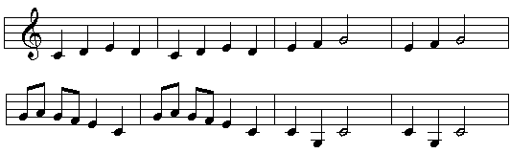
______________________________________________________

______________________________________________________

______________________________________________________

Questions I can now answer…
What is a pattern?
What is a table?
What are strategies I can use to solve pattern problems?

Daily Learning Log and Math Detective Habits:

___ stayed on task (worked well with partner and independently)

___ used math detective language to teach ideas

___ work is neat and easy to read

___ completed work by following instructions

___ work shows precision

How well did I complete these tasks? | Like a Guide (expert) | Like a Pathfinder  (apprentice) | Like a rookie (need more help & practice)

4.

MAFS.6.NS.3.8
Solve real-world and mathematical problems by graphing points in all four quadrants of the coordinate plane. Include use of coordinates and absolute value to find distances between points with the same first coordinate or the same second coordinate.

5.
Essential Progression for MAFS.7.NS.1.1
Apply and extend previous understandings of addition and subtraction to add and subtract whole numbers; represent addition and subtraction on a horizontal or vertical number line diagram.
- Describe situations in which opposite quantities combine to make 0. For example, a hydrogen atom has 0 charge because its two constituents are oppositely charged.
- Understand p + q as the number located a distance |q| from p, in the positive or negative direction depending on whether q is positive or negative. Show that a number and its opposite have a sum of 0 (are additive inverses). Interpret sums of whole numbers by describing real-world contexts.
- Understand subtraction of whole numbers as adding the additive inverse, p – q = p + (–q). Show that the distance between two whole numbers on the number line is the absolute value of their difference, and apply this principle in real-world contexts.
- Apply properties of operations as strategies to add and subtract whole numbers

Essential Progression for MAFS.7.EE.2.3
Solve multi-step real-life and mathematical problems posed with positive and negative whole numbers using tools strategically. Apply properties of operations to calculate with whole numbers; For example: If a woman making $25 an hour gets a 10% raise, she will make an additional 1/10 of her salary an hour, or $2.50, for a new salary of $27.50. If you want to place a towel bar 9 3/4 inches long in the center of a door that is 27 1/2 inches wide, you will need to place the bar about 9 inches from each edge; this estimate can be used as a check on the exact computation. Change to whole number examples.

C. Algebra

Screen Test
Maybe you already know all this? Show your teacher what you know!

Question | Rough Work
 | Show inverse operation to check
 | Show inverse operation to check

9) Solve this problem.
David was asked to put 5 baskets of pencils together with 3 pencils in each (one for each member of the group). How many pencils did he have all together?

How well did I complete these tasks? | Like a Guide (expert) | Like a Pathfinder  (apprentice) | Like a rookie (need more help & practice)

4. Tricky Adding and Subtracting

Algebra

MAFS.6.EE.1.1
Write and evaluate numerical expressions involving whole-number exponents.

RULE: When you add part of a number and the answer is greater than 10, place the last number under the column and any remaining numbers above the column to the left (carry it over). When you subtract numbers where the digit is smaller on top, then you borrow from the left to make the digit larger. This reduces the value of the digit on the left by 1 (borrowing).

EXAMPLES:
1 1  1574  + 6287  7861 | 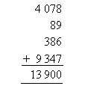

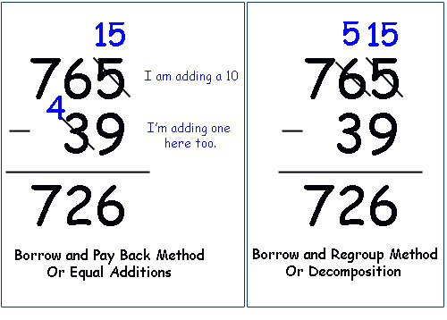
http://www.littlehouseinthevalley.com/wp-content/themes/images/subtraction.jpg

TRY IT OUT: Show your rough work.

Rough Work/Check

TECH TIME:
- http://quizmoz.com/tests/Maths-Tests/a/Adding-and-subtracting-Test.asp

SOLVE IT:
A new movie theater sells 6,783 tickets in the first year, 5,697 tickets in the second year, and in its third year, sells 634 fewer tickets than in its second year. How many tickets are sold in 3 years?
ROUGH WORK

STEP OUTSIDE:

My Problem:

ROUGH WORK

My Classmate’s Problem:

ROUGH WORK

How well did I complete these tasks? | Like a Guide (expert) | Like a Pathfinder  (apprentice) | Like a rookie (need more help & practice)

ES Target - MAFS.6.EE.1.4 - Identify when two expressions are equivalent (i.e., when the two expressions name the same number regardless of which value is substituted into them). For example, the expressions y + y + y and 3y are equivalent because they name the same number regardless of which number y stands for.

Essential Progression for MAFS.7.EE.1.1
Apply properties of operations as strategies to add, subtract, factor, and expand linear expressions using whole numbers.

Linear and exponential growth — Basic example – petrie dish bacteria

Expressions and

Sing along with the following:

https://www.youtube.com/watch?v=9ue9Kux95H0 (4)

Why do I need to know multiples?
Multiples help you learn the pattern of “products” so you can multiply without having to do repeated addition!

RULE: Multiples are lists of products. To find multiples you just need to know how to multiply the number by 1, 2,3,4,5,6,7,8, and 9.

EXAMPLES (View these examples of multiples of 1 and 3):

1, 2, 3, 4, 5, 6, 7…… (multiples of 1)
(1x1), (1x2), (1x3), (1x4), (1x5), (1 x6), (1 x 7)

3, 6, 9, 12, 15, 18, 21, 24, 27, 30.. (multiples of 3)
(3x1),(3x2),(3x3),(3x4),(3x5),(3x6),(3x7),(3x8),(3x9), (3x10)

TRY IT OUT:
1) List the multiples of 2 up to 20.

__ __ __ __ ___ ___ ___ ___ ___ ___

2) List the multiples of 4 up to 40.

__ ___ ___ ___ ____ ____ ____ ____ ____ ___

3) What kind of numbers are multiples of 2?

Odd numbers, Even numbers, Prime Numbers

4) Complete this chart .
MULTIPLES CHART *Fill in the rest…. CHUNK (Do 2 and 4)
 | X1 | X2 | X3 | X4 | X5 | X6 | X7 | X8 | X9 | X10
1 | 1 | 2 | 3 | 4 | 5 | 6 | 7 | 8 | 9 | 10
2
3 | 3 | 6 | 9 | 12 | 15 | 18 | 21 | 24 | 27 | 30
4

TECH TIME: (Prove it by doing a quiz or completing a tech task below!)
- http://www.sheppardsoftware.com/mathgames/multiple/multiple_frenzy.htm
- http://www.homeschoolmath.net/worksheets/examples/multiples-skip-count-3.htm
- http://www.ezschool.com/Games/MultiMultiples.html

How well did you identify multiples of 1 through 5? | Guide (Expert) | Pathfinder  (Apprentice) | Rookie  (Not Yet)

HOME CHALLENGE – “Pillow Talk” – Do multiples of 3 to 30 and 4 to 40 in your head before you go to sleep. Count multiples instead of sheep!

MAFS.8.EE.2.6

Use similar triangles to explain why the slope m is the same between any two distinct points on a non-vertical line in the coordinate plane; derive the equation y = mx for a line through the origin

MAFS.6.EE.1.2
Write, read, and evaluate expressions in which letters stand for numbers.
- Write expressions that record operations with numbers and with letters standing for numbers. For example, express the calculation “Subtract y from 5” as 5 – y.
- Identify parts of an expression using mathematical terms (sum, term, product, factor, quotient, coefficient); view one or more parts of an expression as a single entity. For example, describe the expression 2 (8 + 7) as a product of two factors; view (8 + 7) as both a single entity and a sum of two terms.
- Evaluate expressions at specific values of their variables. Perform arithmetic operations, including those involving whole-number exponents, in the conventional order when there are no parentheses to specify a particular order (Order of Operations).

MAFS.6.EE.1.3
Apply the properties of operations to generate equivalent expressions. For example, apply the
the distributive property to the expression 3 (2 + x) to produce the equivalent expression 6 + 3x; apply the distributive property to the expression 24x + 18y to produce the equivalent expression 6 (4x + 3y); apply properties of operations to y + y + y to produce the equivalent expression 3y.

Distributive Property
- Look at the three posters below and talk about how you can distribute numbers to make them easier to add, multiply, subtract or divide.

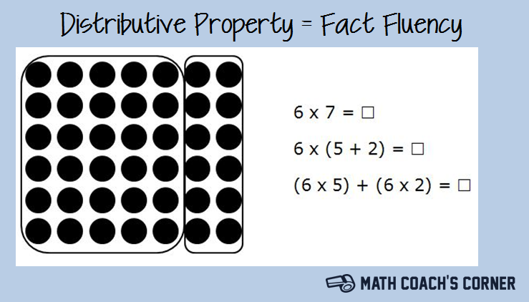

http://www.mathcoachscorner.com/wp-content/uploads/2013/01/Distributive-Property.png

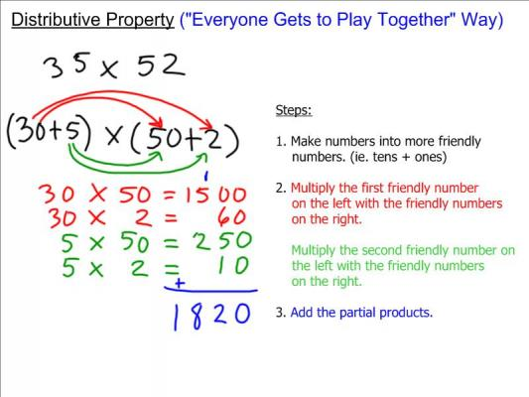

http://weclipart.com/gimg/BE1C0DBED3BEDD93/Distributive%20Property_8.jpeg

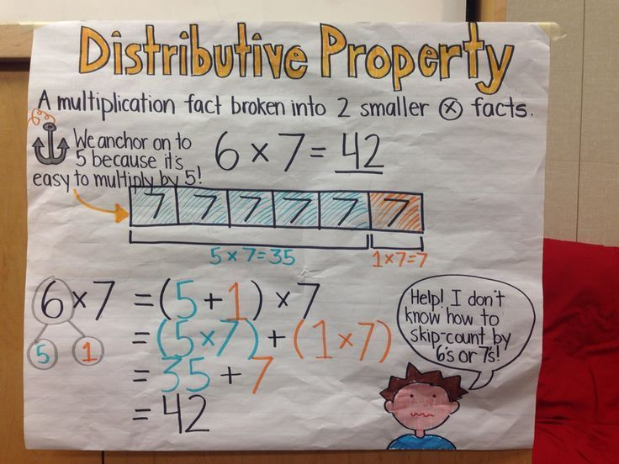

https://s-media-cache-ak0.pinimg.com/736x/63/25/46/6325467e7e1d23f95dff81e6214201cd--math-anchor-charts-math-charts.jpg

6. Fab 4 Multiples (6,7,8 & 9)

RULE: To find the Fab 4 multiples, multiply each digit by 1, 2,3,4,5,6,7,8,9,10,11,12 to get the first 12 multiples. Knowing the pattern of multiples helps you memorize your speedy multiplication tables.

- Sing along with the following videos:

  - https://www.youtube.com/watch?time_continue=178&v=9os1VUUp5io (5 x 6)
  - https://www.youtube.com/watch?v=9XzfQUXqiYY ( 3 times)
  - https://www.youtube.com/watch?v=VEnQbnxWtqM (7)
  - https://www.youtube.com/watch?v=0X620IeUkYE (8)
  - https://www.youtube.com/watch?v=q_zUEV5uK8Q (9) gentle song

EXAMPLES:

7, 14, 21, 28, 35, 42, 49, 56, 63, 70, 77, 84… (multiples of 7)

9, 18, 27, 36, 45, 54, 63, 72, 81, 90, 99, 108… (multiples of 9)

TRY IT OUT:

1) List the multiples of 6 up to 72.

___ ___ ___ ___ ___ ___ ___ ___ ___ ___ ___ ___

2) List the multiples of 8 up to 96.

___ ___ ___ ___ ___ ___ ____ ___ ___ ___ ___ ___

3) List multiples of 11 to 121.

___ ___ ___ ___ ___ ___ ___ ___ ___ ___ ___

4) Complete this chart .

MULTIPLES CHART *Fill in the rest…. CHUNK (Do 6,7,8 and 9)
 | X1 | X2 | X3 | X4 | X5 | X6 | X7 | X8 | X9 | X10
1 | 1 | 2 | 3 | 4 | 5 | 6 | 7 | 8 | 9 | 10
2 | 2 | 4 | 6 | 8 | 10 | 12 | 14 | 16 | 18 | 20
3 | 3 | 6 | 9 | 12 | 15 | 18 | 21 | 24 | 27 | 30
4 | 4 | 8 | 12 | 16 | 20 | 24 | 28 | 32 | 36 | 40
5 | 5 | 10 | 15 | 20 | 25 | 30 | 35 | 40 | 45 | 50
6
7
8
9
10 | 10 | 20 | 30 | 40 | 50 | 60 | 70 | 80 | 90 | 100

TECH TIME:
- https://www.youtube.com/watch?v=VhpUt0vXI4w
- http://espanol.video.yahoo.com/watch/1380772/4752513
- http://www.helpingwithmath.com/by_subject/factors_multiples/fac_multiples.htm
- http://www.ezschool.com/Games/MultiMultiples.html
- http://www.math-play.com/Factors-and-Multiples-Jeopardy/Factors-and-Multiples-Jeopardy.html

Home Challenge – “Pillow Talk” – Do multiples of 6 to 60, 7 to 70, 8 to 80, and 9 to 90 in your head before you go to sleep. Count multiples instead of sheep!

Multiples (Lists of Product) | 60 sec | 30 sec

6, 12, 18, 24, 30, 36, 42, 48, 54, 60

7, 14, 21, 28, 35, 42, 49, 56, 63, 70

8, 16, 24, 32, 40, 48, 56, 64, 72, 80

9, 18, 27, 36, 45, 54, 63, 72, 81, 90

*Sign the Multiples Quilt (poster on wall):
Sign if you can say the “6” multiples in under a minute! | Sign if you can say the “7” multiples in under a minute!
Sign if you can say the “8” multiples in under a minute! | Sign if you can say the “9” multiples in under a minute!

STEP OUTSIDE: Skipping Multiples
Using skipping ropes, jump and say out loud multiples of 6,7,8 and 9.

How well did I complete these tasks? | Like a Guide (expert) | Like a Pathfinder  (apprentice) | Like a rookie (need more help & practice)

Extension:
- Create a quilt for 11, 12, 13, 14 and see which ones you can do in under a minute!

Calculate exponents and correctly use the order of operations.

ES Target – Factor & find least common multiples for simple numbers (1-100)

MAFS.6.EE.1.4
Identify when two expressions are equivalent (i.e., when the two expressions name the same number regardless of which value is substituted into them). For example, the expressions y + y + y and 3y are equivalent because they name the same number regardless of which number y stands for.

7.Common Multiples

Rule: To find common multiples between two numbers you compare multiples for each number and list which ones are common. To find the LOWEST COMMON MULTIPLE (LCM), you list the lowest number that both groups have in common!

EXAMPLE:
- Find the Lowest or least common multiple for 3 and 9.

SHOW THE WORK.

3 – 3,6,9,12,15, 18, 21, 24, 27, 30…
9 – 9, 18, 27….

Common Multiples = 9, 18, 27
Lowest Common Multiple = 9

TRY IT OUT:
- Find the common multiples and the LCM for 2 and 7.

2- _____________________________________________________(end at 40)
7- ___________________________________(end at 42)

2) Find the lowest common multiple for 4 and 6.

4 - __________________________________________
6- ______________________________________________

3) Find the LCM for 5 and 8.

TECH TIME:
- http://www.factmonster.com/ipka/A0933352.html
- http://www.mathsteacher.com.au/year7/ch03_prime/02_comm/comm.htm
- http://www.mathsisfun.com/least-common-multiple.html

How well did you factor & find common multiples for simple numbers (1-100)? | Guide (Expert) | Pathfinder  (Apprentice) | Rookie  (Not Yet)

Essential Progression for MAFS.7.EE.2.4
Use variables to represent quantities in a real-world or mathematical problem, and construct simple equations and inequalities to solve problems by reasoning about the quantities.
- Solve word problems leading to equations of the form px + q = r and p(x + q) = r, where p, q, and r are specific whole numbers. Solve equations of these forms fluently. Compare an algebraic solution to an arithmetic solution, identifying the sequence of the operations used in each approach. For example, the perimeter of a rectangle is 54 cm. Its length is 6 cm. What is its width?
- Solve word problems leading to inequalities of the form px + q > r or px + q < r, where p, q, and r are specific whole numbers. Graph the solution set of the inequality and interpret it in the context of the problem. For example: As a salesperson, you are paid $50 per week plus $3 per sale. This week you want your pay to be at least $100. Write an inequality for the number of sales you need to make, and describe the solutions.

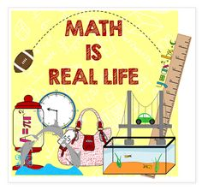
https://s-media-cache-ak0.pinimg.com/236x/fe/27/56/fe275697ca4536056cd24d71ea13453b.jpg

MAFS.6.EE.2.5
Understand solving an equation or inequality as a process of answering a question: which values from a specified set, if any, make the equation or inequality true? Use substitution to determine whether a given number in a specified set makes an equation or inequality true.
and the equation y = mx + b for a line intercepting the vertical axis at b.

ES Target - Multiply & divide within one digit numbers (distributive property)

8. 1 Digit Multiplication

RULE: Memorize these facts. Multiplying saves time! Instead of adding 3 groups of 7 = (7 + 7+ 7) , you know that 7 x 3 = 21.

HERE ARE 12 EASY STEPS for Multiplying and Dividing
- LEARN one MULTIPLE PATTERN at a time!
- Chunk them - Memorize 1,2,3,4 AND 5 MULTIPLES FIRST!
- Try to say them aloud with a partner in under 60 seconds; then try them in under 30 seconds.
- Get the number patterns in your head, “pillow talk” before you go to sleep. Do not count sheep – count multiples!
- THEN Memorize YOUR 6,7,8,9 MULTIPLES.
- Then do Pillow Talk with 6,7,8 and 9 multiples.
- PRACTICE WITH IXL OR OTHER MATH GAMES.
- When multiples are solid, then work on single digit multiplication and single digit division.
- Practice making questions with MULTIPLES and Factors.
- Multiplication saves you time and helps you be ready to do all sorts of mathematics! *For fun sing the multiplier hint songs – or create your own!
- REMEMBER “1” X any number = that number.

12. AND “0” X any number is always 0!!!

- Read the names of the parts of the multiplication equation:

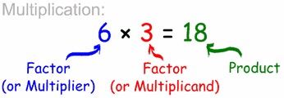

EXAMPLES:
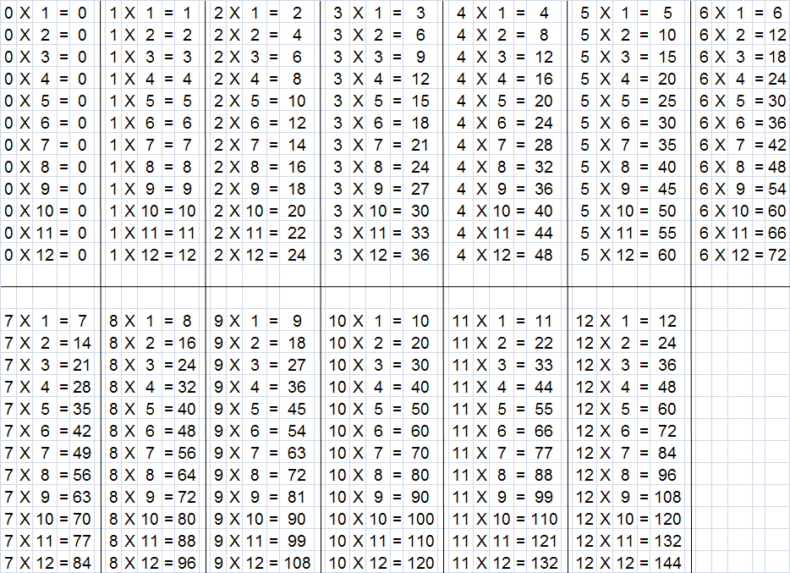http://rightideaproductions.com/wp-content/uploads/2009/05/timestable.png

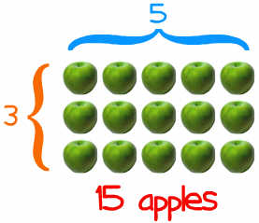

TRY IT OUT:
- How can you draw a diagram to figure out these products?

1) 9 x 6 = ________ | Diagrams
2) 7 x 8 = ________
3) 4 x 4 = ________

TECH TIME:
- http://www.prongo.com/math/multiplication.html
- http://resources.oswego.org/games/SpeedGrid/Multiplication/urikamultires.html
- http://www.wmnet.org.uk/resources/gordon/Hit%20the%20button%20v9.swf
- http://www.factmonster.com/quizzes/multiply/1.html
- http://www.playkidsgames.com/games/Tunnel/multiplyFrame.htm
- http://www.amblesideprimary.com/ambleweb/mentalmaths/tabletrees.html
- ttp://www.multiplication.com/flashgames/GrandPrix.htm
- http://www.kwiznet.com/p/takeQuiz.php?ChapterID=1304&CurriculumID=3&Num=9.5
- http://www.superteacherworksheets.com/multiplication/multiply0-12.pdf
- http://www.superteacherworksheets.com/multiplication/scrambled-facts-basic2.pdf
- http://www.youtube.com/watch?v=MwTvKhyQ0uk
- http://www.google.com/imgres?imgurl=http://www.kwiznet.com/images/questions/grade3/times_table1.gif&imgrefurl=http://www.kwiznet.com/p/takeQuiz.php%3FChapterID%3D200%26CurriculumID%3D3%26Num%3D1.2&h=268&w=370&sz=7&tbnid=FpzCJLcW-zuZlM:&tbnh=88&tbnw=122&prev=/images%3Fq%3D3%2Btimes%2Btable&zoom=1&q=3+times+table&usg=__egr91EkNKYx1EUM6QPBdmgkgzTA=&sa=X&ei=XrZ4TbWQA8XlrAGI5a2QBg&ved=0CCYQ9QEwAw
- http://www.bbc.co.uk/skillswise/numbers/wholenumbers/multiplication/timestables/game.shtml

Sing Along
- http://www.multiplicationhiphopforkids.com/samples-1.htm
- 3’s - https://www.youtube.com/watch?v=dzVyBQ5uTbo
- https://www.youtube.com/watch?v=L6yaevdRgC4

How well did you multiply and divide one digit numbers? (distributive property) | Guide (Expert) | Pathfinder  (Apprentice) | Rookie  (Not Yet)

Home Challenge (Teach it to a parent)

It is time to replay the rules with your parent.
  - Take turns.
  - Use examples to explain the rules.
  - Get some scrap paper.
  - Replay it using the examples above.
  - Replay it without looking!

MAFS.6.EE.2.6
Use variables to represent numbers and write expressions when solving a real-world or mathematical problem; understand that a variable can represent an unknown number, or, depending on the purpose at hand, any number in a specified set

9) Multiplying by 10’s

RULE: Multiply by 10 – just move the numbers one place to the left and add one zero. Multiply by 100 – just move numbers two places to left and add two zeros. Quick Way: count zeros and put them to right of number being multiplied.

EXAMPLES:
 | 36 × 10 | = | 360 |  | Add on one 0.
 | 36 × 100 | = | 3600 |  | Add on two 0's.
 | 36 × 1000 | = | 36,000 |  | Add on three 0's.

TRY IT OUT: (Complete questions below.)
1) 19 x 10 _______ | Rough Work
2) 741 x 100 = ________
3) 4 x 10000 = ________

TECH TIME:
- https://www.khanacademy.org/math/arithmetic/multiplication-division/multi_digit_multiplication/v/multiplying-by-multiples-of-10
- http://www.toonuniversity.com/flash.asp?err=517&engine=13
- http://www.primaryresources.co.uk/maths/pdfs/robot_multiplication.pdf https://www.youtube.com/watch?v=jPO5zAwfRSc
- https://www.youtube.com/watch?v=20aHQOG__8M
- https://www.youtube.com/watch?v=3huvvxUHDmM
- http://www.gscdn.org/library/cms/11/13411.pdf

STEP OUTSIDE: Hopscotch
- Using sticks create your own hopscotch design with at least 5 places to hop to.
- The roll a die to get a number.
- Multiply that number by ten with each jump you take in your hopscotch design.

Example: Mr. Brown rolls a “6”, so when he jumps, he calls out loud:

6, 60, 600, 6000, 60,000 – as he jumps through each spot.

Extension:

Create a hopscotch with 7 or more spaces to hop to!

How well did I complete these tasks? | Like a Guide (expert) | Like a Pathfinder  (apprentice) | Like a rookie (need more help & practice)

Essential Progression for MAFS.6.EE.2.7 (with whole numbers)
Solve real-world and mathematical problems by writing and solving equations of the form x + p = q and px = q for cases in which p, q and x are all non-negative whole numbers.

Essential Progression for MAFS.6.EE.2.8 (with whole numbers)
Write an inequality of the form x > c or x < c to represent a constraint or condition in a real-world or mathematical problem. Recognize that inequalities of the form x > c or x < c have infinitely many solutions; represent solutions of such inequalities on number line diagrams.

10. Multiplying 2 or More Digit Numbers

RULE: Know all 7 steps. You multiply two numbers and then you add them together. Before you multiply the left digit on the bottom, you need to put a zero in the one’s columns.

It is much easier to explain the steps with an example:
http://www.ehow.com/how_6193967_multiply-2-digit-numbers.html

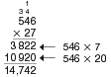
http://www.eduplace.com/math/mw/models/graphics/5_9a.gif

TRY It OUT:
- 32 x 47 | ROUGH WORK

- 25 x 148 | ROUGH WORK

- 457 x 26

TECH TIME:
- http://www.prongo.com/math/multiplication.html
- http://www.quia.com/mathjourney.cgi
- http://www.numbernut.com/basic/activities/mult_quiz_2x1nocarry-v.shtmlhttp://www.myquizzes.ca/viewquiz.asp?quiz_id=8683&quizname=Multiply%202%20digit%20X%202%20digit
- http://www.thatquiz.org/tq/previewtest?XVCX6129

STEP OUTSIDE:
- Create 2 and 3-digit multiplication questions using stones (that you put numbers on).
- Place your multiplication questions here to complete your calculations.

Q: _____________________ | ROUGH WORK

Q: _______________________

How well did I complete these tasks? | Like a Guide (expert) | Like a Pathfinder  (apprentice) | Like a rookie (need more help & practice)

ES Target - Use multiples of 6,7,8 & 9 to find greatest common factor.

Essential Progression for MAFS.8.EE.3.7
Solve linear equations in one variable.
- Give examples of linear equations in one variable with one solution.

- infinitely many solutions, or no solutions. Show which of these possibilities is the case by successively transforming the given equation into simpler forms, until an equivalent equation of the form x = a, a = a, or a = b results (where a and b are different numbers).
- Solve linear equations with whole number coefficients, including equations whose solutions require expanding expressions using the distributive property and collecting like terms

11. Factors

MAFS.8.EE.3.8
Analyze and solve pairs of simultaneous linear equations.
- Understand that solutions to a system of two linear equations in two variables correspond to points of intersection of their graphs, because points of intersection satisfy both equations simultaneously.
- Solve systems of two linear equations in two variables algebraically, and estimate solutions by graphing the equations. Solve simple cases by inspection. For example, 3x + 2y = 5 and 3x + 2y = 6 have no solution because 3x + 2y cannot simultaneously be 5 and 6.
- Solve real-world and mathematical problems leading to two linear equations in two variables. For example, given coordinates for two pairs of points, determine whether the line through the first pair of points intersects the line through the second pair.

Daily Learning Log and Math Detective Habits:

___ stayed on task (worked well with partner and independently)

___ used math detective language to teach ideas

___ work is neat and easy to read

___ completed work by following instructions

___ work shows precision

QUIZ TIME: Complete these questions without looking at the examples.

Question | Rough Work
1) 1364  + 6287 | Show inverse operation to check
2) 6287  - 1364 | Show inverse operation to check
3) List the multiples of 6 (end at 72).

4) List the Least Common Multiples (LCM) of
3 and 4.

5) 7
X 6

6). 11
X 11

7) Factors of 36:

8) Find the Greatest Common Factor (GCF) for 36 and 32.

9). Solve this problem.
David was asked to put 5 baskets of pencils together with 3 each (one for each member of the group). How many pencils did he have all together?

How well did I complete these tasks? | Like a Guide (expert) | Like a Pathfinder  (apprentice) | Like a rookie (need more help & practice)

Functions

Maybe you already know all this? Show your teacher what you know!

Question |  | Rough Work
1) Prove 9 x 7 = 7 x 9

2) Prove (3x2) x 5 = 3 x (2 x 5)

3) Show, using counters, how to find the solution for 27/9

4) Show using a number line how to find 18/3

5) Divide 965 by 5 (show long division) | Rough Work
6) Divide 360 by 12 (show long division)

7) Expand the following number - 501,765

(a) with addition

(b) with addition and multiplication

(c) using powers with addition and multiplication

How well did I complete these tasks? | Like a Guide (expert) | Like a Pathfinder  (apprentice) | Like a rookie (need more help & practice)

- Commutative Property

Functions
MAFS.8.F.1.1
Understand that a function is a rule that assigns to each input exactly one output. The graph of a function is the set of ordered pairs consisting of an input and the corresponding output.

RULE: The commutative property for addition and multiplication is that you can change the order of the numbers being added or multiplied, and the sum or product remains the same.

EXAMPLE:
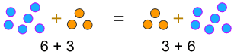
... or when you multiply:
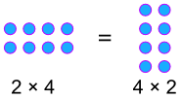

STEP OUTSIDE and TRY IT OUT:
- Create 2 examples for addition and 2 examples for multiplication.
- Use natural materials to show these operations.
Addition | Multiplication

Addition | Multiplication

How well did I complete these tasks? | Like a Guide (expert) | Like a Pathfinder  (apprentice) | Like a rookie (need more help & practice)

MAFS.8.F.1.2
Compare properties of two functions each represented in a different way (algebraically, graphically, numerically in tables, or by verbal descriptions). For example, given a linear function represented by a table of values and a linear function represented by an algebraic expression, determine which function has the greater rate of change.

13. Associative Law

RULE: The associative “law” says that it doesn’t matter how we group the numbers for addition and multiplication, the results will be the same. You can change the order of the numbers being added or multiplied and the sum or product remains the same. (Note: Always do parentheses/brackets first).

It is much easier to explain the steps with an example!

EXAMPLE: 7 + 4 = 11 and 4 + 7 = 11 (addition)
(2 + 5) + 4 = 11 and 2 + (5 + 4) = 11

7 x 4 = 28 and 4 x 7 = 28 (multiplication)
7 x (2 x2) = 28 and (7 x2) x2 = 28

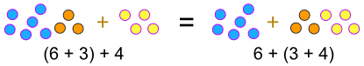

... or when we multiply:
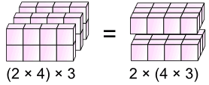

TRY IT OUT:
*Prove these by doing the rough work in the box.

Prove these equations are correct:
(9 + 3) + 4 = 16 and 9 + (3 + 4) = 16

(3 x 2) x 4 = 24 and 3 x (2 x 4) = 24

How well did I complete these tasks? | Like a Guide (expert) | Like a Pathfinder  (apprentice) | Like a rookie (need more help & practice)

Extension:
- Step outside and look for patterns in nature.
- Instead of counting trees, stones, or bushes, how can you create equations to show numbers?
- Example: 36 bushes = 3 rows of 10 + 6 random bushes

= (3 X 10) + 6 = 36 (equation)
- Place your equations here:

MAFS.8.F.1.3
Interpret the equation y = mx + b as defining a linear function, whose graph is a straight line; give examples of functions that are not linear. For example, the function A = s² giving the area of a square as a function of its side length is not linear because its graph contains the points (1,1), (2,4) and (3,9), which are not on a straight line.

14. Division as Inverse Operation

RULE: Division questions are the inverse of multiplication question.

EXAMPLE:

The equation 3 x 7 = 21 has the inverse relationships:
21 ÷ 3 = 7 21 ÷ 7 = 3
Similar relationships exist for division.
The equation 45 ÷ 5 = 9 has the inverse relationships:

5 x 9 = 45 9 x 5 = 45

TRY IT OUT: Figure out the following blanks.

1) If 5 * 7 = 35, then 35 /____ = 7

- If 10 * 4 = 40, then 40 /____ = 4

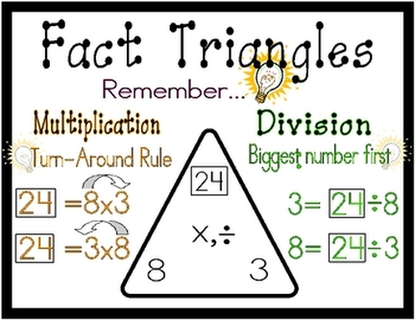
http://missdupont.weebly.com/uploads/2/4/4/2/24421791/3909085.jpg?432

- Make fact triangles using numbers that multiply and divide with 6, 7, 8 and 9.

How well did I complete these tasks? | Like a Guide (expert) | Like a Pathfinder  (apprentice) | Like a rookie (need more help & practice)

Extension:
- Make fact triangles for large numbers that multiply and divide with two digit numbers.

STEP OUTSIDE: Nature Triangles
- Make fact triangles using natural materials.
- Take a picture of your Nature Triangle and post on the math board.

ES Target - Use arrays to solve math problems.

MAFS.8.F.2.4
Construct a function to model a linear relationship between two quantities. Determine the rate of change and initial value of the function from a description of a relationship or from two (x, y) values, including reading these from a table or from a graph. Interpret the rate of change and initial value of a linear function in terms of the situation it models, and in terms of its graph or a table of values.

15. Division with Arrays and Number Lines

RULE: Since division is the inverse, or opposite, of multiplication, you can use arrays to help understand how multiplication and division are related. If in multiplication we find the product of two factors, in division we find the missing factor if the other factor and the product are known. Division “undoes” multiplication and multiplication “undoes” division. So, when multiplying or dividing, you can use a fact from the inverse operation.

EXAMPLES:
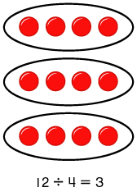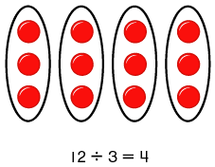
Since you know that 4 x 5 = 20, you also know the related division fact 20 ÷ 4 = 5 or 20 ÷ 5 = 4. You can also check their work by using the inverse operation.
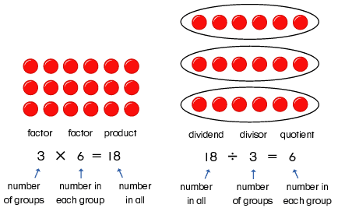
In multiplication the numbers you multiply are called factors; the answer is called the product. In division the number being divided is the dividend, the number that divides it is the divisor, and the answer is the quotient.

Here is an example using a number line.
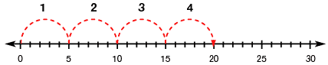
Factor  4 | x | Factor  5 | = | product  20
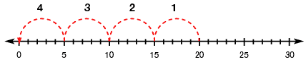
Dividend  20 | ÷ | Divisor  5 | = | quotient  4

TRY IT OUT:
- Create a diagram with counters and a number line to show the following division questions:
18 ÷ 6 = ____ | Show using counters
Number Line

27/9 = ____ | Show using counters
Number Line

How well did you use arrays to solve math problems? | Guide (Expert) | Pathfinder  (Apprentice) | Rookie  (Not Yet)

STEP OUTSIDE:
- Make number lines outside with natural materials.

MAFS.8.F.2.5
Describe qualitatively the functional relationship between two quantities by analyzing a graph (e.g., where the function is increasing or decreasing, linear or nonlinear). Sketch a graph that exhibits the qualitative features of a function that has been described verbally.

16. Divide by Single Digit Numbers

RULE: Put the number being divided (the “dividend” under the bracket; put the number doing the dividing “the divisor” on the left of the bracket. Leave room for the quotient (the answer) to go above the bracket!

EXAMPLES:
http://www.coolmath4kids.com/long-division/images/long-division-31.gif | http://cnx.org/content/m26903/latest/graphics1.png

TRY IT OUT:
Question | Rough Work

1) 252/6

2) 104/8

3) 414/9

TECH TIME:
- http://www.youtube.com/watch?v=yUp8biwdvA4&feature=relmfu
- http://www.quia.com/mathjourney.cgi
- http://www.numbernut.com/basic/activities/div_quiz_2x1rem.shtml
- http://www.glencoe.com/sec/math/studytools/cgi-bin/msgQuiz.php4?isbn=0-02-105733-8&chapter=8&lesson=2&&headerFile=0

How well did I complete these tasks? | Like a Guide (expert) | Like a Pathfinder  (apprentice) | Like a rookie (need more help & practice)

PEER TEACH

It is time to replay the rules with a partner.
1. Take turns.
- Use examples to explain the rules.
- Get some scrap paper.
- Replay it using the examples above.
- Replay it without looking!

ES Target - Multiply and divide two digit numbers without remainders. (distributive property).

MAFS.8.EE.2.6

Use similar triangles to explain why the slope m is the same between any two distinct points on a non-vertical line in the coordinate plane; derive the equation y = mx for a line through the origin

17) Dividing by 2 or More Digit Numbers

Rule: Multiply to guess the first number to place in quotient. Then subtract what you multiply from dividend. REPEAT until you get to O remainder. In whole numbers – there are no remainders. If you get one, you need to go back and check for careless errors.

EXAMPLE:

http://www.tutornext.com/system/files/u27/fig4.JPG | http://www.kwiznet.com/px/homes/i/math/G5/di45.gif

TRY IT OUT:
(a) 1,034/47 | ROUGH WORK

(b) 9,828/78

(c) 24,986/62

TECH TIME:
- http://www.quia.com/mathjourney.cgi

- http://www.eduplace.com/kids/hmcam/practice/templates/rules.jsp?ID=hmcam_ep/gr5/15&GRADE=5&UNIT=6&CHAPTER=15&UNIT_TITLE=Operations%20with%20Decimals&CHAPTER_TITLE=Divide%20by%202-Digit%20Divisors
- http://www.kwiznet.com/p/takeQuiz.php?ChapterID=2357&CurriculumID=5&Num=3.9

Distributive Property
- Look at the three posters below and talk about how you can distribute numbers to make them easier to add, multiply, subtract or divide.

http://www.mathcoachscorner.com/wp-content/uploads/2013/01/Distributive-Property.png

http://weclipart.com/gimg/BE1C0DBED3BEDD93/Distributive%20Property_8.jpeg

https://s-media-cache-ak0.pinimg.com/736x/63/25/46/6325467e7e1d23f95dff81e6214201cd--math-anchor-charts-math-charts.jpg

STEP OUTSIDE: Dirt Division
- Experiment with dividing numbers outside.
- Keep track of which numbers wind up giving you no remainders, and which ones have remainders.
- Talk about patterns and ways to predict how certain numbers may leave no remainders and others do.

How well did you multiply and divide with two digit numbers without remainders (distributive property)? | Guide (Expert) | Pathfinder  (Apprentice) | Rookie  (Not Yet)

Daily Learning Log and Math Detective Habits:

___ stayed on task (worked well with partner and independently)

___ used math detective language to teach ideas

___ work is neat and easy to read

___ completed work by following instructions

___ work shows precision

18. Expanded Form by Adding

Rule: To expand a number just using addition, you must break down a number into place value parts.

EXAMPLE:
Another way of looking at numbers is by seeing what adds up to the number.

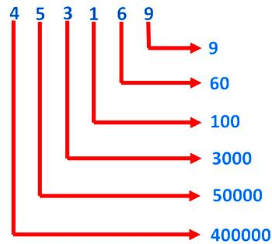
http://www.math-only-math.com/images/find-the-expanded-form.jpg

- Check out how to expand 4,985,346, vertically and horizontally.

4,000,000 +
900,000 +
80,000 +
5,000 +
300 +
40 +
6 +

4,985,346 = 4,000,000 + 900,000 + 80,000 + 5,000 + 300 + 40 + 6

TRY IT OUT:
- Expand the following using addition.

2,985 = ___________________________________

7,628,406 = ________________________________

3,500,650 = ________________________________

TECH TIME:
- http://www.youtube.com/watch?v=4Ll0Rh32PZo&feature=related
- http://www.kwiznet.com/p/takeQuiz.php?ChapterID=800&CurriculumID=5&Num=1.28
- http://www.quia.com/cc/279741.html
- http://www.proprofs.com/quiz-school/story.php?title=expanded-notation-quiz
- http://www.superteacherworksheets.com/place-value/expanded-form-millions.pdf

STEP OUTSIDE:
- Throw a coloured rock as far as you can.
- Count the steps it takes to find it.
- Then expand this number.
- Show work here:

- Find out the address of the school – and then expand this number.
- Show work here:

How well did I complete these tasks? | Like a Guide (expert) | Like a Pathfinder  (apprentice) | Like a rookie (need more help & practice)

19. Expanded Form with Addition and Multiplication

RULE: To expand a number using addition and multiplication, you need to multiply the digit by a factor of 10 and add the number in the 1’s place. Use brackets to keep the multiplied numbers together!

EXAMPLE:
4,985, 346 =
(4 x 1,000,000) +
(9 x 100,000) +
(8 x 10,000) +
(5 x 1,000) +
(3 x 100) +
(4 x 10) +
6
Or 4.985, 346 = (4 x 1,000,000) + (9 x 100,000) + (8 x 10,000) + (5 x 1,000) + (3 x 100) + (4 x 10) + 6

TRY IT OUT:
- Expand the following using addition and multiplication
- 5,079,541 | - 1,772,005 | - 6,800,540

TECH TIME:
- http://www.dadsworksheets.com/v1/Worksheets/Numbers%20in%20Standard,%20Expanded%20and%20Word%20Form/Seven_Digit_Number_With_Gaps_To_Word_Form_V1.html
- http://www.youtube.com/watch?v=whPuseMqs2s&feature=related

How well did I complete these tasks? | Like a Guide (expert) | Like a Pathfinder  (apprentice) | Like a rookie (need more help & practice)

Use expanded form with whole numbers & base 10.

20. Expanded Notation using POWERS

RULE: To expand a number using addition and multiplication of powers, you need to multiple the digit by a power of 10 and add the number in the 1st place value. Use brackets to keep the multiplied numbers together!

EXAMPLE:
4,985, 346 =
(4 x 10⁶)+
(9 x 10⁵)+
(8 x 10⁴)+
(5 x 10³)+
(3 x 10²)+
(4 x 10¹)+
6

4.985, 346 = (4 x 10⁶)+ (9 x 10⁵)+(8 x 10⁴)+(5 x 10³)+(3 x 10²)+(4 x 10¹)+ 6

- Why do you think scientists need to learn about notation?

________________________________________________________________________

___________________________________________________

TRY IT OUT:
- Expand the following using powers:

- 6,800,540
=

- 3,578,644
=

TECH TIME:
- http://www1.teachertube.com/viewVideo.php?title=Power_of_Ten_Expanded_Notations&video_id=49690

How well did you use expanded form with whole numbers & base 10? | Guide (Expert) | Pathfinder  (Apprentice) | Rookie  (Not Yet)

Extension:
- Use scientific notation with whole numbers.

Quiz Time: Complete these questions without looking at the examples.

Question |  | Rough Work
1) Prove 6 x 7 = 7 x 6

2) Prove (3x4) x 5 = 3 x (4 x 5)

3) Show, using counters, how to find the solution for 32/8

4) Show using a number line how to find 28/4

5) Divide 955 by 5 (show long division) | Rough Work
6) Divide 480 by 12 (show long division)

7) Expand the following number - 5210765

(a) with addition

(b) with addition and multiplication

(c) using powers with addition and multiplication

How well did I complete these tasks? | Like a Guide (expert) | Like a Pathfinder  (apprentice) | Like a rookie (need more help & practice)

Checking Your Understanding
Date: ______________

Dear students,

We have completed Whole Numbers Unplugged.

Did I learn from making mistakes? ______

I am proudest about the work we did on page ___ because….

_____________________________________________
We think the trickiest part of this Math was….

_____________________________________________

because______________________________________

I enjoyed working (with others or on my own) because….

___________________________________________
Sincerely,

_________________

https://i.ytimg.com/vi/0uZiqk_ZdcA/hqdefault.jpg

Daily Learning Log and Math Detective Habits:

___ stayed on task (worked well with partner and independently)

___ used math detective language to teach ideas

___ work is neat and easy to read

___ completed work by following instructions

___ work shows precision

Appendix A:

Florida State Mathematics Standards (related to Whole Numbers)

Number Systems Review

MAFS.6.NS.2.2 (Review – Whole Numbers)
Fluently divide multi-digit numbers using the standard algorithm.

MAFS.6.NS.2.4 (Review)
Find the greatest common factor of two whole numbers less than or equal to 100 and the least common multiple of two whole numbers less than or equal to 12. Use the distributive property to express a sum of two whole numbers 1–100 with a common factor as a multiple of a sum of two whole numbers with no common factor. For example, express 36 + 8 as 4 (9 + 2).

Integers and Coordinates
MAFS.6.NS.3.6
Understand a rational number as a point on the number line. Extend number line diagrams and coordinate axes familiar from previous grades to represent points on the line and in the plane with negative number coordinates.
- Recognize opposite signs of numbers as indicating locations on opposite sides of 0 on the number line; recognize that the opposite of the opposite of a number is the number itself, e.g., –(–3) = 3, and that 0 is its own opposite.
- Understand signs of numbers in ordered pairs as indicating locations in quadrants of the coordinate plane; recognize that when two ordered pairs differ only by signs, the locations of the points are related by reflections across one or both axes.
- Find and position integers and other rational numbers on a horizontal or vertical number line diagram; find and position pairs of integers and other rational numbers on a coordinate plane.
MAFS.6.NS.3.8
Solve real-world and mathematical problems by graphing points in all four quadrants of the coordinate plane. Include use of coordinates and absolute value to find distances between points with the same first coordinate or the same second coordinate.

Essential Progression for MAFS.7.NS.1.1
Apply and extend previous understandings of addition and subtraction to add and subtract whole numbers; represent addition and subtraction on a horizontal or vertical number line diagram.
- Describe situations in which opposite quantities combine to make 0. For example, a hydrogen atom has 0 charge because its two constituents are oppositely charged.
- Understand p + q as the number located a distance |q| from p, in the positive or negative direction depending on whether q is positive or negative. Show that a number and its opposite have a sum of 0 (are additive inverses). Interpret sums of whole numbers by describing real-world contexts.
- Understand subtraction of whole numbers as adding the additive inverse, p – q = p + (–q). Show that the distance between two whole numbers on the number line is the absolute value of their difference, and apply this principle in real-world contexts.
- Apply properties of operations as strategies to add and subtract whole numbers

Essential Progression for MAFS.7.EE.2.3
Solve multi-step real-life and mathematical problems posed with positive and negative whole numbers using tools strategically. Apply properties of operations to calculate with whole numbers; For example: If a woman making $25 an hour gets a 10% raise, she will make an additional 1/10 of her salary an hour, or $2.50, for a new salary of $27.50. If you want to place a towel bar 9 3/4 inches long in the center of a door that is 27 1/2 inches wide, you will need to place the bar about 9 inches from each edge; this estimate can be used as a check on the exact computation. Change to whole number examples.

Algebra

MAFS.6.EE.1.1
Write and evaluate numerical expressions involving whole-number exponents.

MAFS.8.EE.1.3
Use numbers expressed in the form of a single digit times an integer power of 10 to estimate very large or very small quantities, and to express how many times as much one is than the other. For example, estimate the population of the United States as 3 × and the population of the world as 7 × , and determine that the world population is more than 20 times larger.

Essential Progression for MAFS.7.EE.1.1
Apply properties of operations as strategies to add, subtract, factor, and expand linear expressions using whole numbers.

MAFS.6.EE.1.2
Write, read, and evaluate expressions in which letters stand for numbers.
- Write expressions that record operations with numbers and with letters standing for numbers. For example, express the calculation “Subtract y from 5” as 5 – y.
- Identify parts of an expression using mathematical terms (sum, term, product, factor, quotient, coefficient); view one or more parts of an expression as a single entity. For example, describe the expression 2 (8 + 7) as a product of two factors; view (8 + 7) as both a single entity and a sum of two terms.
- Evaluate expressions at specific values of their variables. Perform arithmetic operations, including those involving whole-number exponents, in the conventional order when there are no parentheses to specify a particular order (Order of Operations).

MAFS.6.EE.1.3
Apply the properties of operations to generate equivalent expressions. For example, apply the
the distributive property to the expression 3 (2 + x) to produce the equivalent expression 6 + 3x; apply the distributive property to the expression 24x + 18y to produce the equivalent expression 6 (4x + 3y); apply properties of operations to y + y + y to produce the equivalent expression 3y.

MAFS.6.EE.1.4
Identify when two expressions are equivalent (i.e., when the two expressions name the same number regardless of which value is substituted into them). For example, the expressions y + y + y and 3y are equivalent because they name the same number regardless of which number y stands for.

Essential Progression for MAFS.7.EE.2.4
Use variables to represent quantities in a real-world or mathematical problem, and construct simple equations and inequalities to solve problems by reasoning about the quantities.
- Solve word problems leading to equations of the form px + q = r and p(x + q) = r, where p, q, and r are specific whole numbers. Solve equations of these forms fluently. Compare an algebraic solution to an arithmetic solution, identifying the sequence of the operations used in each approach. For example, the perimeter of a rectangle is 54 cm. Its length is 6 cm. What is its width?
- Solve word problems leading to inequalities of the form px + q > r or px + q < r, where p, q, and r are specific whole numbers. Graph the solution set of the inequality and interpret it in the context of the problem. For example: As a salesperson, you are paid $50 per week plus $3 per sale. This week you want your pay to be at least $100. Write an inequality for the number of sales you need to make, and describe the solutions.

MAFS.6.EE.2.5
Understand solving an equation or inequality as a process of answering a question: which values from a specified set, if any, make the equation or inequality true? Use substitution to determine whether a given number in a specified set makes an equation or inequality true.

MAFS.6.EE.2.6
Use variables to represent numbers and write expressions when solving a real-world or mathematical problem; understand that a variable can represent an unknown number, or, depending on the purpose at hand, any number in a specified set

Essential Progression for MAFS.6.EE.2.7 (with whole numbers)
Solve real-world and mathematical problems by writing and solving equations of the form x + p = q and px = q for cases in which p, q and x are all non-negative whole numbers.

Essential Progression for MAFS.6.EE.2.8 (with whole numbers)
Write an inequality of the form x > c or x < c to represent a constraint or condition in a real-world or mathematical problem. Recognize that inequalities of the form x > c or x < c have infinitely many solutions; represent solutions of such inequalities on number line diagrams.

Essential Progression for MAFS.8.EE.3.7
Solve linear equations in one variable.
- Give examples of linear equations in one variable with one solution.

- infinitely many solutions, or no solutions. Show which of these possibilities is the case by successively transforming the given equation into simpler forms, until an equivalent equation of the form x = a, a = a, or a = b results (where a and b are different numbers).
- Solve linear equations with whole number coefficients, including equations whose solutions require expanding expressions using the distributive property and collecting like terms

6A.2. Solve problems involving whole numbers .

6A.3. Demonstrate an understanding of factors and multiples by:
• _determining multiples and factors of numbers less than 100
• _identifying prime and composite numbers
• _solving problems using multiples and factors.

6A.7. Demonstrate an understanding of integers, concretely, pictorially and symbolically

6A.9. Explain and apply the order of operations, excluding exponents, with and without technology (limited to whole numbers).
PATTERNS AND RELATIONS (Patterns)
6B.1. Represent and describe patterns and relationships, using graphs and tables.
6B.2. Demonstrate an understanding of the relationships within tables of values to solve problems.

Appendix C:
Common Core State Standards (Whole numbers Grades 3-5)

Grade 3

3.0A.A1 Interpret products of whole numbers, e.g., interpret 5 × 7 as the total number of objects in 5 groups of 7 objects each.

3.0A.A2 Interpret whole-number quotients of whole numbers, e.g., interpret 56 ÷ 8 as the number of objects in each share when 56 objects are partitioned equally into 8 shares, or as a number of shares when 56 objects are partitioned into equal shares of 8 objects each.
3.0A.A4 Determine the unknown whole number in a multiplication or division equation relating three whole numbers. For example, determine the unknown number that makes the equation true in each of the equations 8 × ? = 48, 5 = _ ÷ 3, 6 × 6 = ?

3.0A.B5 Apply properties of operations as strategies to multiply and divide… (Commutative property of multiplication; Associative property of multiplication; (Distributive property.)

3.0A.B.6 Understand division as an unknown-factor problem. For example, find 32 ÷ 8 by finding the number that makes 32 when multiplied by 8.

3.0A.C.7 Fluently multiply and divide within 100, using strategies such as the relationship between multiplication and division…By the end of Grade 3, know from memory all products of two one-digit numbers.
3.0A.D.9 Identify arithmetic patterns (including patterns in the addition table or multiplication table), and explain them using properties of operations. For example, observe that 4 times a number is always even, and explain why 4 times a number can be decomposed into two equal addends.
3.NBT.A.1 Use place value understanding to round whole numbers to the nearest 10 or 100.
3.NBT.A.2 Fluently add and subtract within 1000 using strategies and algorithms based on place value, properties of operations, and/or the relationship between addition and subtraction.
3.NBT.A.3 Multiply one-digit whole numbers by multiples of 10 in the range 10-90 (e.g., 9 × 80, 5 × 60) using strategies based on place value and properties of operations.

Grade 4

4.NBT.B.5 Multiply a whole number of up to four digits by a one-digit whole number, and multiply two two-digit numbers, using strategies based on place value and the properties of operations. Illustrate and explain the calculation by using equations, rectangular arrays, and/or area models.

4.NBT.B.6 Find whole-number quotients and remainders with up to four-digit dividends and one-digit divisors, using strategies based on place value, the properties of operations, and/or the relationship between multiplication and division

4.NBT.B.4 Fluently add and subtract multi-digit whole numbers using the standard algorithm.

4.NBT.B.5 Multiply a whole number of up to four digits by a one-digit whole number, and multiply two two-digit numbers, using strategies based on place value and the properties of operations

4.0A.A.1 Interpret a multiplication equation as a comparison, e.g., interpret 35 = 5 × 7 as a statement that 35 is 5 times as many as 7 and 7 times as many as 5. Represent verbal statements of multiplicative comparisons as multiplication equations.

4.0A.A.2 Multiply or divide to solve word problems involving multiplicative comparison, e.g., by using drawings and equations with a symbol for the unknown number to represent the problem, distinguishing multiplicative comparison from additive comparison.¹
4.0A.A.3 Solve multistep word problems posed with whole numbers and having whole-number answers using the four operations, including problems in which remainders must be interpreted. Represent these problems using equations with a letter standing for the unknown quantity. Assess the reasonableness of answers using mental computation and estimation strategies including rounding.

4.0A.B.4 Find all factor pairs for a whole number in the range 1-100. Recognize that a whole number is a multiple of each of its factors. Determine whether a given whole number in the range 1-100 is a multiple of a given one-digit number. Determine whether a given whole number in the range 1-100 is prime or composite.

4.NBT.A.1 Recognize that in a multi-digit whole number, a digit in one place represents ten times what it represents in the place to its right. For example, recognize that 700 ÷ 70 = 10 by applying concepts of place value and division.
4.NBT.A.2 Read and write multi-digit whole numbers using base-ten numerals, number names, and expanded form. Compare two multi-digit numbers based on meanings of the digits in each place, using >, =, and < symbols to record the results of comparisons.

4.NBT.B.4 Fluently add and subtract multi-digit whole numbers using the standard algorithm.
4.NBT.B.5 Multiply a whole number of up to four digits by a one-digit whole number, and multiply two two-digit numbers, using strategies based on place value and the properties of operations. Illustrate and explain the calculation by using equations, rectangular arrays, and/or area models.
4.NBT.B.6 Find whole-number quotients and remainders with up to four-digit dividends and one-digit divisors, using strategies based on place value, the properties of operations, and/or the relationship between multiplication and division. Illustrate and explain the calculation by using equations, rectangular arrays, and/or area models.

Grade 5

5.OA.A.2 Write simple expressions that record calculations with numbers, and interpret numerical expressions without evaluating them

5.OA.B.3 Generate two numerical patterns using two given rules. Identify apparent relationships between corresponding terms

5.NBT.A.1 Recognize that in a multi-digit number, a digit in one place represents 10 times as much as it represents in the place to its right and 1/10 of what it represents in the place to its left

MAFS.8.EE.3.8
Analyze and solve pairs of simultaneous linear equations.
- Understand that solutions to a system of two linear equations in two variables correspond to points of intersection of their graphs, because points of intersection satisfy both equations simultaneously.
- Solve systems of two linear equations in two variables algebraically, and estimate solutions by graphing the equations. Solve simple cases by inspection. For example, 3x + 2y = 5 and 3x + 2y = 6 have no solution because 3x + 2y cannot simultaneously be 5 and 6.
- Solve real-world and mathematical problems leading to two linear equations in two variables. For example, given coordinates for two pairs of points, determine whether the line through the first pair of points intersects the line through the second pair.

Functions
MAFS.8.F.1.1
Understand that a function is a rule that assigns to each input exactly one output. The graph of a function is the set of ordered pairs consisting of an input and the corresponding output.

MAFS.8.F.1.2
Compare properties of two functions each represented in a different way (algebraically, graphically, numerically in tables, or by verbal descriptions). For example, given a linear function represented by a table of values and a linear function represented by an algebraic expression, determine which function has the greater rate of change.

MAFS.8.F.1.3
Interpret the equation y = mx + b as defining a linear function, whose graph is a straight line; give examples of functions that are not linear. For example, the function A = s² giving the area of a square as a function of its side length is not linear because its graph contains the points (1,1), (2,4) and (3,9), which are not on a straight line.

MAFS.8.F.2.4
Construct a function to model a linear relationship between two quantities. Determine the rate of change and initial value of the function from a description of a relationship or from two (x, y) values, including reading these from a table or from a graph. Interpret the rate of change and initial value of a linear function in terms of the situation it models, and in terms of its graph or a table of values.

MAFS.8.F.2.5
Describe qualitatively the functional relationship between two quantities by analyzing a graph (e.g., where the function is increasing or decreasing, linear or nonlinear). Sketch a graph that exhibits the qualitative features of a function that has been described verbally.

MAFS.8.EE.2.6
Use similar triangles to explain why the slope m is the same between any two distinct points on a non-vertical line in the coordinate plane; derive the equation y = mx for a line through the origin and the equation y = mx + b for a line intercepting the vertical axis at b.

Extension:
It doesn’t stop with millions – there are billions and trillions and even more numbers out there!

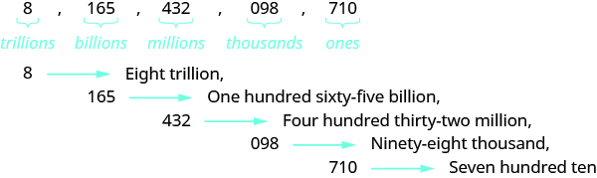
http://cnx.org/resources/30b147ad3d69711bd28cef174ae62cf550104bca/CNX_ElemAlg_Figure_01_01_005_img.jpg

http://www.mathatube.com/sitebuilder/images/place-value-chart-53-609x431.jpg

- Create a giant place value chart that orders numbers and place value and notation form from 0.01 to 1 billion.

