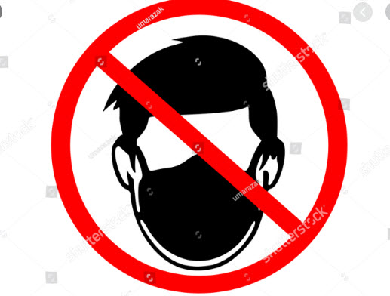
I am exempt from all regulation mandating face mask usage in public. Wearing a face mask poses a health risk to me. My condition makes it unsafe for me to breathe wearing a mask.
HIPAA prohibits individuals or law enforcement from requiring me to disclose my medical condition to anyone without my consent. It is a violation of the Americans with Disabilities Act to require me to wear a face mask against my will. 1st offense violation of the ADA is $75,000. 2nd offense is $150,000. Department of Justice ADA violation line is 800-514-0301.
Attention Law Enforcement
Title II of the ADA applies to law enforcement agencies because law enforcement agencies are deemed to be, 'programs of state or local governments.' The ADA affects the core activities of law enforcement including enforcing laws like distancing. face masks, tracing etc.
Nothing in Title II, its regulations, or its legislative history suggests that any police activities are excluded from Title II coverage under the ADA.
The following court cases have been won by plaintiffs against law enforcement for ADA violations.
- Wrongful arrest
- Failure to train
- Failure to accommodate during arrest

Mandatory quarantine, stay at home, social distancing, contact tracing, vaccination, business closure, face mask usage and the like are clear violations of the constitution. “Life, liberty and the pursuit of happiness.”
Mayberry vs Madison “a law repugnant to the Constitution is void”
The people do not give their consent. Stand down. Treason is being exposed at the highest levels of government. The people of this state are recording names of treasonous law enforcement at the local level for future trials. Pick a side.

