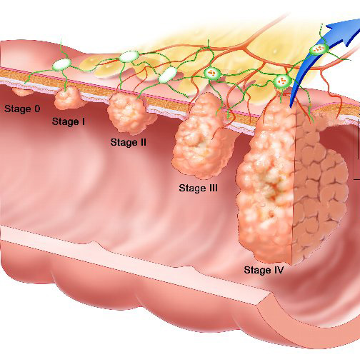
Colon Cancer:

- Surgery is essential
  - The pathology report from the surgery will show what stage it was and whether it was contained.

    - If it was contained there is less risk, and an absolute minimum supplement program should include:
      - Optiflora (part 1 & 2)
      - Herb-Lax (enough to maintain 3 easy, formed stools every day) ... VitalMag may be needed as well to support good bowel elimination
      - Vitalizer
      - Soy Protein
      - NutriFeron
      - Vivix

    - A better program would include:
      - additional Vitamin C (no less than 3,000 mg)
      - additional NutriFeron

    - if the cancer is not contained, a more aggressive cancer protocol is recommended

- In preparation for surgery, and for recovery from surgery,
  - make sure to keep your cells very hydrated by drinking no less than ½ ounce of water for every pound of body weight daily
  - include an electrolyte drink (Shaklee Performance) daily

- Diet should be chosen wisely … lots of raw foods. A juicer is a great investment. It is advised to drink fresh carrot juice every day. Adding other vegetables to the juice is great (celery, red beets, etc.).

