In 1578, woodcutter Thomas Michalek saw a bright light in the forest. It was the Virgin Mary, who asked him to alert the authorities to build a church on the site. Thomas was scared and did nothing.
The Virgin then reappeared and instructed him to take action. Which he did – but he was not believed. In fact, the local curate took him to court. After the curate's death, a small chapel was finally built.
By the way, Lezajsk is also a place of pilgrimage for Jews, who come to visit the tomb of 18th-century rabbi Elimelech, one of the founders of the Hasidic movement.
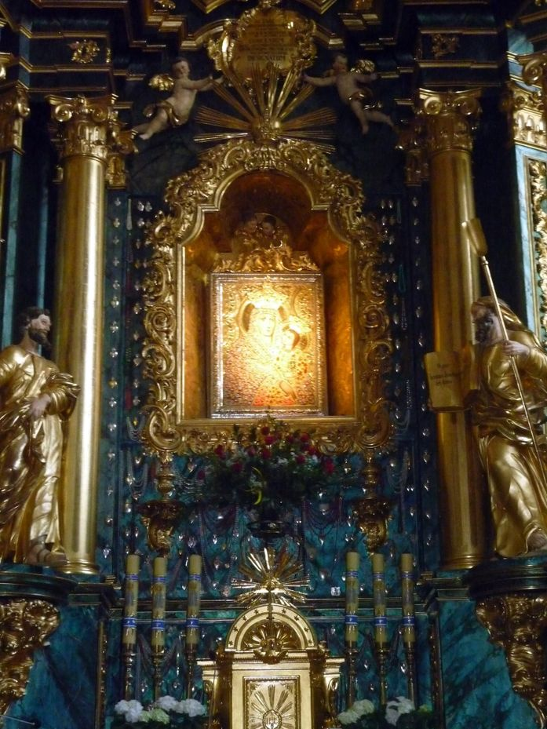

Icon of the Virgin of Lezajsk.
upload.wikimedia.org

