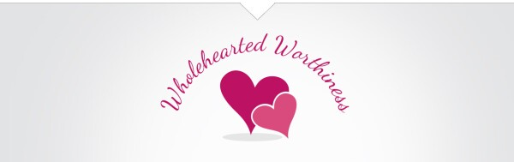
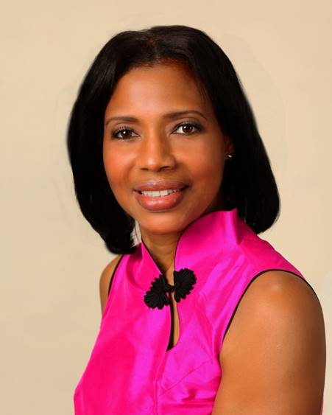
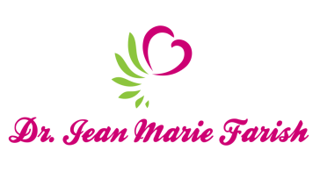

LOVE LIGHT NewsLetter

I am excited to host my VoiceAmerica Empowerment Show-LOVE LIGHT with amazing Guests to cultivate a lifestyle of love and wholehearted connections through worthiness. My show is aligned with my mission to live an altruistic and heart centered life.

MEET LOVE LIGHT GUEST

KAREN GIBSON
Certified Life Coach

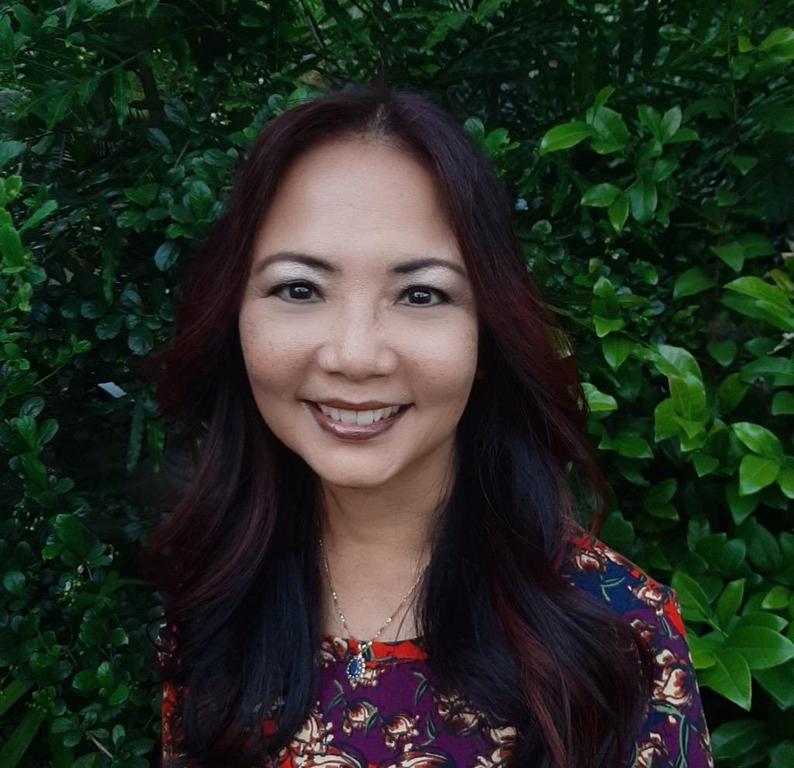

PARENTING WITH PEACE
May 8, 2020

ABOUT KAREN GIBSON

Karen Gibson is a certified life coach, former special education teacher, and owner of Brain Builders, a private tutoring business she started in 1999. She earned her NLP (neuro-linguistic programming) certification which helps clients understand how the language of their mind creates patterns that can be rewired to get rid of negative behavior. Karen is the founder of Letting Go with Aloha which offers an online course, one-one coaching and group coaching for overwhelmed moms and those in parenting roles who want to parent with peace. She offers virtual tutoring sessions during the “stay at home” order due to coronavirus.

Karen was the former marketing director at the Hawaii State Bar Association (1990-1994). Her two decades of experience working with students ages 3 to 61, as well as parents, have provided her with countless opportunities in learning how to parent with peace instead of pain.

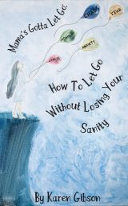

Website:
www.LettingGowithAloha.com

Email:
Karen@LettingGowithaloha.com

“An empowered self is a loving self, and keep your love light shining.”

