Nutrition Plus, Inc.

121 Mays Rd., Winfield, KS. 67156
www.nutritionplusinc.com

Executive Director: Emily Roark (620) 221-2777 roark2@cox.net
Administrative Supervisor: Patti Brenn (620) 218-1811 pattibrenn@cox.net
Topeka Area Coordinator: Susan Morrell
(785) 230-7441 smorrell12@gmail.com
Menu Advisor: Jacque Zimmerman (620) 660-0236 jacque.nutritionplus@gmail.com

December is:

1st – National Eat a Red Apple Day
6th – National Gazpacho Day
9th – National Pastry Day
14th – Monkey Day
15th – Cat Herders Day
19th – National Oatmeal Muffin Day
24th – National Eggnog Day
25th – Christmas Day
30th – Bacon Day!

Important Dates:

5th – Claim Due
31st – Checks and Direct Deposits go out

Vitamin ABC’s

I don’t know why I love this topic so much, but I do. Children love learning, and if new information is introduced in a fun way, they’ll remember better. It isn’t always easy to get them to try foods they aren’t used to or don’t like. If we can reintroduce foods they’ve rejected before, using fun, maybe they’ll give them a try again. If they can learn about the vitamins found in the healthy foods you offer, they’ll be more likely to give them a try.

The best part for me is when they take their newly-discovered knowledge home and teach their parents and siblings. If we teach them why their bodies need these vitamins, maybe it’ll sink in for some of them!
December 2021

A vitamins help me see!
B vitamins give me energy!
C vitamins help me stay healthy!
D vitamins make my bones strong!
E vitamins feed my brain!

A vitamins can be found in eggs, peaches, spinach, squash, carrots & milk.
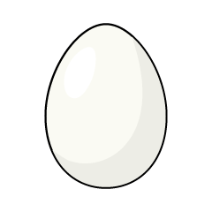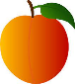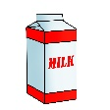

B vitamins can be found in beans, apples, bananas, beef, chicken & cheese.
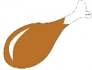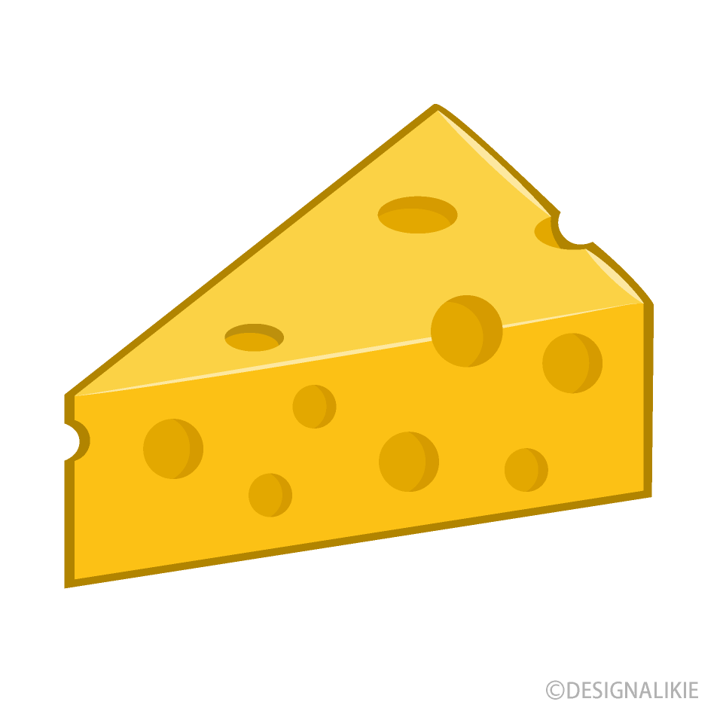

C vitamins can be found in oranges, kiwi, strawberries, tomatoes, peppers & sweet potatoes.
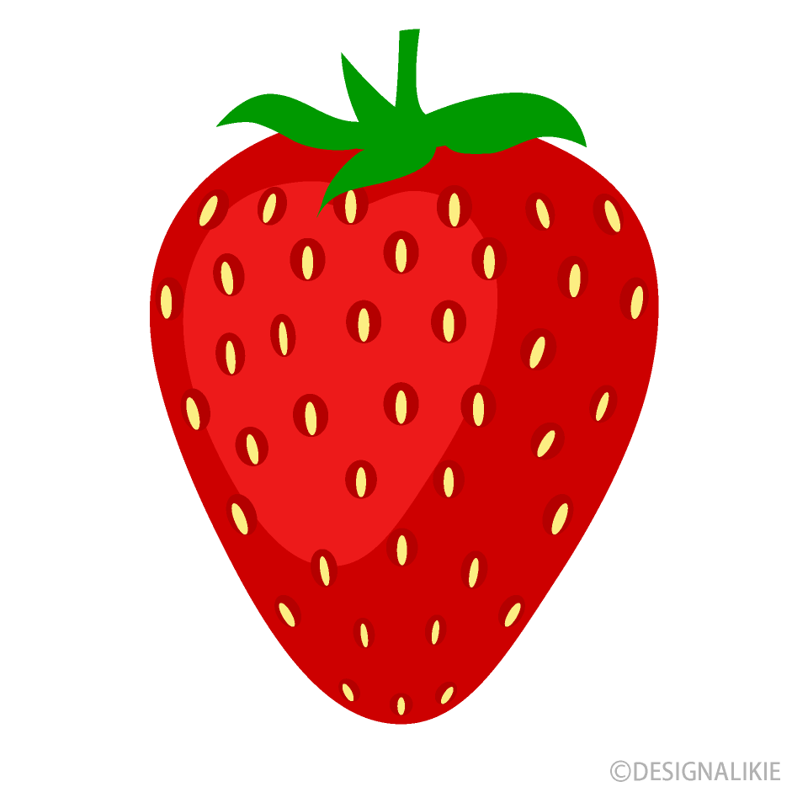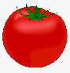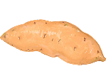

D vitamins can be found in cereal, milk, cheese, tuna & salmon.
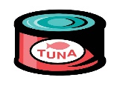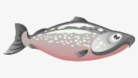

E vitamins can be found in eggs, broccoli, avocados, mangos, butternut squash & nuts.
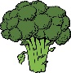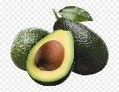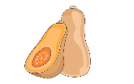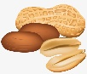

Yarn Tree
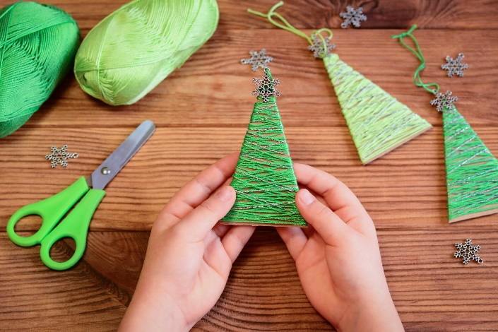

Supplies:
Cardboard
Scissors
Green yarn or craft string
Glue
Ornamental topper (snowflake, button, star…)

This gift will be a keepsake and on our trees for years to come!
Cut a piece of cardboard into a triangle shape.
Wrap green yarn or string around it, starting at the top. ( glue the start of the string and the end. It will surely last longer if it isn’t coming unraveled). Finally, glue the topper just below the point at the top.

Reindeer Food
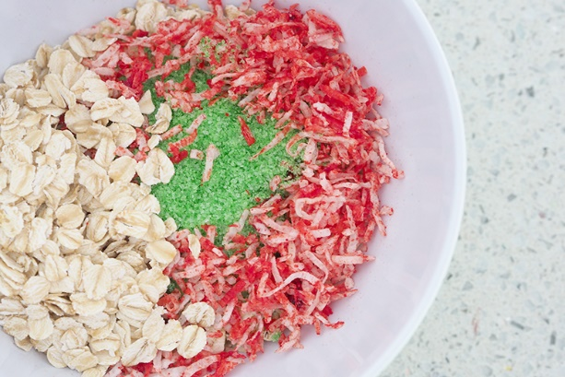

Supplies:

- Oatmeal 3-4 Tablespoons
- Sugar Cookie Sprinkles-all shapes and colors-1-2 tablespoons
- Snack-size zip lock bags

Mix oats and sprinkles together in bag. You can really get creative if you want to attach stickers, ribbons or a handmade card with a reindeer printed on it.
On Christmas Eve, sprinkle food on sidewalk or in a pile in the yard! Rudolph deserves love, too!
Ham and Cheese Puffs
This is a delicious spin on the beloved ham and cheese, but uses melt-in-your-mouth pastry dough!

2 (10 inch) puff pastry sheets
2 tablespoons butter
2 tablespoons all-purpose flour
1 cup whole milk, room temperature
1/4 teaspoon salt
1/4 teaspoon pepper
2 cups cooked ham, diced
2 cups fresh spinach
1 1/2 cup Swiss cheese, grated and divided
1 egg white, lightly beaten

- Pre-heat your oven to 400°F.
- Cut the puff pastry sheets into 8, 5-inch squares. Set aside in the refrigerator.
- Melt butter over medium heat in a saucepan. Add flour and salt; cook for 1 minute, stirring frequently.
- Pour in the warm milk slowly, whisking constantly until smooth and boiling. Reduce heat to low and simmer, stirring occasionally until sauce starts to thicken.
- Add in spinach and cook for 1 minute, just until wilted.
- Add ham and 1 cup of Swiss cheese and stir well. Set aside.
- Arrange the puff pastry squares on a parchment-lined baking sheet.
- Top with a heaping spoonful of ham and cheese mixture, and sprinkle with grated cheese.
- Fold the corners onto the top, forming a smaller square.
- Brush the pastry with the egg wash, making sure to coat all sides.
- Bake for 20 minutes, until puffed and golden.
Serves 8.

As always, thanks for all you do for our children!

