Amelia-Nottoway Technical Center News 5/14/2021
ANTC STUDENT SPOTLIGHT!
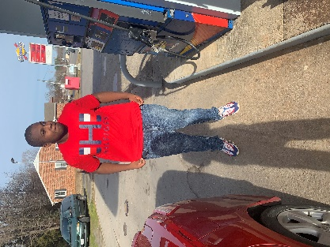
ACHS Senior
Drayvon Harris
Auto Body I
What brought you to ANTC? I like to work on cars.
What is your dream job? Welder
What is your favorite class that you have taken so far? Why? Auto Body
What is the best advice you have been given by your instructor at ANTC? “You are not going to understand in the beginning.”
What is your favorite memory at ANTC? Welding a trailer
What was the first feeling you had when you attended ANTC? Excitement
What words of wisdom do you have for other students? Take your time and learn as much as you can
ANTC ALUMNI HIGHLIGHT!
Jamie Higgins
Joint Board Member
High School: Nottoway High School
ANTC Program: Carpentry
Career: Truck Driver for JR Tharpe Trucking Company; Rice, VA
Words of Wisdom:
Dream Big and Go Big! Never hold back; if someone tells you that you can’t prove them wrong!

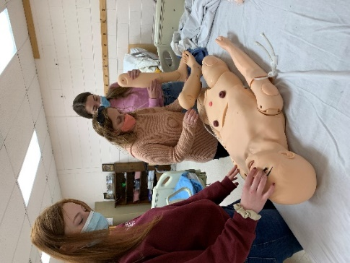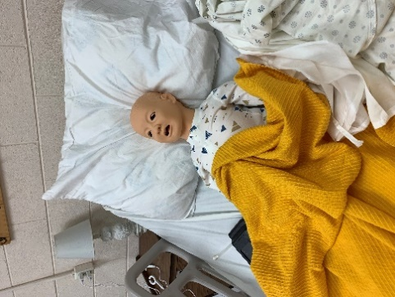
Medical Assistant I & II

Superintendent of Public Instruction James Lane recently announced the awarding of $600,000 in competitive grants to 16 high schools and technical centers to upgrade equipment for their career and technical education programs. Each school or center will receive $37,500 to purchase new equipment.
ANTC was has been awarded the grant to establish the ANTC Simulation Laboratory for our CNA and Medical Assistant programs. The lab will include Geriatric Nursing Manikins, Pediatric Nursing Manikins, a Closed Fracture Trauma Manikin, a Real Care Geriatric Simulator, Auscultation Trainer Class Pack, and a Blood Pressure Simulator.

Quinn

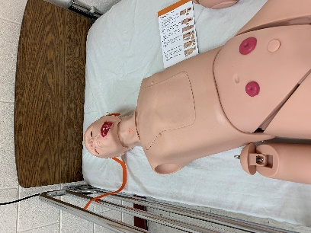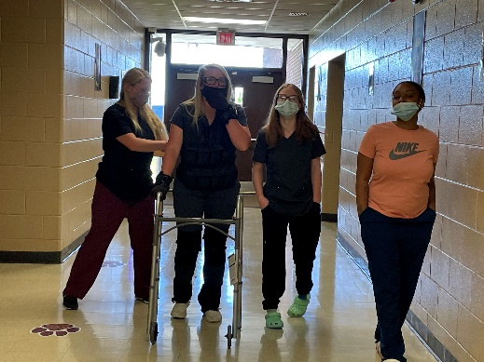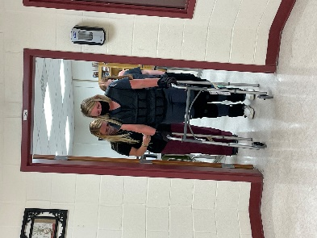
Health Sciences Waiting Room!

Quinn

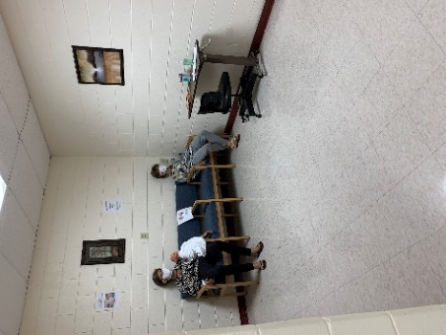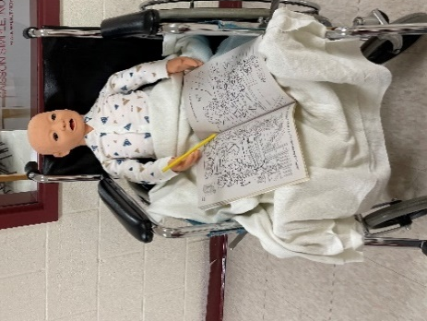
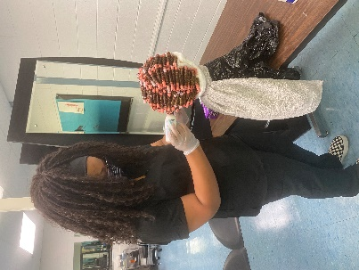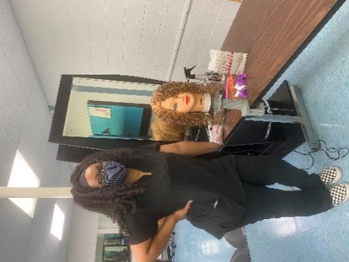
Roller Set
Wash & Rinse
Cosmetology l & II

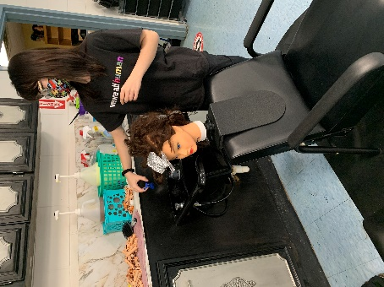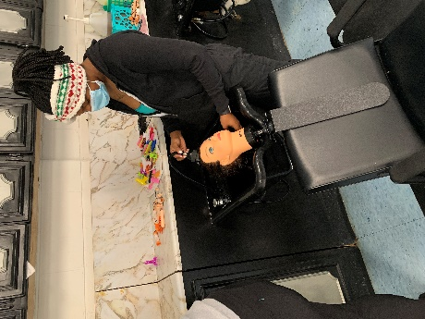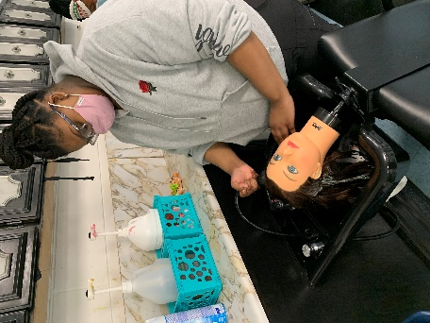
Auto Body l & II

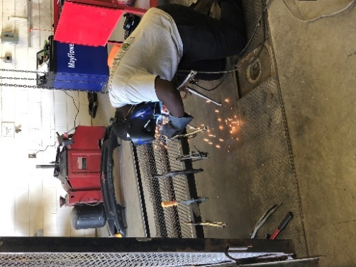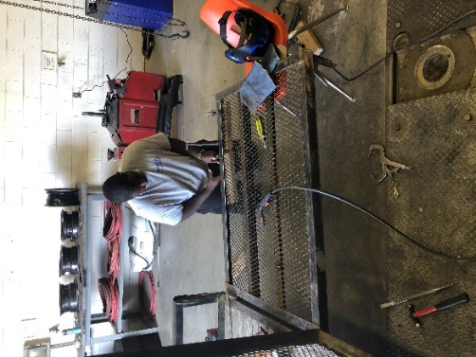
Senior Drayvon hopes to become a welder in the future. He has applied to The Apprentice School! Kudos to Mr. Spradlin for helping him to realize his dream.

QuinnNash
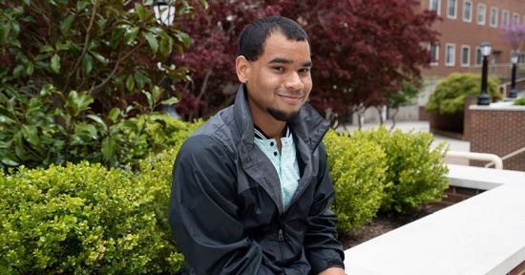Jamal Hill just wrapped up his first year as a Highlander at Radford University, and it’s been an eventful one for the student from Amelia, Virginia. Like many first-time college students, he arrived on campus with a plan, but he would soon have to adjust that plan to suit his talents.
Celebration! – Jamal is featured on Radford University’s website!
ANTC Program: Medical Assistant

At the beginning of the academic year, Hill was a biology major. He knew he wanted to help people in the career he eventually pursued, but he wasn’t sure what that career might be. He soon found he was struggling and decided he needed a change.
“In the middle of my freshman year, I changed my major to undecided,” said Hill. “I knew I still wanted to support people in whatever they were going through, but I needed to find out how I could best do that.”
To help him rebound academically after a tough first semester, Hill was referred to Radford University’s Academic Success Center (ASC). The ASC strives to empower students to thrive by providing a variety of quality academic support services. The objective of the ASC is to maximize the student’s personal and academic goals and to encourage them to persist, achieve and succeed.
Through the ASC, students find opportunities to work with academic advisors; engage and connect with peers; meet with faculty and graduate student mentors and coaches; and gather together for educational and social programming.
“The Academic Success Center has been the biggest factor in helping me stay a successful student,” Hill said. “It is hard to put in words how amazing everyone is at the center. They just make me feel at home because everyone is always smiling, and they always speak whenever they walk by, but the biggest reason why is that everyone knows my name and is always making sure I am doing okay.”
Hill not only found academic support at the ASC but discovered an alternate path that would allow him to help people during some of the most difficult times of their lives.
“During the second semester of my freshman year, I chose psychology as my new major,” Hill recalled, “because I wanted to help people by talking with them. I found I was really good at it, and it opened a lot of doors for me and my career.”
Now, Hill is earning A’s and B’s with the support of the ASC and has found his rhythm as a Highlander.
The ASC’s executive director, Corey Cassidy, Ph.D., said that Hill is an outstanding example.

