Storms Come to Clear your Path
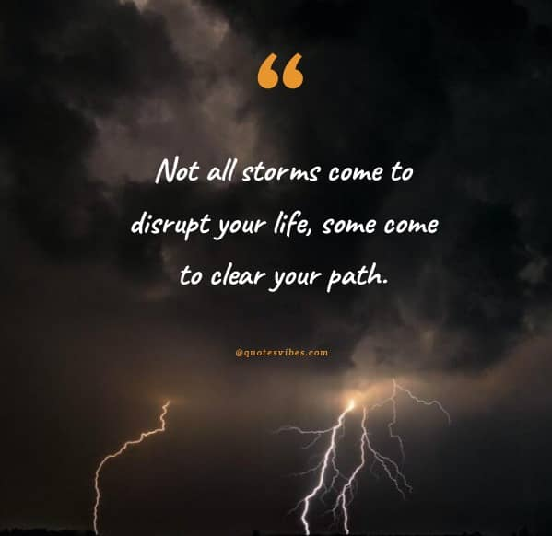
Many are facing huge storms right now, and it seems like the storm will never stop raging. It's one thing after another, and it won't let up. Just know your promise or breakthrough is on the other side. You have made it too far to give up now! I don't know who this message is for but God said keep your eyes and focus on HIM and HIS word. Keep him in mind, and the enemy won't be able to take you out the game physically, emotionally or mentally. The devil speaks lies in order to take you out the game. It's like a game of pick-up basketball. Where your opponent may call you names or throw insults in order to shake you and get you off your game. Sit down, refocus and get your head back in the game. You have the victory, but you still have to fight. Stand-up, speak to your storm and tell it to BE STILL!! You got this! I promise you! You have been trained for this spiritual warfare. Whether it's problems in your health, relationship, family, job, living situation, that is trying to punk you, you will overcome!!! Keep your eyes focused on the number one PROBLEM SOLVER and you will be DELIVERED!!!! Get your head back in the game God's soldier!!! You are not fighting this battle alone! God is fighting with you! There are many watching how you will handle the storm, so they can come behind you. You are a LEADER, You are a WARRIOR, You are a OVERCOMER, You are a BOSS, You are God's chosen SOLDIER for such a time as this!!! No matter what your situation is looking like that will never change! The devil comes the same way every time, always remember that. His warfare comes in cycles. Usually the same time of the year. The situations will even be similar, but there will be different players. Stay focused! Again, you got this!

