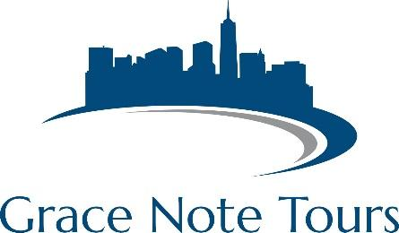

*The easiest trip-planning experience ever….guaranteed!*

**Williamsburg, VA – Sample Proposal**

**Package Inclusions:**

2 nights lodging

2 breakfasts

2 dinners

Tour of Colonial Williamsburg

Admission to Busch Gardens Williamsburg

$1,000,000 tour liability insurance

1 free director package

Director Resource Binder

**Options:**

Water Country USA

Historic Jamestown/Yorktown

Governor’s Palace

Shopping at Williamsburg Outlets

Transportation is NOT included in this proposal.

**Not what you want? Let’s customize to suit YOUR needs and educational requirements!**

**Williamsburg Sample Itinerary**

**Day 1**

Arrive at hotel/Check-in

Tour of Colonial Williamsburg

Dinner in Colonial Williamsburg

**Day 2**

Clinic/Workshop/Performance in the morning

Busch Gardens

**Day 3**

Shopping or Tours of Jamestown/Yorktown