FOB
A rapid, one step test for the qualitative detection of human occult blood in feces.
For professional in vitro diagnostic use only.

INTENDED USE
The FOB One Step Fecal Occult Blood Test Device (Feces) is a rapid chromatographic immunoassay for the qualitative detection of human occult blood in feces.

SUMMARY
Most of diseases can cause hidden blood in the stool. In the early stages, gastrointestinal problems such as colon cancer, ulcers, polyps, colitis, diverticulitis, and fissures may not show any visible symptoms, only occult blood. Traditional guaiac-based method lacks sensitivity and specificity, and has diet-restriction prior to the testing.^{1,2}
The FOB One Step Fecal Occult Blood Test Device (Feces) is a rapid test to qualitatively detect low levels of fecal occult blood in feces. The test uses double antibody sandwich assay to selectively detect as low as 50 ng/mL of hemoglobin or 6 μg hemoglobin/g feces. In addition, unlike the guaiac assays, the accuracy of the test is not affected by the diet of the patients.

PRINCIPLE
The FOB One Step Fecal Occult Blood Test Device (Feces) is a qualitative, lateral flow immunoassay for the detection of human occult blood in feces. The membrane is pre-coated with anti-hemoglobin antibody on the test line region of the device. During testing, the specimen reacts with the particle coated with anti-hemoglobin antibody. The mixture migrates upward on the membrane chromatographically by capillary action to react with anti-hemoglobin antibody on the membrane and generate a colored line. The presence of this colored line in the test region indicates a positive result, while its absence indicates a negative result. To serve as a procedural control, a colored line will always appear in the control line region indicating that proper volume of specimen has been added and membrane wicking has occurred.

REAGENTS
The test device contains anti-hemoglobin antibody particles and anti-hemoglobin antibody coated on the membrane.

PRECAUTIONS
- For professional in vitro diagnostic use only. Do not use after expiration date.
- Do not eat, drink or smoke in the area where the specimens or kits are handled.
- Handle all specimens as if they contain infectious agents. Observe established precautions against microbiological hazards throughout the testing and follow the standard procedures for proper disposal of specimens.
- Wear protective clothing such as laboratory coats, disposable gloves and eye protection when specimens are being tested.
- Humidity and temperature can adversely affect results.

Patient Preparation
- Specimen should not be collected during or within three days of a menstrual period, or if the patient suffers from bleeding hemmorhoids or blood in the urine.
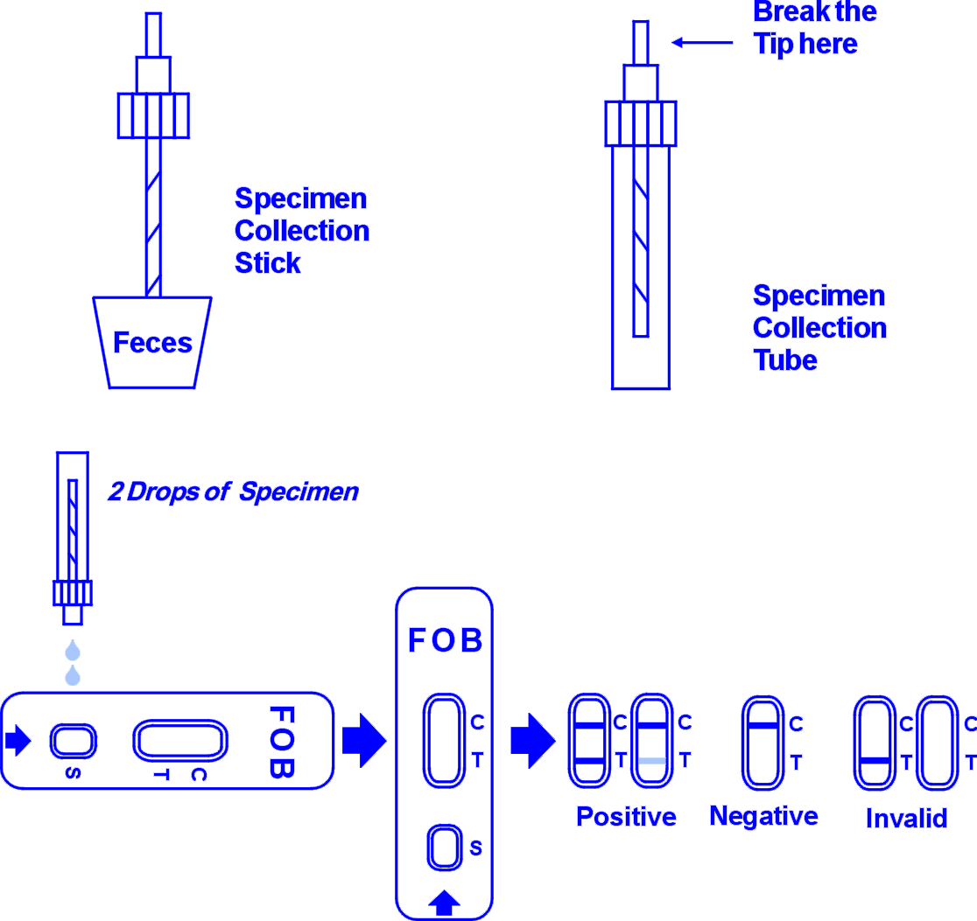
- Alcohol, aspirin and other medications taken in excess may cause gastrointestinal irritation resulting in occult bleeding. Such substances should be discontinued at least 48 hours prior to testing.
- Dietary restrictions are not necessary.

STORAGE AND STABILITY
The kit can be stored at room temperature or refrigerated (2-30°C). The test device is stable through the expiration date printed on the sealed pouch. The test device must remain in the sealed pouch until use. DO NOT FREEZE. Do not use beyond the expiration date.

MATERIALS

Materials Provided
- Test device
- Specimen collection tube with extraction buffer
- Package insert

Materials Required But Not Provided
- Specimen collection container
- Timer

DIRECTIONS FOR USE
Allow test device, specimen collection tube, specimen, and/or controls to equilibrate to room temperature (15-30°C) prior to testing.
- To collect fecal specimen: Collect feces in a clean, dry specimen collection container. Best results will be obtained if the assay is performed within 6 hours after collection. Specimen collected may be stored for 3 days at 2-8°C if not tested within 6 hours.
- To prepare fecal specimen:
- Unscrew the cap of the specimen collection tube, then randomly poke the specimen collection stick into the fecal specimen on at least 3 different sites. Do not scoop the fecal specimen.
- Screw on and tighten the cap to the specimen collection tube, then shake the specimen collection tube vigorously to mix the specimen and the extraction buffer. Specimen prepared in the specimen collection tube may be stored for 6 months at -20°C if not tested within 1 hour after preparation.
- Remove the test device from the sealed pouch and use it as soon as possible.
- Hold the specimen collection tube upright and break off the tip of the specimen collection tube. Invert the specimen collection tube and transfer 2 full drops of the extracted specimen (approx. 90 μL) to the specimen well (S) of the test device, then start the timer. Avoid trapping air bubbles in the specimen well (S). See illustration below.
- Wait for the red line(s) to appear. The result should be read at 5 minutes. Do not interpret the result after 10 minutes.

INTERPRETATION OF RESULTS
(Please refer to the illustration above)
POSITIVE:* Two distinct red lines appear. One line should be in the control region (C) and another line should be in the test region (T).
*NOTE: The intensity of the red color in the test line region (T) will vary depending on the concentration of hemoglobin present in the specimen. Therefore, any shade in the test region indicates positive result.
NEGATIVE: One red line appears in the control region (C). No apparent red or pink line appears in the test region (T).
INVALID: Control line fails to appear. Insufficient specimen volume or incorrect procedural techniques are the most likely reasons for control line failure. Review the procedure and repeat the test with a new test device. If the problem persists, discontinue using the test kit immediately and contact your local distributor.

QUALITY CONTROL
A procedural control is included in the test. A red line appearing in the control region (C) is the internal procedural control. It confirms sufficient specimen volume and correct procedural technique.
Control standards are not supplied with this kit; however it is recommended that positive and negative controls be tested as a good laboratory practice to confirm the test procedure and to verify proper test performance.

LIMITATION
- The FOB One Step Fecal Occult Blood Test Device (Feces) is for in vitro diagnostic use only.
- The FOB One Step Fecal Occult Blood Test Device (Feces) will only indicate the presence of human hemoglobin in the specimen and the presence of blood in feces may be other than colorectal bleeding.
- As with all diagnostic tests, all results must be considered with other clinical information available to the physician.
- Other clinically available tests are required if questionable results are obtained.

EXPECTED VALUES
The FOB One Step Fecal Occult Blood Test Device (Feces) has been compared with another leading commercial rapid test. The correlation between these two systems is 98%.

PERFORMANCE CHARACTERISTICS

Sensitivity
The FOB One Step Fecal Occult Blood Test Device (Feces) can detect the levels of human occult blood as low as 50 ng/mL hemoglobin or 6 μg hemoglobin/g feces.

Specificity
The FOB One Step Fecal Occult Blood Test Device (Feces) is specific to human hemoglobin. Specimen containing the following substances at the standard concentration were tested on both positive and negative controls with no effect on test results.
Substances | Concentrations (Diluted  with the extraction buffer)
Bovine hemoglobin | 1 mg/mL
Chicken hemoglobin | 1 mg/mL
Pork hemoglobin | 1 mg/mL
Goat hemoglobin | 1 mg/mL
Horse hemoglobin | 1 mg/mL
Rabbit hemoglobin | 1 mg/mL
Turkey hemoglobin | 1 mg/mL

BIBLIOGRAPHY
- Simon J.B. Occult Blood Screening for Colorectal Carcinoma: A Critical Review, Gastroenterology, Vol. 1985; 88: 820.
- Blebea J. and Ncpherson RA. False-Positive Guaiac Testing With Iodine, Arch Pathol Lab Med, 1985;109:437-40

Latest revision 09.05.2011

ATLAS LINK, INC
No. 811 Zeyang Plaza, No.166 Fushi Road
Shijingshan Dist., Beijing 100043, China
Tel: 86-10-88909112 Fax: 86-10-88909115
USA Headquarters:
10758-A Ambassador Drive
MANASSAS, VA 20109 USA
Tel: 703-3663851

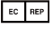
CIRIANO GLOBAL S.L. (UNILATEX GROUP)
CIF: B50927532 C/Blancas 4-6, 1 B Oficina 1
50001 Zaragoza Spain
Tel: 34-976910399

