GOUT (hyperuricemia)
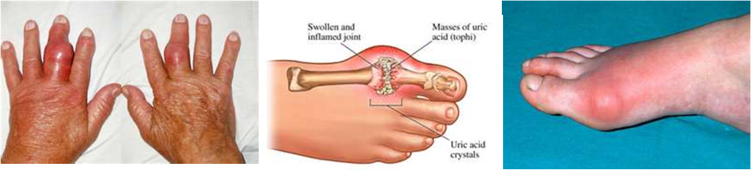

Gout is an accumulation of uric acid in the blood and deposits of uric acid salts in the tissue around the joints, especially in the fingers and the toes. It can also occur in the heel, knee, hand, ear, or any joint of the body. These high levels of uric acid come from your diet or metabolic disturbance.

Acute pain is usually the first symptom. Then the affected joints become inflamed, almost infected-looking …. red, swollen, hot and extremely sensitive to the touch.

Gout results when certain crystals are formed as an end product of improper protein metabolism. These crystals are deposited in a joint, forming a bump or growth that irritates the joint, causing it to become inflamed …. Thus an attack of gout occurs.

In chronic gout, uric acid crystals can accumulate in the blood vessels of our brains and kidneys. This can lead to high blood pressure, stroke, kidney stones and/or kidney failure if left untreated.

Gout is caused by:
- Regular use of low-dose aspirins
- Diuretics or water pills
- Lack of fluids
- Accumulation of heavy metals (especially lead … a hair analysis is a simple way to determine if you are accumulating heavy metals – call 905-871-4281 to order your test kit)
- Decreased elimination of uric acid by the kidneys caused by lack of digestive enzymes
- Metabolic disorders such as low thyroid or lack of coenzymeQ10 production
- Physical or emotional stress
- Injury to a joint
- Low calorie diet
- Eating meat or seafood that is high in purines
- Drinking excessive alcohol
- Vegetarians who consume excessive refined food products
- Obesity (which increases acidity of body)
A change in the diet is imperative for recovery.

Diet:
- Eliminate or reduce red meat
- Avoid alcohol, sugar and caffeine
- No fried foods or heated oils
- Lots of RAW nuts & seeds including milled flaxseed
- Lots of vegetables / lots of GREENS
- High fibre

Severe GOUT responds to a therapeutic approach!
Most people find that it starts to subside by the second day.

This is a Recommended Protocol: (the products listed below are Shaklee Products)
- Vita Lea (Multi Vitamin/mineral) – 1 at morning & noon (2 in total)
- B Complex – 2 with each meal
- DTX (Complete Liver Detox Formula) – 1 at each meal & bedtime (4 in total)
- Alfalfa – 10 at each meal & bedtime (40 in total)
- Herb Lax – 1 at bedtime (to support total body detox)
(This protocol costs about $5.50 per day to follow … it is recommended to follow it for 10 days and then follow-up with a daily maintenance program.)

- For two weeks eat abundant RAW fruits & vegetables … 1 fruit to every 3 vegetables to maintain more alkalinity in your body (or drink raw vegetable juice from a juicer)
- Drink at least 8 glasses of water daily
- Eat a high fibre diet
- Two to three tablespoons of ground flaxseed or 4 to 8 capsules of Shaklee OmegaGuard capsules (a complex of 7 omega 3 fatty acids). This provides essential fatty acids that are very anti-inflammatory)

The following is a testimony of a gentlemen who suffered with gout in his foot, and who was also a diabetic …. who followed the above protocol:
“The gout started to subside the next day. By the second day he called and was totally amazed. In the past, even on medication it wouldn’t take the inflammation down so that he could walk on it …. yet this natural method had no side effects and it completely took the gout away. He kept up the suggested protocol for seven days, and then lowered the amounts that he was taking to a maintenance level.”

For added benefit:
- Drink the VEGETABLE BROTH (see recipe below)
- Do a one-day “Gastrointestinal Flush – also known as the Celery Flush” …. you will flush a LOT of acid from the system
- Take 1 tablespoon of unpasteurized apple cider vinegar in ¼ cup of water with every meal (or you can purchase apple cider vinegar capsules)

Maintenance Program: (this costs approximately $1.40 per day)
- Vita Lea (Multi Vitamin/Mineral) 2 per day
- B Complex 2 per day
- Alfalfa 12 per day

VEGETABLE BROTH RECIPE:
- In a stainless steel pan add 1 ½ qts. water
- Add: 2 chopped potatoes, 1 cup each of shredded carrots & celery, + beet tops, turnips or onions
- Boil: turn down & simmer for 30 minutes
- Strain: drink broth warm or cooled. Can be refrigerated or rewarmed.
- Drink as much & as often as you like (reduces uric acid)

GASTROINTESTINAL FLUSH – Celery Flush
(The following flush has done wonders for many people. For example, people with arthritic joint pain, achy muscles, or gout, have reported much relief.)

Step 1: First thing in the morning: Drink 16 oz of prune juice with 3 tablespoons
of lemon juice and take 4 Shaklee EZ-Gest.

Step 2: Thirty minutes later do the following, and repeat every 30 minutes
(approximately twelve times, based on your body weight – see below)

- Drink fresh pressed celery juice (12 oz for 100 – 200 lbs / or 16 oz.
for 200+ lbs of body weight) and take 2 EZ-Gest
- Do this every half hour until you’ve taken enough ounces to cover your body weight (eg: 100 lb = 100 oz)

Step 3: For a thorough cleansing, do this six weeks in a row only once a week. Set one day a week (the same day each week is best). You will be amazed how much better you will feel the second and third week.

This is a tissue flush that helps alleviate the proteins stuck to the wall of the
gastrointestinal tract. The enzymes, with the celery juice, break down and
pull undigested protein (i.e. cheese products stuck to the intestinal walls). You will
release an incredible amount of acid from your system which can cause a burning in the
rectal area. For this reason, you are wisely advised to use Vaseline as a skin protector
in the rectal and surrounding cheek area prior to flushing.

NOTE:
- While doing this flush, you could experience a fowl odour coming from your mouth …. This is garbage (formaldehyde, ammonia, dymethalformahyde, etc.) being released from your system, and is not uncommon. All of these odours are being released from tissues, which is a good thing.
- If you have an incredible amount of acid in your system, you could encounter the feeling of nausea or vomiting. The reason for this is it cannot be expelled fast enough from your bowels.

If you cannot take the total amount of juice required for your weight in ounces, do what you can the first time. You can always increase the second time you do this cleanse.

You should NOT eat while doing this flush, and you will be tired after the day (your body has been working hard to detoxify). Do this on a day off, and be sure to give yourself a rest ….. don’t plan anything that requires lots of energy.

Traditional Medical Treatment for GOUT
There are a variety of drugs that are prescribed for GOUT. Three of the most popular drugs and their side effects are:

- Allopurinol – inhibits uric acid synthesis
  - Skin eruptions
  - Inflammation of the blood vessels, unusual bleeding or bruising
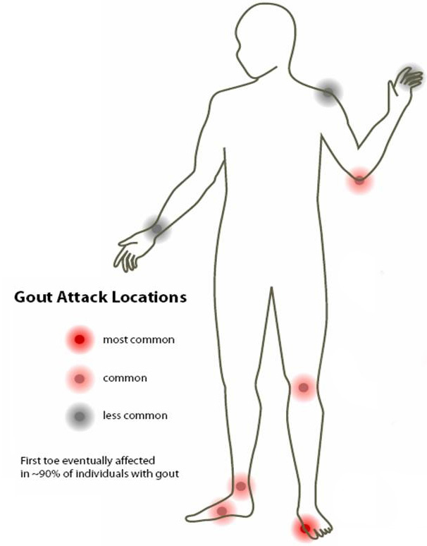
  - Liver toxicity & jaundice
  - Kidney damage
  - Diarrhea, stomach pain, nausea or vomiting
  - Headache
  - Drowsiness
  - Numbness, tingling, pain in hands & feet
  - Long-term use often leads to bowel cancer

- Colchicine – relieves joint pain, inflammation & swelling
  - Liver damage and jaundice
  - Headaches
  - Mouth or lip sores / hives
  - Unusual bruising or bleeding
  - Unusual tiredness or weakness
  - Breathing difficulty
  - Hair loss
  - Headaches
  - Fever / chills

- Cortisone - anti-inflammatory & immuno-suppressive
  - Adrenal damage
  - Liver damage
  - Fragile thinning skin / bruise easily
  - Fragile bones and osteoporosis
  - May lead to glaucoma, cataracts, diabetes, etc.
  - Weight gain
  - Headaches
  - Insomnia, restlessness
  - Muscle cramps or weakness
  - Stomach, hip or shoulder pain

- Krystexxa
  - Fewer than half the people in the trial actually ended up with a positive response to the medicine
  - 41% of the patients suffered severe infusion reactions, despite taking antihistamines and steroids before their Krystexxa treatment.
  - 77% suffered from gout flare-ups, compared to 51% taking placebo – despite being pretreated for at least a week with NSAIDs, colchicine, or both
  - An unusually large percentage of anaphylactic reactions (despite premedicating with antihistamines and steroids!)
  - Some people with pre-existing heart conditions died while on the study.
  - Other very unpleasant side effects included: chest pain, nausea, vomiting, and bruises.

If you want to continue to control with symptomatic relief … use drugs

If you have decided to get well, listen to what many have done to address the CAUSE!

