Nasal Polyps
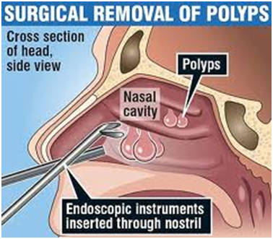

A simple surgery can quickly remove them, but a person can easily reform them if the cause is not addressed.

- STEP #1:
- Take lots of Shaklee Alfalfa (5 per meal) = 15 in total (which if crushed would be 1 tablespoon of Alfalfa powder). This alkalizes the blood and helps reduce the inflammation or the size. It also acts like a natural anti-histamine.
- Remove all chemical cleaners out of their home and replace with the toxin-free Shaklee Laundry products and cleaners ... many chemicals aggravate the polyps
- STEP #2: Shaklee Garlic tablets daily
- STEP #3: Eating lots of asparagus for the sulfuric acid it contains that helps reduce the aggravation and sometimes the size
- STEP #4: Increase selenium & zinc ... therefore, use Shaklee Vita Lea which contains both. Additional zinc tablet besides the Vita Lea is usually an excellent choice
- STEP #5: Increase essential fatty acids ... eat fresh ground flaxseed, and/or take OmegaGuard and GLA (EFAs act like natural anti-inflammatories).

