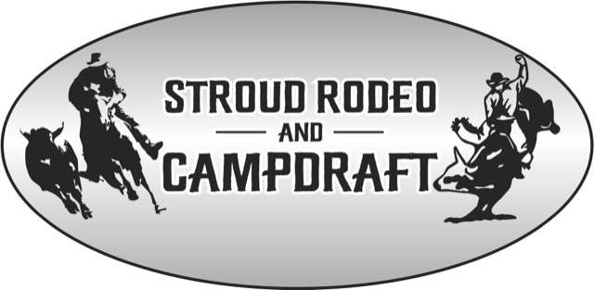

Stall Application
Date: _____________________________________________________
Stall Name: _____________________________________________________
Contact Person: _____________________________________________________
Postal Address: _____________________________________________________
Town/Suburb: _____________________________________________________
Post Code: _____________________________________________________
State: _____________________________________________________
Email: _____________________________________________________
Phone Contact 1: _____________________________________________________
Phone Contact 2: _____________________________________________________
Brief Description of stall: _____________________________________________________
__________________________________________________________________________
__________________________________________________________________________

Site Information
Powered Site square metre ________________________________________________
Unpowered Site square metre ________________________________________________
If stall holders have a generator is advisible to bring along incase needed.

Stall Holders must have their own Public Liability Insurance
Please attach a copy here:

PAYMENT to be made in full by the 1st September once contacted by committee via phone or email.
Payment Details are as follows:
Cheque – Please make cheque out to Stroud Rodeo Association and post to
Stall Coordinators
PO Box 50
Stroud NSW 2425
Bank Deposit
Account Name: Stroud Rodeo Association
BSB: 062 535
Account Number: 10022803

I agree to the terms and conditions as set out in the provided information attached to the application.

For any more information please contact

Glen Cummings or Annette Baldwin 0437 759 459

Stall Holders must comply with COVID19 regulations, this is the rules for now but you will be contacted if they change.

Thank you for your application to be apart of our event at the
Stroud Rodeo and Campdraft
held at the
Stroud Showgroud 3rd weekend in September

Please Note:
Stall holders will be encouraged to sponsor as well as pay the site fees which will be calculated individually taking into account the size and products being sold.
Thank you
Stroud Rodeo Committee

