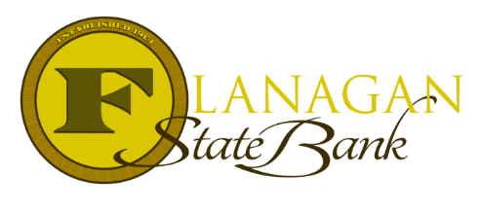
Mortgage Tidbits

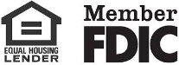
Keeping you informed and in the know….

Conventional Manufactured Homes Guide

In general, a Manufactured home is defined as a home that is built entirely in the factory under a federal building code administered by the U.S. Department of Housing & Urban Development (HUD). The Manufactured home must meet specific requirements. Please call us to learn more about financing a Manufactured Home!

Here at Flanagan State Bank, we offer conventional financing for Manufactured homes, see our nifty little chart below!

Transaction Type | Occupancy | Units | Restrictions | Maximum LTV/CLTV/HCLTV | Minimum credit Score | Cash Out
Purchase & Limited Cash out Refinance (LCOR) | Primary Residence  Second Home  Investment | 1  1  Ineligible | Fully Amortizing  Fully Amortizing  Ineligible | 95/95/95%  FNMA: Mgmt Exception Only  FHLMC: 85/85/85%  Ineligible | 620  620  Ineligible | Ineligible
Cash out Refinance | Primary Residence  Second Home  Investment | 1  1  1 | Fully Amortizing  Fully Amortizing  Ineligible | Ineligible as of 2/1/2022  Ineligible as of 2/1/2022  Ineligible | 620  620  Ineligible | 0  0  Ineligible
A Few things to keep in mind:
- If the LTV is greater than 90%, the max term is 20 years. If the LTV is less than or equal to 90%, then 30-year terms will be allowed.

Call us today for the best answers to the mortgage questions!
Insert photo here or delete box when ready to use
~ Provided to you by ~
Name: Phone:
Title: Email:
Address: City, State, Zip
Apply Now Link:

