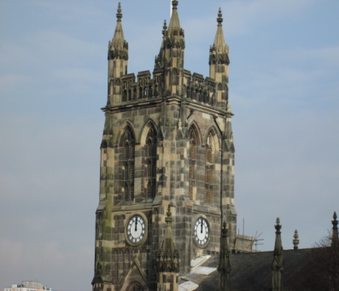
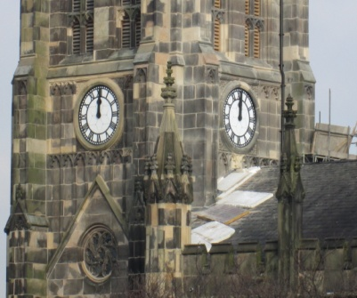
Well not everything goes to plan and it is rather unfortunate the St Mary’s is unable able to tell everyone the correct time after all! Our excitement of last week to see the clock going again being a little “short-lived”. We’ve had the hands set to twelve o’clock so that it is relatively clear the clock isn’t working. We knew it needed new parts to get the chimes working correctly, but now it appears that it also needs a good clean and service.

St Mary’s will be open during Holy Week for services only:
Tuesday,26th March 10.00am & 12.15pm
Maundy Thursday 07.00 pm (Holy Communion)
Good Friday 10:00am (Family Service)
11.00am (Walk of Witness)
12.00 noon & 02.00pm

St Mary’s in the Marketplace.

Issue No 36 (24th March 2013)

“Securing the future for the next 100 years”
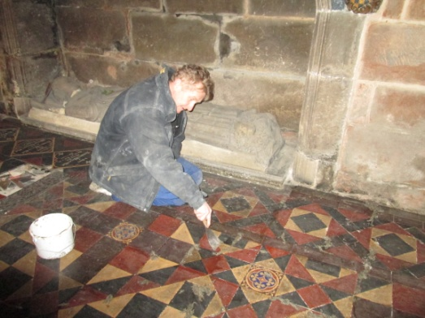
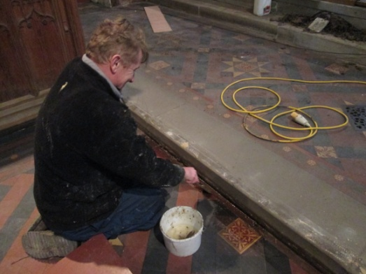
Another week on bended knee – maybe not in prayer – but restoring the floor, in particular at the east end of the building. Slowly by surely progress is being made and the end of the job is in sight. Our next site meeting is scheduled for early April and we hope by then all the flooring ill be completed.
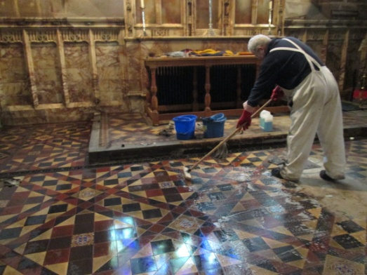

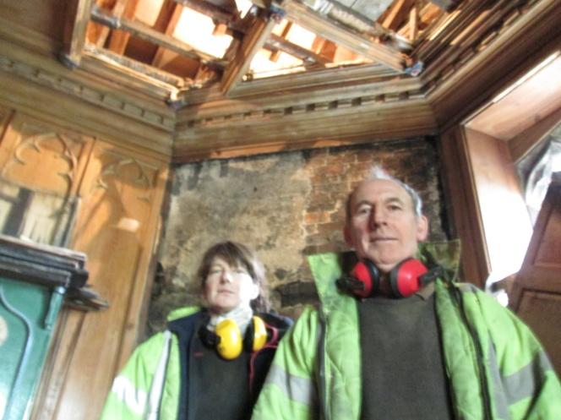
Meanwhile it was a delight to welcome back to St Mary’s an expert team of Dendrologists to check the ancient timbers in roof area of the Rector’s Vestry. We await with interest the results of their findings and to be able to compare them with the report we already have for the Chancel roof. Exciting times ahead!

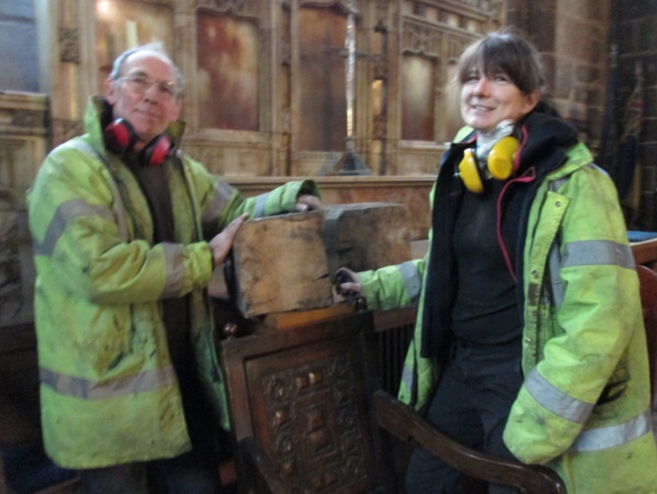
Also taken away for further investigation the timber ends removed from the tower.

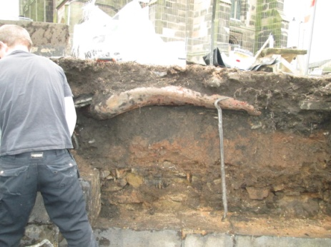
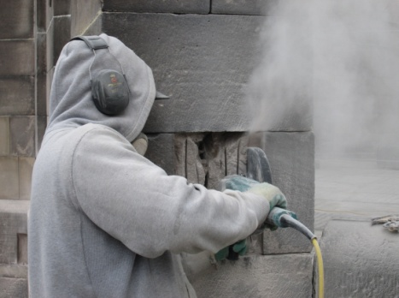
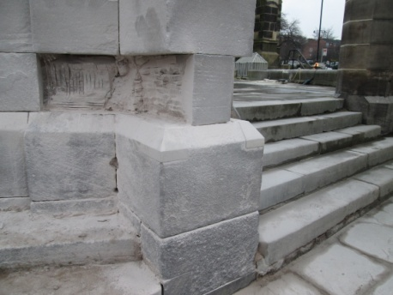
Most other activity has been outside – in the freezing cold - as work continued to complete the work on the archway to the church-yard and on the boundary wall. The willow has left behind rather chunky roots!

