**O** 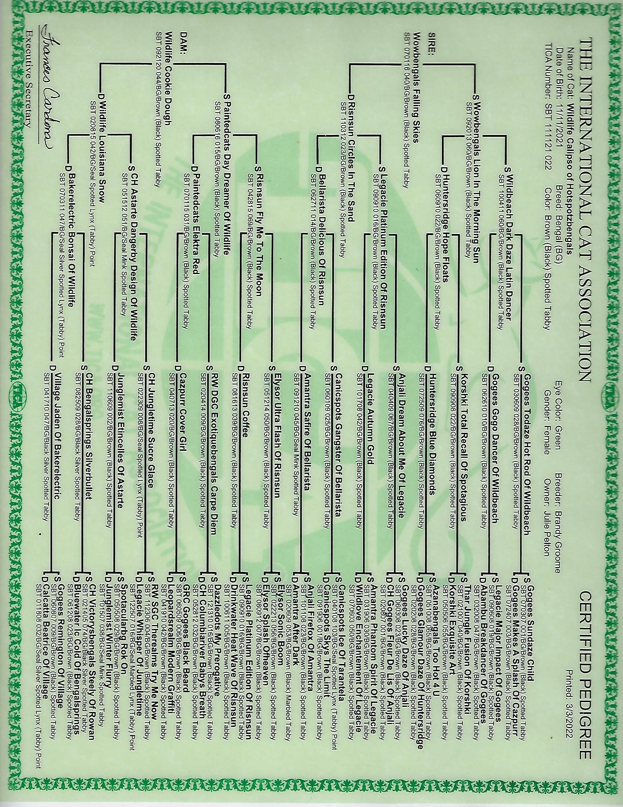

**DO NOT COPY**

**PROPERTY OF:**

**© HOT SPOTZ BENGALS**