Little Lanes

Data Protection Policy
At Little Lanes we respect the privacy of the children attending the Club and the privacy of their parents or carers, as well as the privacy of our staff. Our aim is to ensure that all those using and working at Little Lanes can do so with confidence that their personal data is being kept secure.
Our lead person for data protection is Cheri . The lead person ensures that the Club meets the requirements of the GDPR, liaises with statutory bodies when necessary, and responds to any subject access requests.
Confidentiality
Within the Club we respect confidentiality in the following ways:
- We will only ever share information with a parent about their own child.
- Information given by parents to Club staff about their child will not be passed on to third parties without permission unless there is a safeguarding issue (as covered in our Safeguarding Policy).
- Concerns or evidence relating to a child’s safety, will be kept in a confidential file and will not be shared within the Club, except with the designated Child Protection Officer and the manager.
- Staff only discuss individual children for purposes of planning and group management.
- Staff are made aware of the importance of confidentiality during their induction process.
- Issues relating to the employment of staff, whether paid or voluntary, will remain confidential to those making personnel decisions.
- All personal data is stored securely in a lockable file / on a password protected computer / passcode-locked phone.
- Students on work placements and volunteers are informed of our Data Protection policy and are required to respect it.
Information that we keep
The items of personal data that we keep about individuals are documented on our personal data matrix The personal data matrix is reviewed annually to ensure that any new data types are included.
Children and parents: We hold only the information necessary to provide a childcare service for each child. This includes child registration information, medical information, parent contact information, attendance records, incident and accident records and so forth. Our lawful basis for processing this data is fulfilment of our contract with the child’s parents. Our legal condition for processing any health-related information about a child, is so that we can provide appropriate care to the child. Once a child leaves our care we retain only the data required by statutory legislation, insurance requirements and industry best practice, and for the prescribed periods of time. Electronic data that is no longer required is deleted and paper records are disposed of securely or returned to parents.
Staff: We keep information about employees in order to meet HMRC requirements, and to comply with all other areas of employment legislation. Our lawful basis for processing this data is to meet our legal obligations. Our legal condition for processing data relating to an employee’s health is to meet the obligations of employment law. We retain the data after a member of staff has left our employment for the periods required by statutory legislation and industry best practice, then it is deleted or destroyed as necessary.
Sharing information with third parties
We will only share child information with outside agencies on a need-to-know basis and with consent from parents, except in cases relating to safeguarding children, criminal activity, or if required by legally authorised bodies (eg Police, HMRC, etc). If we decide to share information without parental consent, we will record this in the child’s file, clearly stating our reasons.
We will only share relevant information that is accurate and up to date. Our primary commitment is to the safety and well-being of the children in our care.
Where we share relevant information where there are safeguarding concerns, we will do so in line with Government guidance ‘Information Sharing Advice for Safeguarding Practitioners’ (www.gov.uk)
Subject access requests
- Parents/carers can ask to see the information and records relating to their child, and/or any information that we keep about themselves.
- Staff and volunteers can ask to see any information that we keep about them.
- We will make the requested information available as soon as practicable, and will respond to the request within one month at the latest.
- If our information is found to be incorrect or out of date, we will update it promptly.
- Parents /carers can ask us to delete data, but this may mean that we can no longer provide care to the child as we have a legal obligation to keep certain data. In addition, even after a child has left our care we have to keep some data for specific periods so won’t be able to delete all data immediately.
- Staff and volunteers can ask us to delete their data, but this may mean that we can no longer employ them as we have a legal obligation to keep certain data. In addition, even after a staff member has left our employment we have to keep some data for specific periods so won’t be able to delete all data immediately.
- If any individual about whom we hold data has a complaint about how we have kept their information secure, or how we have responded to a subject access request, they may complain to the Information Commissioner’s Office (ICO).
GDPR
We comply with the requirements of the General Data Protection Regulation (GDPR), regarding obtaining, storing and using personal data.

This policy was adopted by: Cheri Garratt | Date: February 2022
To be reviewed: February 2023 | Signed:  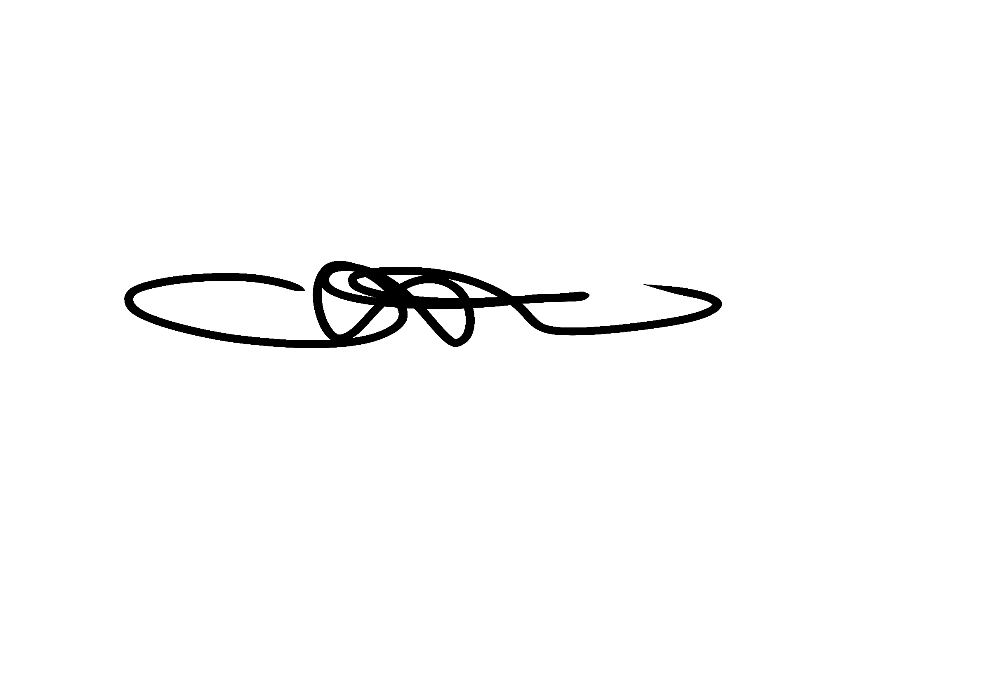

Written in accordance with the Statutory Framework for the Early Years Foundation Stage (2021): Safeguarding and Welfare Requirements: Information and records [3.67 -3.72].

